Cruising Guide
of the
SOUTH BAY CRUISING CLUB

This Cruising Guide is intended to be a practical handbook to assist members of the South Bay Cruising Club (SBCC) sail the Great South Bay and the waters that the SBCC summer cruisers roam: providing the skipper with information. When used in conjunction with the latest Nautical Charts, Coast Pilot, Light List, Tide and Current Publication and a copy of the Rules of the Road (boats larger than 39 feet must have a copy aboard) will provide the ship’s captain and crew with an enjoyable cruising season.

1

©2017 by South Bay Cruising Club

2016-2017 Edition

Prologue

C
ruising. …Blue sky and dancing seas beckon, exciting voyages, the peace and loveliness of quiet anchorages, camaraderie and the majestic crimson sunset await the cruiser, at night fall when the sails are furled and the ensign has been lowered one can relax on deck and study the heavens.

Since the original edition (1966) and two revised publications, many changes have taken place. This, the 2016 edition, continues the tradition of providing local information to SBCC members now includes New England, Connecticut, New York, New Jersey, Delaware and Maryland.

Care has been taken to provide the SBCC membership with accurate information. Nevertheless, remember that as time goes by buoy locations change, telephone numbers and area codes change, marinas close and new ones open; inlet waterways shift. Do your homework before setting sail on a journey.
The committee suggests that members use this copy as the name implies as a guide and not for navigation.

The South Bay Cruising Club is well known throughout the yachting world along the Eastern shore of the United States, members should conduct themselves in a manner that will enhance their own and the SBCC‘s reputation.

Acknowledgements

W

riting a cruising guide can be a time consuming task. However the available information from previous editions and the fact that everyone I queried for advice gave it freely made this undertaking a pleasure. The end result is a more complete and accurate guide.

This edition committee acknowledges the contributions made by the original, the second and the third edition teams as well as the many SBCC members who contributed information over the years, without which this revised copy would not be possible. Thank you all!

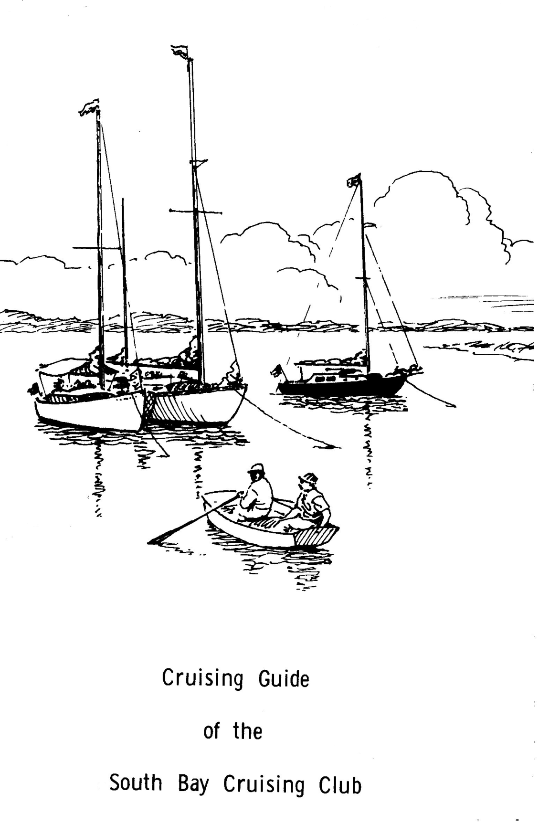

First Edition Cover 1966
Art by Hervey Garrett Smith

First Edition 1966 Third Edition 1989
Editor Editors
M. Whiting Thayer, Robert and Carole Sheppard
Committee Committee
John P. Berdolt John and Pearle Canning
William H. Cook Kenneth A. Kondor
Harry N. Klesick Edward and Joan Petroske
Alex Pearson Norman and Doris Robertson
Bud Rosenberg Roy and Peggy VanNostrand
Jack Ryan Alexander and Vi Yaxis
Philip B. Wainwright Donald and Laurie Zimmer
Judson F. Worden Cover Bernadette Hurley- Poulos
Art Hervey Garrett Smith Renderings Roger Ramsdell

Second Edition 1974 Fourth Edition 2002
Editors Writer
Bud Rosenberg Frank Peter
Jack Ryan Constructive Critique
M. Whiting Thayer Joel Becker
Committee Dorothy Becker
Richard C. Nehring Ed Petroske
John P. Berdolt William Menger
Arthur H Bertapelle Jeff Mattera
Donald P. Brown Medical
Dr. John A. Canning Andrew Peters, M. D.
Harry J. Colleran Legal
Cadman H. Frederick Ed Pshedesky
Robert C. Horn Cover
Edward S. Johnson Cover Graphics Marjorie Peter
Kenneth A. Kondor
William F. Milligan, Jr. 2012 Printing
Roger G. Ramsdell, Jr. Writer
Robert C. Thompson Frank Peter
Philip B. Wainwright Review
George F. Walsh Jane Glinski
Alfred Wieda Medical
John D. Woodward Jennifer DeMarco DO
Alexander G. Yates
Art by Les Segal

2014 Edition 2016 – 2017 Edition
Writer Editor
Frank Peter Frank Peter
Review Medical Margaret Christiansen
Legal Review Jennifer Demarco DO
Medical M.G. Van Tassel Medical Team
Joyce Gotard
Jane Glinski

Table of Contents

Who is invited to SBCC rendezvous? 10
Cruises and Awards 10
The Blast 10
Raft up Protocol 10
Summer Cruises 12
Who’s in Charge? 13
Guide for Cruise Captains 13
Notes on the New York Harbor Area 14
Bannister Bay 14
Rockaway Inlet 14
Deadhorse Bay 14
Sheepshead Bay 14
NOAA Chart 12350 14
West 79th Street Boat Basin 14
Horseshoe Cove 15
Atlantic Highlands Municipal Harbor 15
Ellis Island 15
Global Marine 15
Staten Island 15
North Brother Island 16
New York Verrazano Bridge North-Hudson River 16
Tarrytown 16
Haverstraw 16
Chelsea 16
Hyde Park 16
Indian Kill 16
Rondout Creek 16
Notes on Anchorages and Gunkholes 17
East Rockaway Inlet to Jones Inlet 17
East Rockaway Inlet 17
Zachs Bay 17
Navigate to Jones Inlet 17
Short Beach 17
The Bridges 18
Jones Inlet 18
The Western Area of the Great South Bay 19
Anchorages and Havens in the Western end of The Great South Bay 20
Unqua Heading 20
Gilgo Heading 20
Narrasketuck Creek 20
Amityville Creek 20
The Unqua Corinthian Yacht Club 21
Hemlock Cove 21
Cedar Beach 21
Garvage Cove 21
Oak Island Lead 22
Babylon 22
Sampawams Creek 22
Carlls River 22
West Babylon Creek 22
Bay Shore 23
Secret Harbor (Heckscher State Park) 23
Great River 23
Long Island Maritime Museum 24
Brown Creek, Sayville 24
Sayville Yacht Club 24
Patchogue River 24
Swan River 24
Fire Island or Great South Bay 25
Sore Thumb 25
Robert Moses State Park Boat Basin 25
Kismet 25
Saltaire and Clam Pond 25
Atlantique 25
Ocean Beach 26
Sailor’s Haven 26
Cherry Grove 27
Fire Island Pines 27
Talisman 27
Barrett Beach 27
Water Island 27
Davis Park and Leja Beach 28
Watch Hill 28
Bellport Bay and East 28
Beaverdam Creek 29
Carmen’s River 29
Old Inlet 29
Bellport Beach 29
Smith Point 29
Home Creek 29
Great Gun 30
Moriches Inlet 30
Westhampton 30
Tiana Bay 30
Shinnecock Bay and Cormorant Point 30
Shinnecock Canal 31
Block Island and Long Island Sound 31
Block Island (New Shoreham) 31
Point Judith Harbor of Refuge 32
Watch Hill Cove, Rhode Island 32
Stonington Harbor, Rhode Island 32
Mystic Seaport, Connecticut 32
Fishers Island 33
Essex, Connecticut 33
Hamburg Cove, Connecticut 33
East Haddam, Connecticut 33
The Gulf, Connecticut 34
Shelter Island 34
Coecles Harbor 35
Dering Harbor 35
West Neck Harbor 35
Eastern End of Long Island 35
Greenport Harbor and Stirling Basin 35
Sag Harbor 36
Lake Montauk 36
Great Peconic Bay 36
Bullhead Bay 36
Shinnecock Canal 37
North Shore 37
Mattituck Inlet 37
Northport 37
Lloyd Point 37
Oyster Bay Harbor 37
Manhasset Bay 38
Hempstead Harbor 38
Narragansett Bay, Cape Cod and Islands 38
East Passage 38
Newport 38
Bristol Harbor 39
West Passage 39
Dutch Island Harbor, Rhode Island 39
Wickford, Rhode Island 39
East Greenwich, Rhode Island 39
Buzzards Bay 40
New Bedford, Massachusetts 40
Marion, Massachusetts 40
Onset, Massachusetts 41
Red Brook Harbor, Massachusetts 41
Cape Cod Canal and Bay 41
Plymouth, Massachusetts 41
Provincetown, Massachusetts 42
Boston 42
Buzzards Bay and Vineyard Sound 43
Cuttyhunk, Massachusetts 43
Hadley Harbor, Massachusetts 43
Woods Hole 43
Tarpaulin Cove 44
Falmouth 44
Hyannis 44
Chatham (Stage Harbor) 44
Martha’s Vineyard and Sound 44
Menemsha 45
Lake Tashmoo 45
Vineyard Haven 45
Oak Bluffs 45
Edgartown 45
Nantucket Island 46
New Jersey 46
Shark River 46
Manasquan Inlet 46
Point Pleasant Canal 47
Barnegat Bay 47
Barnegat Inlet 47
Absecon Inlet 47
Cape May 48
DELAWARE 48
MARYLAND 49
Chesapeake and Delaware Canal 49
THE BOHEMIA AND SASSAFRAS RIVERS 49
Sassafras River 49
Annapolis 49
St. Michaels 50
Kent Island Narrows 50
Baltimore Inner Harbor 50
Hints for the Cruiser 51
Getting Ready 51
Menu Planning 51
Avoiding Pitfalls 52
Some Boat keeping Ideas 52
Suggested Medical Kit for the Cruising Sailor 53
Preparing Your Medical Kit for Cruising 54
Emergency Medical Assistance 55
Hemorrhoids – Preparation H with Cortisone 57
Bridges (VHF 13) (except Florida VHF 09) 57
Directory of Useful Telephone Numbers 59
Flag Etiquette 60
The Private Signal 61
Flag Officers Flags 61
Race Committee Flag 61
Signal Flags 61
Size of Flags 62
Use of VHF Marine Radio 62
U.S. VHF Marine Radio Channels and Frequencies 62
Handheld Radio Transmission Range Possibilities 63
Marine Operator 64
Weather channels 64
WX-1, WX-2 and WX-3 64
How to call another Yacht 64
Emergency Marine Radio Traffic 64
Distress calls 64
Urgent calls 64
Safety calls 65
VHF Digital Selective Calling (DSC) 65
Pump Out Facilities 65
New York 65
Pump out Facilities 66
Rhode Island 66
Connecticut 66
Massachusetts 67
New Jersey 67
Pump out Facilities 67
Maryland 67
Great South Bay Marinas 68
Moriches Bay Marinas 70
Shinnecock Bay Marinas 71
Long Island North Shore 72
Hudson River Marinas // Yacht Clubs 73
Block Island Marinas 74
Mileage (nautical miles, fairly accurate) 74
Location, Location, Location ….. 76
New York Harbor & Hudson River 76
South Shore, Long Island 77
Great South Bay 77
Long Island’s North Shore & East End 78
Massachusetts / Rhode Island 79
Connecticut 80
New Jersey 81
Delaware 81
Maryland 81
SBCC Cruising Song 83
Glossary 84
Tidal time difference from reference to local area 86
Conversions 89
References 90
Recommended Reading 90

Who is invited to SBCC rendezvous?

All hands are invited including members their children and guests! Please no pets. You don’t have to participate in a club race or function to join the rendezvous raft up that follows and you do not have to notify anyone in advance or arrive at any particular time. Just come when you are ready, with your club burgee flying and join the fun. Every weekend from May to October there is generally a rendezvous somewhere on the bay. Check the yearbook, The Masthead or the web site for the dates and locations. Each rendezvous has a designated Captain appointed by the Fleet Captain to host the gathering and record all participants.
A cumulative attendance record is kept and awards are given at the SBCC awards dinner.

Cruises and Awards

The major cruising events of the year are the one, two and three week cruises. Each one has a captain assigned who has the experience and is familiar with the suggested journey.
The one week cruise normally sails the Great South Bay with stops at ports like Bellport, Watch Hill, Great River, Atlantique, Democrat Point.
The two-week cruise becomes more adventurous and may include a visit to Block Island and ports in New England.
The three-week cruise challenges your skills, with ports of call as far north as Boston or south to Maryland.
All SBCC participants receive an award at the Annual Cruise Award Dinner.

The Blast
Weeks before the Blast begins the hospitality committee arranges social events and the racing committee organizes races. Location for this event is selected earlier in the year and is listed in the SBCC Year Book and on its web site.
The party begins on Saturday when the racers assemble; races are scheduled for the novice through to the experienced sailor, from spinnaker to Corinthian class. The party is underway!
For the champagne breakfast, captains dink over to the host boat for a bottle of champagne and then back to the raft for camaraderie.

Raft up Protocol
Tradition holds that no invitation is necessary to join a raft (defined as a group of boats tied together alongside each other at anchor). All you have to do is ask, “May we come alongside?” Most new members hesitate to intrude where a lively party is underway so the onus falls on the host to invite new members to come alongside. If the new member is reluctant because he lacks experience in rafting and anchors off, someone should be sent over to invite them to the party.
What if you do not want to raft? Then don’t hesitate to drop the hook well apart from the raft. However, you might like to state your intentions to the host boat before doing so and mention that you’d like to dink over to the raft later.
When you do decide to raft use your biggest and fattest fenders. Caution: if the ship’s hull has been painted use fender covers. Have your bow, stern and spring lines ready to pass over to waiting hands.
Generally when rafting, you should check with the host boat as to whether or not to lower your anchor. When you join a group aboard a raft it is customary to bring your own bottle, BYOB, and glasses, contribute to the snacks and offer to help with ice and mixers. Because space aboard is limited please take your bottle and litter with you when you depart. Should you decide to visit a boat at one end of the raft it is polite to ask permission, and cross via the foredeck.
Do any boats remain rafted all night? Sure, but as a rule only close friends and long time cruise mates keep the raft together or when the rain is pelting down and no one feels like getting wet untying lines.
On occasion, some SBCC boats rafted together have had exciting nights when the weather takes charge or the main anchor breaks loose.
Don’t try to free your boat from a big raft without help from the skippers on each side of you.
Please tie the ship’s halyards away from the mast before you go below for the night.

Summer Cruises

The annual summer cruises take place during the month of July or August, with an occasional trip south in June. Early in the year the Fleet Captain and his committee scout the membership for ideas. With these suggestions, tentative itineraries are fashioned and the Fleet Captain than seeks experienced skippers for the cruises. Once the cruise captains accept they organize their teams and complete a draft of each proposed itinerary for publication in the Masthead. In March draft itineraries are presented to the SBCC membership. Lively debate follows, recommended changes are considered and a more detailed journey is agreed upon.
Some cruise captains include information on charts, guides, tides, currents, latitude and longitude positions of ports of call, travel distance and time to destination.
They might also include data on harbors; marinas, anchorages and pump out services, fuel, ice, groceries etc.
During the actual cruise, the schedule may change due to weather or because the group has found an interesting deviation.
Cruise Captains normally get all the shipmates together for one or two cocktail parties during the cruise. Of course, you can volunteer to host a cocktail party; the cruise captain will not be offended.

Shellfish………”are they edible?”

Call 631-444-0480 for information on New York State Shell fishing areas that are closed for the harvest of shellfish.

Who’s in Charge?

The person in charge (PIC) of each vessel is responsible; the “PIC” should have proper charts and safety equipment aboard. The yacht must be seaworthy and in good order, knowledge of seamanship and piloting are a prerequisite. For safe passage the PIC of each vessel should review charts, currents, hazards etc the night before the next day’s journey. The PIC should also conduct daily maintenance checks of fuel; engine oil and coolant water levels.
The SBCC takes no responsibility for the above. However it does provide information, instruction and inspiration to assist skippers in their preparations.
If, during the cruise, a member needs assistance other members will help in any way possible.
The cruise captain is not in charge of the boats; the cruise captain is a source of information and advice. If you are inexperienced you may stay with the cruise captain, who is expected to maintain the basic itinerary for the sake of those who like to sail in fleet formation.
Traditionally, the club cruises use a buddy system: the captains team boats with one or two of the same length and cruising speed, they watch each other during particular passages like the offshore one from Fire Island Inlet to Shinnecock Inlet.
If you indicated earlier that you plan to stay with the cruise and then change your mind, it is your responsibility to inform the cruise captain because if you don’t show at the next port of call the group may call the Coast Guard and report you missing.
When hailing another SBCC vessel on VHF radio please use channel 9. After contact has been established, switch to an agreed “conversational channel”
Other than the guidelines stated, the South Bay Cruising Club avoids any suggestion of control of cruising. After all, one reason for cruising in the first place is to escape restrictions.

Guide for Cruise Captains
- Months before cruise
Research itinerary; develop basics
Route, water depths, main anchorages and alternates
Publish preliminary cruise in The Masthead and on SBCC web site
Schedule meeting invite SBCC members to attend
Have charts available
- Later
Review tide and current tables
Bridge heights, bascule bridges – when do they open?
How long will (hours) the daily cruise be?
Average boat speed expected
Restaurants, Marinas, Yacht Clubs and their reservation policies
Cancellation policies
Pump-out service, water, electric, fuel - are the services available?
Publish final cruise schedule in The Masthead and on SBCC web site
Before getting underway, host a captain’s meeting
Review any concerns such as inlets, shoal areas etc
Decide on a VHF channel for communication

- During the cruise
Maintain cruise log
Assist in raft ups and communication with marinas or yacht clubs
Cruise Captain should always have the ship’s VHF radio on and tuned to the agreed channel
Give special attention to new members
Organize activities such as cocktail parties
Insist that if anyone leaves the cruise that they notify the Cruise Captain

- After the cruise
Complete the cruise log; ask for input from all participants
Finalize and submit copy to the Fleet Captain, The Masthead Corresponding Secretary and to the Yearbook committee.

Notes on the New York Harbor Area

Bannister Bay
NOAA Chart 12352
Sailing west about 22nm from Fire Island Inlet is East Rockaway Inlet and Bannister Bay our first inside anchorage (40°36.270’ N // 073°43.800’ W) Enter East Rockaway Inlet and sail east under the bascule bridge, the first north channel on your port leads to the anchorage that has 7 to 29ft of water.

Rockaway Inlet
This inlet located at 40°32.400’ N // 073°56.600’ W is the entrance to Jamaica, Deadhorse and Sheepshead Bays. Check the current tables before entry; the inlet’s current velocity can reach 2.7 knots.

Deadhorse Bay
Deadhorse Bay in Jamaica Bay is the second anchorage west of Fire Island Inlet (about 30nm) be careful when entering just northeast of buoy R”2” there is a shoal area about ⅛ by ¼ of a mile in size.
The Gateway Marina (40º35.267’ / 073º53.921’) located here is now part of the National Seashore Park Facilities they offer dockage at $3.50/ft for sailboats and power, marina landline is 718-252-8761. They monitor VHF channel 16.

Sheepshead Bay

NOAA Chart 12350
The Sheepshead Bay Yacht Club (718-891-0991) (VHF 68) here is very friendly and will provide moorings for a reasonable fee that includes launch service to the main land. A second yacht club, Miramar, also has moorings at $40.00/night they monitor VHF 68: landline is 718-769-3548. Within walking distance are stores and restaurants

West 79th Street Boat Basin
NOAA Chart 12341 (212-496-2105)
This boat basin is located just 4 nm south of the George Washington Bridge on the east shore of the Hudson River. They have berths at $3.50/ft and orange moorings for transients at $30.00/night, electric $10.00/day (2016)
Services include pump-out, electric and water. Be careful the entrance is shallow!

Horseshoe Cove
NOAA Chart 12401
Located on the bayside of Sandy Hook, south of the Coast Guard Station, it was a relatively well-protected anchorage with 10 to 15 ft of water; the mud bottom provides good holding. Chart on page 90.
The “HOOK” that protected the cove from the West wind is now submerged. This cove is still a popular site with New Jersey sailors and can be crowded on weekends, nearby

Gunnison Beach was deemed by the Clean Beaches Councils as one of the top ten in the United States. Clothing is optional.

Atlantic Highlands Municipal Harbor
NOAA Chart 12401
Atlantic Highlands Municipal Harbor (732-291-1670, VHF 09) is about 2 nautical miles Southwest by South from Horseshoe Cove has slips, fuel, ice, and water, pump out service and supplies. Tidal range here is close to 6 feet.
The Atlantic Highland Yacht Club (732-291-1118 VHF 9) might have a mooring for the SBCC cruiser. Call the dock at 732-291-3232 or hail the “AHYC” via VHF 09 for a mooring, $50.00 / night includes launch service. (2016)
Ten nm west is the Keyport Yacht Club located on the Mattawan River, approximate location is. N40° 28.4' - W74° 11.0' the entrance channel has been dredged to a depth of 15ft (2001)

Ellis Island
NOAA Chart 12335

The SBCC fleet anchored here recently on the northwest side and found the holding ground firm even though a storm went through. However, there is no protection from the commercial traffic that generates turbulent waters. The least exposed anchorage is on the northwest; it offers a spectacular view of lower Manhattan. Strong eddy currents pose a problem and cause anchors to drag.

Global Marine
Located in (40°40.300’ N // 074°04.000’ W) Greenville Channel offers good holding ground in 5 to 15 feet of water. Stay close to the Global Marine bulkhead and clear of the Greenville Yard, as it is an active ConRail facility. From here the view of the Statue of Liberty and lower Manhattan is impressive. Remember, like Ellis Island, the waters are turbulent.

Staten Island
NOAA Chart 12327/ 12331
Great Kills Harbor has a Special Anchorage; it is located on the south side of Staten Island. The Great Kills Light, 35 feet high, and marks the entrance channel (40°31.300’ N // 074°07.900’ W) access to the harbor is through a dredged channel that has a depth of 9 feet at MLW, tidal range is nearly 6ft. There are several marinas here that offer berths, fuel, ice etc. Guest moorings are available at the Richmond County Yacht Club; contact launch operator via VHF 09 or the club house at 718-356-4120.

North Brother Island
NOAA Chart 12342
Sailing the East River one passes many islands; one of them North Brother (40º48.000’ N // 073º54.000’ W) was the home of a famous person “Typhoid Mary”. She was imprisoned against her will without judicial recourse. Although she continued to fight for freedom she remained here until her death at age 68.

New York Verrazano Bridge North-Hudson River

Tarrytown
NOAA Chart 12343
Just north of the Tappan Zee Bridge on the east side is a “Special Anchorage” with 6 – 8 feet of water. On the west side north of Nyack is another “Special Anchorage” in 9 /13 ft (2.7/4m) of water. The nearby Nyack Boat Club (845-353-0395) or the Hook Mountain Yacht Club (718-251-9791) may have facilities available.

Haverstraw
Numerous small craft facilities on Grassy Point can provide berths, electric, fuel, water, ice and marine supplies. Located on the west bank in West Haverstraw is the Hudson Cove Yacht club (hudsoncove.com)

Chelsea
NOAA Chart 12343
Three miles north of the Newburgh – Beacon Bridge on the east bank is the town of Chelsea and the home of the Chelsea Yacht Club, circa 1881,and a boatyard. Either can provide a berth with the expected marine amenities. Call 845-831-SAIL
Latitude N 41° 33.190 Longitude W 073° 58.221

Hyde Park
About 1-½ miles north of Hyde Park, the cruiser will find a “Special Anchorage”. The Poughkeepsie Yacht Club located south of the anchorage has slips ($1.50/ft) electric, fuel, water, ice and a pump out service. On a previous cruise here the fleet had a difficult time leaving the dock because of floating debris. One boat had to be pulled out of its slip.

Indian Kill
NOAA Chart 12347
Indian Kill is part of the Taconic State Park operated by the State of New York. The entrance channel has water depth of 7 ½ feet with 5 ½ feet in the basin. Fuel, water, ice and pump out service are available.

Rondout Creek
Just below the word “Kingston” on the nautical chart is about 3 miles long with only one bridge, vertical height 56 ft (17m), which might be a problem. Marinas located here can supply all your needs including pump out service. Rondout Creek is one of three watersheds that feed New York City’s thirst of one billion gallons a day.
Hidden Harbor Yacht Club, 914-338-0923, is just south of Rondout Creek.
Note: SBCC members who have sailed the Hudson River in July do not recommend it because the summer temperatures can be sizzling.

Notes on Anchorages and Gunkholes

East Rockaway Inlet to Jones Inlet

East Rockaway Inlet
NOAA Chart 12350
Compared with Jones and Fire Island Inlets this inlet is usually the safest to navigate. This inlet is about 8 nautical miles, on the ocean side; west of Jones Inlet provides access to the Intracoastal Waterway. It leads into Reynolds Channel and Hempstead Bay. Because of shifting sands at the entrance, inlet markers are frequently moved. Be alert. Should you decide to travel east along the inland waterway to Great South Bay you must be patient, there are 3 bascule bridges and one Swing Bridge en route. When you reach Point Lookout there is a fixed bridge with vertical clearance of 20 feet. Sail north along Sea Dog Creek to the next bascule bridge which leads south into the Sloop Channel and points east.

Zachs Bay
NOAA Chart 12352
A meeting place for club boats heading out Jones Inlet to New York Harbor. Zachs Bay is located at the west end of the State Boat channel (identified with day markers) and the east end of Jones Beach State Park. Zachs Bay should be avoided on summer weekends unless you enjoy anchoring in a crowded boat basin. The best approach is the west entrance (40°36.500’ N // 073°29.270’ W); the east entrance is noted for shoaling. There is no area within the basin where you are permitted to dock or come ashore. However you are permitted to anchor, 4 to 25 ft deep, overnight. Note the holding ground is not good. Make sure your anchor has a strong bite.

Navigate to Jones Inlet
From Zachs Bay follow the channel northeast by north. Proceed with caution at the mouth of Sloop Channel. Shoaling is a continual problem. Travel north along the Sloop Channel about 1 nm to the bascule bridge which is south of Green Island. Once thru, head southwest (Snipe Island will be on your starboard) and proceed to Meadowbrook Parkway bascule bridge. From here, Short Beach is a 1⁄2 mile west with Jones Inlet 1 1⁄2 miles ahead.

Short Beach
This is a good place to rest while waiting for favorable current to transit Jones Inlet. Short Beach should be approached from the west entrance to avoid a large unmarked shoal area 1 to 3 feet deep by an eighth of a mile long, Southwest of Short Beach Island is the West End Boat Basin docking facilities courtesy of Jones Beach State Park Be careful, the slips are not too wide and the water can be shallow. Regulations prohibit overnight stays. Here you will find a refreshment stand, pump out service and comfort stations. Good holding ground to drop the anchor is in the southeast corner or near the Coast Guard Station. On a previous SBCC cruise, when a storm warning forecast winds of 50 to 85 mph, the captains brought their vessels in here for safe haven.

The Bridges
Wantagh, Meadowbrook and the Loop parkway bridges are not continually staffed. During the summer the bridge operators may be hailed via VHF channel 13. When a number of SBCC boats are going inland and through the bridges, inform the Department of Transportation North Merrick office by telephone- 516-578-5905 –the day before passage. They will advise the bridge tenders of the fleets estimated time of arrival.
Note if there is a medical or fire emergency at Jones Beach the bridges will not open. There is ample room and deep water by these bridges to wait until the emergency passes.

Jones Inlet
About 1 mile west of Short Beach is Jones Inlet, a buoyed channel that leads to the ocean. Like most inlets, buoys are moved as the sands shift and therefore may not be listed on the local chart. Transit only after checking current (flood velocity can reach 4 knots, mean tidal range is 3.6 feet) and wind conditions. Opposing wind and current will make the exodus interesting.
Did you know that Jones Inlet was the passage way to the mainland in the 1920’s for bootleggers?

“Move over!”
From “The Art of Coarse Sailing” by Michael Green

Holding Tank Full?
and
You are sailing on the
Waters of
Patchogue
or
Moriches
call
Pump-out Boat
VHF 73

The Western Area of the Great South Bay

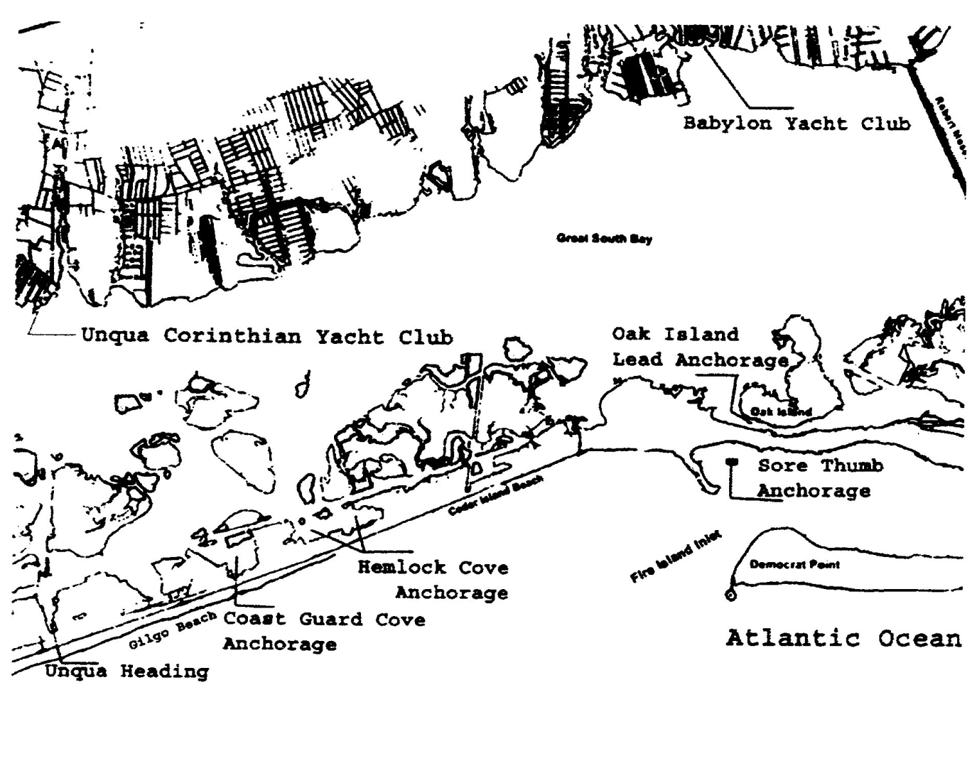
From Sampawams Point (40°41.000’ N // 073°18.600’ W) in Babylon west to the Nassau County line (Unqua Point) there is a well marked channel with numbered buoys on the north side of the bay: water depth is 5 to 11 ft.
One can sail in water depths of 6 to 8 ft from the Robert Moses Causeway west about 1.5 miles to Oak Island Channel. Local knowledge required if you continue west beyond this channel.
A longer route from Robert Moses Causeway to Amityville with many distractions is via the state channel. Sailing west from the bridge to Oak Island pick up Buoy G “9” and follow the channel south to G “65” (do not cut the corner short it is extremely shallow here), to Cedar Beach: head west along the State Boat Channel sailing past Oak Island, Cedar Beach, Gilgo Beach and finally reaching the Amityville Cut at buoy “29” turn north, sailing past Wansers Island on your port and Gilgo Island on your starboard. Be careful, as you exit the north end of the channel. Shoaling has been reported.
Here you will find the Narrasketuck Creek just north of your port and Amityville Creek directly ahead with Woods Creek on the starboard.
The Unqua Corinthian Yacht Club is located on Amityville Creek and the Narrasketuck Yacht Club can be found at the mouth of the Narrasketuck Creek. As you travel north you will see boatyards with fuel and facilities.
West of Nassau Shores, local knowledge is required to continue along the shoreline. However, a captain may take the Amity Channel from Unqua Point passing West Island on the starboard and Townsen Island on the port to the state channel and then west to Jones Beach.

Anchorages and Havens in the Western end of The Great South Bay

Unqua Heading
Unqua Heading south of buoy “29” Fl G 4s is a small cove south of the state boat channel opposite the south end of the Amityville Cut. This has been the site of the SBCC’s first rendezvous of the new season. The west bank is privately owned by the Unqua Corinthian Yacht Club (631-691-6570) and is open to members only from May 31 to Labor Day.
In early spring and late fall it is a convenient place to leave one’s yacht for a stroll along the ocean beach. This cove is protected from the east, south and west wind but not from the wash of passing boats in the state channel.

Gilgo Heading
This Town of Babylon facility located at 40°37.200’ N // 073°23.900’ W has slips, pump out service and showers available for boaters; dock side electric and water may be available in year 2004. Berths for residents with a permit cost $15.00/weekday and $25.00 for weekend days. There is a bar and food establishment located on the boardwalk that serves the public’s appetite.

Narrasketuck Creek
Narrasketuck Creek is roughly one half mile west of the Amityville Creek north of buoy “22”, with water depths of 9 ft at the entrance to 3 feet up north. Local knowledge is helpful if proceeding north to the marinas.

Amityville Creek
Amityville Creek east of Narrasketuck Creek has a private light, 25 feet high G “1” on the west bank at the entrance. The water’s depth is 7 to 9 ft with shoaling along the banks that have private homes and docks, leaving little room for a transient to tie up. There is a boat yard (Yacht Service, an SBCC member) north on the west bank that caters to sailboats. In easterlies, the mouth of the creek provides good anchorage for lunch.
This was the home of the Narrasketuck Class builder and designer Wilbur Ketcham.

The Unqua Corinthian Yacht Club
631-691-6570
The Unqua Corinthian Yacht Club, situated west of Amityville Creek (40°39.200’ N // 073°25.070’ W), has an adjacent basin with bulk heading on the bay side. There is a narrow canal neighboring the club where dockage is available to members. This is a good emergency landing. Further up, the rivers afford more protection and convenience. Boats with a draft of more than 3 ½ ft are advised to use caution and high tide when entering the Amityville area.
Coast Guard Cove
Follow the Amityville Cut south to its intersection with the State Boat Channel, turn east and steam to day marker “35” continue for 0.5 nm to the entrance (40°37.600’ N //073°23.2600’ W) which will be on the south side (starboard). This cove, well protected from boat traffic, is a popular anchorage with 9 to 15 ft of water. Gilgo Beach, with its surfing, restaurant and telephones, is an easy ½ mile walk westward. If you are sailing in the state channel from the east continue 0.25 nm past day mark R “38” to entrance.

Hemlock Cove
Sail east approximately 0.9 nautical miles from Coast Guard Cove today mark G “41”. Continue for 300 ft and you will come upon a “pole marker” off your starboard, turn south,
keep this marker on your starboard, continue south for a few boat lengths to avoid the shallow sides. Although the National Oceanic and Atmospheric Administration National Ocean Service Coast and Geodetic Survey Chart 12352 shows only a narrow 11 ft channel, the cove has been dredged east and west to depths of 15 to 40 ft. On most weekends you will find SBCC boats rafted here for the afternoon or weekend. Swimming in the cove or across the highway in the ocean is popular.
ON BUSY SUMMER WEEKENDS WHEN THE SKIPPER DROPS THE ANCHOR IN 40 FEET OF WATER BE AWARE THAT THE SUGGESTED SCOPE (40ft + freeboard) X 7 or at least 280 feet) MAY NOT BE POSSIBLE BECAUSE OF THE MANY BOATS AT ANCHOR. SWING ROOM IS EXTREMELY LIMITED! Use a sentinel, lower it about half way down the anchor rode, this will lower the anchor angle and allow for a shorter scope.

Cedar Beach
Cedar Beach is a town of Babylon marina restricted to town residents with permits from June to September. However, after the season comes to a close it can be a quiet place to spend a frosty weekend (no charge) except it is open to the north wind.
Cedar Beach is located between Hemlock Cove and Fox Creek Channel along the south side of the state boat channel. One will find telephones, barbecue pits and picnic tables and a highway underpass to the ocean beach. 40°38.140’N - 073°20.700’W
Pump out service is available at the west end corner dock.

Garvage Cove
Located at the south end of Fox Creek Channel, just southwest at day mark “48” is a deep water anchorage (20ft) open to north wind but protected from south, east and west blows. This cove is named after Mr. Garvage There may be a wreck or two but the cove is clean and a decent stop for a break.

Oak Island Lead
Oak Island Lead is south of Oak Island; once inside along the south shore the channel is about 150 ft wide and carries deep water, up to 30 ft in depth to the westerly end.
The entry can be a challenge. If you are coming in through the Oak Island Channel maintain your compass course of 170°M come alongside poles on portside until you pass the point of Oak Island then turn west into the cove, stay close to the northern shore until the water depth is 15 ft or greater. The summer cottages that line the shore do not have electric service, only solar panels and telephone connection to the main land.

Babylon
Babylon, home of the active and hospitable Babylon Yacht Club, “the birth place of the South Bay Cruising Club and the annual SBCC commissioning day” is familiar to most SBCC members. The Babylon Yacht Club buildings, located at the end of Eaton Lane in West Islip, were moved to this site by a large barge from a point south of the Babylon Village Municipal Dock around 1930, as part of a real estate promotion by the Sequams Colony.
Except for an east wind, a safe anchorage is along the west shore of the Babylon Cove between the municipal dock and the village-bathing beach. Nearby there are two waterways, Sampawams and Carlls, which are worth exploring. (5 to 12 ft deep)
As the years go by and one looks back many changes are apparent except the following it seems to remain constant!
From “Learning to Cruise” circa 1935
My mate who will stoutly maintain
That she’d much rather travel by train,
Who declares hard and fast
That each cruise is her last,
Then relents, and goes cruising again.

Sampawams Creek
Sampawams (the Indian name for Babylon before 1803) Creek is just west of the Babylon Yacht Club has marine facilities at the south and north ends.
Along the east shore are many lovely waterfront homes. At the head of the creek is Davis Southard’s small boatyard. Main Street is an easy walk from here.

Carlls River
Carlls River is home to the Long Island Yacht Club (former residence of Mrs. Edward Trenchard ,1910).and a yacht yard midway up the on east side. Fine homes line the riverbanks: up north at the head of the river one will find the Babylon Village Bandstand. A two-block walk east from either tributary brings one to the village shops.

West Babylon Creek
40°40.500’ N // 073°20.200’ W
Locally known as Mud Creek has fuel and some groceries available at Bergen Point Fuel Dock.

Bay Shore
Bay Shore, about 2.75 miles north by northeast of the Robert Moses Causeway, has a large Town of Islip Marina that provides a self-service pump out station located at the fuel dock on your port as you enter the harbor on the southwest side. Approximate coordinates
40°42.750’ N // 073°14.280’ W

Secret Harbor (Heckscher State Park)
The compass rose on NOAA Chart 12352 hides Secret Harbor boat basin. To enter from buoy N “6”, off Heckscher, head 350°magnetic to the readily visible entrance. The unmarked channel carries 3 to 5 ft of water (use extreme caution). The inner basin has depths of 8 to 10 feet. This is a New York State Park (1,657 acres) and caters to people who like to spend a day picnicking, bathing or listening to an outdoor concert.
Facilities are available for launching small craft.
In the past SBCC members would stop here and anchor overnight in the basin but not any more. Recently one of the SBCC boats anchored here was informed that was forbidden and was asked to leave. Queries should be address to the park attendant at 631-581-2100.

Great River
Great River is the yachtsmen’s name for one of the finest harbors on the Great South Bay as well as the name of a small hamlet on the southwest bank of the river. Shown on NOAA Chart 12352 as Connetquot River, it lies on the north of the bay about halfway between Bay Shore and Patchogue. The entrance is easily recognizable by the appearance of large red brick buildings (circa 1897) of St. John’s University, formerly LaSalle Military Academy.
Sailing in from Nicoll Bay you will notice small craft heading through a cut between the high sand bluff of Timber Point and the marsh to the northeast, Nicoll Island. Do not follow! This passage is not recommended for boats with a draft of more than 3 feet.
At the entrance to Connetquot River there is a private marker, a red nun buoy “2” that marks the shallows (2 feet). Keep it at least 100 ft off your starboard beam with Nicoll Island about 1/8 of a mile off your port. Proceed at 293 degrees magnetic for 0 .9 miles to the “4-Miles per Hour” buoy, anchor in good holding ground (soft mud).
Swimming here has been acceptable in recent years.
As you sail up river you will pass one marina on your starboard that supplies fuel, ice, water and service.
Also on your starboard are two restaurants: The View, formerly the Vanderbilt Tea House and The Snapper Inn. Both have docking for dinner guests. Reservations are a must! The Snapper Inn is a popular restaurant with many SBCC members. Besides docking facilities they have a grassy area for SBCC members and guests to park during Great River celebrations. It is also our titular home. To the south of the Snapper Inn lies the Grand Canal. This is a fascinating dink trip through Idle Hour the former Vanderbilt estate, traversing back yards and under fixed bridges with clearances of 5 ft
A dink ride up river from the anchorage finds a state park, The Bayard Cutting Arboretum, located on your port. Unfortunately, landing is not permitted. Continue and one comes upon Dowling College complex the former summer home of W. K. Vanderbilt.
Located south of the anchorage is a Suffolk County Park with golf course and tennis courts.

Long Island Maritime Museum
Formerly known as the Suffolk Marine Museum, is located in the basin of the old Hard estate in West Sayville. Its first director was the late Hervey Garrett Smith a charter member of the SBCC and a yachtsman instrumental in establishing this museum.
Traveling by sea the museum is east off Green Point with the entrance just west of Green Harbor (40°43.200’ N // 073°05.600’ W). Shallow water (4 ft) leads to the entrance, which on occasion has been dredged. We suggest that you anchor out and dink in. Here one will find maritime exhibits and antique boats, oyster and clam activities.

Brown Creek, Sayville
40°43.200’ N // 073°04.100’ W
Brown Creek about 1 mile east of Green Harbor has fuel and ice available just inside the breakwater on the west side, approach at high water if possible.
As you enter the breakwater there is a FREE town pump out station on your starboard side.
Ferry services to Cherry Grove, Fire Island Pines and Sailor’s Haven are located here.

Sayville Yacht Club
40°43.800’ N // 073°02.200’ W
Sayville Yacht Club, circa 1901, is an active sailing club, which is no longer, located in Sayville but instead is located on the east shore of the town of Blue Point and can be identified by its prominent flagpole visible after rounding the Point. In your approach from the west stay near buoy “35” before heading into Patchogue Bay, the water is shallow off the Point.
The entrance to the bulkhead basin is north of the clubhouse. Once inside, favor the south side. The slips are all leased for the season by club members and cannot be used by transients except with permission of the lessee or the Chairman of the Basin Committee. However, visitors may tie to the inside bulkhead near the entrance.
The Sayville Yacht Club has been a gracious host to the SBCC Labor Day Regatta and other events throughout the year.

Patchogue River
40°44.750’ N // 073°01.000’ W

Patchogue River is a commercial river with many boatyards on both banks. Ferries commute to Watch Hill and Davis Park. There are two restaurants: one on the east side just north of the Davis Park ferry where one can tie to the bulkhead and come ashore for a cocktail, lunch or dinner; the second restaurant is at the head of the river on the west side with slips available for transients.

Swan River
Swan River, just under one mile east of the Patchogue River, has a narrow entrance with water at a depth of 3 to 4 ft. There is one buoy marking the entrance (G “1” FlG 4s). Keep it on the port side.

Fire Island or Great South Bay

Sore Thumb
NOAA Chart 12352
Sore Thumb has been a favorite overnight anchorage for the SBCC cruisers that set sail in the morning to travel thru the Fire Island Inlet, it is about 2 miles west of Robert Moses State Park Boat Basin; however recent storms have changed the contour of the anchorage base, do your home work before dropping the anchor.
An alternate is Robert Moses Boat Basin.

Robert Moses State Park Boat Basin
The boat basin, located south of Captree Island and 1/4-mile west of the Robert Moses Bridge, has 40 berths with deep water and pump out service (no electric). You may stay for the day; however you are permitted to stay overnight if the captain has a park permit. As of May 2003 there is an overnight fee of $50.00/boat. For an application contact Long Island State Park Region Permit Office PO Box 247 Babylon New York; land line 631-321-3515.
One can secure the craft here and walk under the highway to the ocean beach. There are concession stands that serve fast food, beverages and ice cream.
A two-mile walk east along the ocean beach will find one at the Fire Island Lighthouse. Walk in the other direction and you will find a beach where clothing is not obligatory.

Kismet
Kismet, shown on NOAA Chart 12352, is the western most beach community between Saltaire and Fire Island Lighthouse. It lies south of buoy GR “EW” at the end of West Channel and south of buoy N “6”. There is good food and, if you’re fortunate, dockage for dinner at the Kismet Inn. A grocery is nearby. It is a fine stop for lunch and a walk to the beach on a cement path or to the Fire Island National Seashore Lighthouse, which is approximately one mile west via a sand trail. The Lighthouse is open Wednesday to Sunday between 0930 and 1700 hours from Memorial Day to Labor Day. Here one will find nautical exhibits, information and a restroom.

Saltaire and Clam Pond
Saltaire was founded as a family community in 1910. It is the only community with a natural harbor on the bay side.
Saltaire and Clam Pond are east of Kismet. The entrance buoy to Clam Pond is FlG “1” located at 40°38.600’ N // 073°11.100’ W. Take heed on your way in shallows (1 to 2 ft) are all around. Inside the water depth is about 25 ft.
A village ordinance prohibits anchoring in Clam Pond. Moored boats within Village waters may not be occupied except for the purpose of mooring them. Clam Pond Cove has been closed to swimming because of pollution.

Atlantique
NOAA Chart 12352
Atlantique, a Town of Islip Marina, located between Fair Harbor and Ocean Beach is about 500 yards west of State Boat Channel buoy R “12”, this will put the ship in line with the marina opening and its channel buoys. Inside there are two sections: one east and one west. The east side is preferred because it offers protection from the state channel boat traffic as well as the surge from the ferries. Facilities include a boardwalk to the ocean beach, bathrooms, cold showers, barbecues with tables, a kiddies’ playground and a fast food concession. This marina is open to Islip Town residents during the summer and to transients during the week at the dock master’s discretion. (631-583-8610) Pump out service is located at the dock master’s office. Weekend docking fee is $60.00/day for a 11ft berth; $38.00 with a beam under 11 ft. (2016)

Dunewood, Fair Harbor and Ocean Beach
Within walking distance from Atlantique along the beach or via the sand dunes pathway are Dunewood, Fair Harbor and Ocean Beach. Fair Harbor is west about ½ mile; Ocean Beach is east about 1 mile. Both have grocery stores, although Ocean Beach has more restaurants, shops, bakery, two groceries and an active community.

Ocean Beach
Ocean Beach is Fire Island’s largest summer resort community. It offers shops, theater, restaurants and nightlife activities; ships provisions are also available. The entrance channel between buoys N “14” and C”15 has been dredged to a depth of 9 feet. Be aware no transient slips are available here. Seasonal ferry service is offered from Bay Shore.
Ocean Bay Park
Ocean Bay Park is a small community west of Point O’ Woods. Flynns Restaurant located here has slips for customers. No slip available? Anchor off and dink in. Flynn’s is a preferred nightspot with yachtsmen.
Point O’ Woods
A private community founded in 1894 is east of Ocean Beach has an enclosed anchorage accessible by invitation only.

Sailor’s Haven
Sailor’s Haven one mile east of Point O’ Woods is a National Seashore Park Facility. There is berthing for about 36 boats. The narrow entry has been dredged to a depth of 7 ft and is well marked with private aids. The concessioner can be reached at 631-597-6171.
Water depth in the center of the basin is 13 feet with 4 ½ to 6 ft at the berths, the east side being the deepest. Electric (125/250 V 50 amps $8.00/day) and water are available at each slip. Slip fee $2.00 / ft on weekends, Monday – Wednesday $1.00/ft. Entry day or night is easy, range lights and lighted buoys mark the way. A radar reflector, used by ferries as a turning mark, that leads into the channel, is located at 40°40.000’ N // 073°06.724’ W. Be aware that there is a 3 ft shoal about 250 yards east. If all slips are occupied leave your boat’s name with the harbormaster and anchor out north of the entrance buoy in 4-1/2 to 6 ft of water.
The park rangers have regularly scheduled day and evening programs during July and August. There is swimming on the ocean side with lifeguards on duty during the day.
The main attraction is Sunken Forest: a primeval holly forest, a sanctuary for wildlife, a field for study by scientist and lover of nature. The park rangers request that all yachtsmen and yachtswomen observe park regulations, that they do not discharge sewage into the marina, don’t swim in the basin and observe the quiet hours from 10:00 pm to 6:00 am when no generators may be operated. Pump out service is available. As of January 15, 2015 the channel will have been dredged to 100 ft in width and to a depth of 6 feet.

Cherry Grove
Cherry Grove, a summer resort 4 miles south of Connetquot River across the Great South Bay, is a very active community during the day and night. Popular restaurants include The Bay Leaf, Top of The Bay and Rachel’s Restaurant at The Grove. There are no docking facilities here, except the occasional slip for a price. Local knowledge is a must to enter this shallow harbor. The Grove is a short walk east (3/4 mile) from Sailor’s Haven along the ocean beach. Cherry Grove is not for children.

Fire Island Pines
The community of Fire Island Pines has a protected man made harbor that is crowded during the summer. The well-marked channel should be approached from the northwest; depth of water is about 4 feet. The slips are rented by the season; transients may find a slip by checking with the dock master at 631-597-9581. The afternoon Tea Dance noisy, brash and swinging is popular with the younger group. The Pines is quiet and enjoyable in the early spring and late fall.
Slip fee is $6.00/ft with a minimum charge of $180.00, electric $20.00/day (2016)

Talisman
Talisman lies about 300 yards west of Barrett Beach and is a small Fire Island National Seashore Park. Local knowledge suggests that boats with drafts greater than 3 feet should not attempt to enter the well-marked channel. Instead it is possible to anchor in the small 50 by 150 yard dredged area by entering from Barrett Beach side, split the southernmost buoys marking the entrance to the anchorage and you will find 5 to 6 ft of water all the way. Proceed with caution. No docking here but Talisman offers picnic areas and bathroom facilities on the bay front and a boardwalk through the native foliage to the ocean beach.

Barrett Beach
The Town of Islip has closed its marina here (NOAA Chart 12352) and it is now part of The Fire Island National Seashore. Services for the boating community are no longer available.

Water Island
Water Island, located ¾ of a mile east of Talisman is a family community. The yellow buoy that marks the flats between Water Island and Davis Park to the east should be left to port as you approach. If your vessel draws more than 3 ½ ft do not enter. Anchor out and beach your inflatable. There are no facilities here and no ferry service.

Davis Park and Leja Beach
Davis Park is a large Town of Brookhaven Marina, standard docking fee is $1.75/ft for Brookhaven residents ($4.00/ft for others) electric $12.00 (30 amp 125V connector). Enter by leaving the head buoy of Watch Hill at a compass course of 180º. Carefully review NOAA Chart 12352 for shoal areas on both the east and west sides of the entrance channel.
Davis Park is a family oriented community although the cocktail hour at 5:00 pm attracts a large crowd to the marina and the place at night can be quite noisy. There is no quiet time. Marina landline is 631-597-9090.
Groceries, liquor, ice, ice cream etc. are obtainable at the stores on the dock. For the evening there is the Casino for dinner or for cocktail hour with a view of the bay and the ocean.
Pump out service is available at the Dock Master’s office.

Watch Hill
40°42.175’ N // 073°00.600’ W
Watch Hill, part of the Fire Island National Seashore, is directly across the bay from Patchogue and east of Davis Park. The entrance channel, one mile in length, is well marked with seasonally lighted buoys (ten) and a range light. Take care; the water on either side is only 2-3 ft deep.
As of January 15, 2015 the Watch Hill Channel will have been dredged to 100 ft in width and to a depth of 6 feet.
The marina has deep water with 195 berths available. Services include electric (125/250V 50 amps) and water. Restrooms, showers and telephones as well as campgrounds can be found here. A pleasant walk (1/2 mile) along the boardwalk leads to the ocean beach, where the park service has lifeguards on duty. The Park rangers have regularly scheduled walks as well as daily and evening programs during the months of July and August. This is a very popular place on weekends. Come early to secure a slip, especially during the SBCC family weekends held here during the season. Slip reservations are available on the same day you expect to arrive. Call 631-597-3109 about 9:30 am. Slip fee Friday – Sunday is $2.00/ft + electric, Monday – Thursday $1.00/ft + electric about $7.00/day. On the east bank there is a self-service pump out station.
Need groceries? A ¾ mile walk west on the boardwalk through the dunes will bring you into Davis Park.
Ferry service from the main land is available at the head of the Patchogue River by the National Park Service.

Bellport Bay and East
At the eastern end of the Great South Bay, bounded on the north by Bellport and Brookhaven and on the east by Mastic-Shirley, Bellport Bay is the happy playground of the Bellport Yacht Club (#45 on NOAA Chart 12352).
Locate the flagstaff (072°56.000’ W) shown on the chart and you have found the club, or traveling by car one will find the club at the foot of Bellport Lane. Anchoring northeast of Howell’s Point in Bellport Bay in 6 ft of water affords a good night’s stay. During the summer, Bellport sponsors outdoors concerts as well as an annual art and craft fair and will show an occasional movie. A short walk north finds shops, churches, restaurants and a summer theater.

Beaverdam Creek
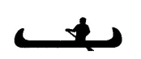 Beaverdam Creek, 0.6 nm northeast of Bellport Yacht Club, has deep water up to a marina at the north end. Explore this creek with your inflatable. It is a pleasant trip. The creek splits a short way in. To the right are wetlands and a few houses with large boats. Take the left passage and you will be surprised when large homes come into view.

Carmen’s River
 Carmen’s River, on the north side of the Bellport Bay, has a water depth of 2 feet through the entrance. The river’s mouth is marked by private seasonal buoys and is entered between Long Point on the west and Sandy Point on the east side. Although landing is not permitted the area is ideal for exploring by inflatable. Maurice Wertheim deeded to the government the area that makes up most of the river’s wetlands now known as the Wertheim National Wildlife Refuge.

Old Inlet
This inlet existed before the Revolutionary War; access is south of state channel buoy R”6”. The waterway (1.40 miles in length) is marked with 6 buoys to Old Inlet dock, which is primitive with 20 narrow slips; no facilities are available. The channel is shallow (3.5 to 4ft.) and is not dredged. This Fire Island National Seashore Facility leads to the Fire Island Wilderness which is surrounded by salt marsh and therefore has an abundance of mosquitoes.

Bellport Beach
Bellport Beach is located on Fire Island, south of Bellport village. It can be accessed by sailing south leaving buoy R “2” on your starboard and buoy C “1” on your port. Be careful: NOAA Chart 12352 indicates shallow water. Occasionally the channel is dredged to a depth of 10 ft. Be sensible and seek local knowledge before proceeding. The landing is maintained by the village of Bellport and is a fine place to visit off-season.

Smith Point
Smith Point is an occasional gathering place for cruising yachts heading east via the inside route. Just west of the bascule bridge and southeast of R “12” is an anchorage that has water depth of 5 ft. A Suffolk County Park located on the ocean side, a popular retreat for campers on weekends, can be reached by dink. Another snug anchorage is east of the bridge (40°44.300’ N // 072°51.700’ W) in 9 to 13 ft of water.
Need a pump out? Contact the Southampton Pump-out Boat on VHF 9 and they will come alongside (no charge for this service, tips are appreciated).

Home Creek
Home Creek is a beautiful, quiet, almost deserted, deepwater (9 ft) anchorage off the western end of Moriches Bay between Forge Point and the mouth of Forge River. Entry can be difficult because of shallows on both sides; the compass course is 226 degrees from the bay. Be cautious, the Moriches Bay water leading to the entrance is only 4 ft deep. Tall trees, marshes, little fields and birds will surround you. Drop an anchor near the shore to starboard.

Great Gun
Great Gun is another haven for those sailing east inside. The entrance buoys R “2” and
G “1” located at 40°46.400’ N // 072°47.200’ W guide you through a ¾ mile long buoyed channel with 6 feet of water to the anchorage. The Town of Brookhaven maintains the Great Gun Marina with about 40 slips, bathrooms and a boardwalk to the ocean. Non resident’s slip fee is $4.00/ft.

Moriches Inlet
The June 2004 Local Notice to Mariners (LNM) stated that the Moriches Inlet was dredged to a depth of 20ft and has buoys in place. There is a west and east channel that lead into Moriches Bay. The Fl 2.5s 38ft tower marking the entrance has been replaced by two markers south of the entrance – Fl G 2.5s 14ft “1” and Fl R 2.5s 14ft “2”. In July 2004 SBCC members returning from New England entered here rather than thru Shinnecock Inlet. A US Army Corps of Engineers report (Oct 2004) shows depths at the center of the entrance channel to be 3.7 ft at MLW! Seek local knowledge before entering breakwater. Just outside (ocean side) there is a bar that runs east and west.
Caution your insurance company may not provide coverage for your vessel.
Check with your agent before you venture through here.

Westhampton
Here you will find the Westhampton Beach Yacht Basin, a marina that offers a change from the usual SBCC rendezvous. You can dock overnight for a fee, $3.00/ft and $12.00 for electric and enjoy the comforts of dockside running water, electric, showers, and telephone, nearby shopping, restaurants and the beach. Rafting alongside the bulkhead can be arranged for a short stay. For slip reservations call the dock master at 631-288-9496 or 288-9782.
If you are the type who can plan ahead, call the village office at 631-377-9013 for slip reservations. Paying an additional fee to your mooring fee will grant one access to the town beach, a 5-minute walk from the marina.
Entrance to the marina (#24 on NOAA Chart 12352) is just past the first bascule bridge east of Moriches Bay as you enter Quantuck Canal. Be careful of the overhead power cable at Potunk Point - its height is 77 ft (23.5m). About 900 ft east of the bridge on your port is a privately dredged channel that leads to the yacht basin. This channel is well marked by private seasonal lights and buoys. The entrance to the boat basin is on your starboard about ½ mile north.

Tiana Bay
NOAA Chart 12352
Tiana Bay, 6 miles east of Westhampton, is for the adventurer who travels inside: a good place to overnight before sailing out Shinnecock Inlet. The anchorage is north, 800 yards east of G”9 ”, in soft ground with 5/6 ft of water.

Shinnecock Bay and Cormorant Point
 Shinnecock Inlet, circa 1938, RW “SH” Whistle is 40 nautical miles east of Fire Island “FI” Whistle. Both are excellent anchorages for an overnight stay. The cove (4/7 ft deep) formed by Cormorant Point is generally used for the first official stop on our annual cruise east. Need supplies? The town of Hampton Bays is a short ½ mile walk west.
When you approach G “29” and turn west, continue for 1/8 of a mile past C “31” and N “30” before heading south to the anchorage thereby avoiding the 2ft shallows on your port.
North of Cormorant Point is Jackson’s Marina, 631-728-4220, where fuel, ice and water are available. The same supplies can be bought just before you enter Shinnecock Inlet to sail off shore. Marinas will be off your starboard beam. There is good fishing in July and August at the northeast corner of the bay near the Shinnecock Reservation on Old Fort Pond.

Shinnecock Canal
If you plan to lower the mast and pass through the canal, call the lock tender at 631-852-8291 for the latest information. For slip reservations call 631-854-4952, there is a two-week limit for transients. There is a six-hour window to pass safely through the canal locks: 3 ½ hours before high water at Sandy Hook and 2 ½ hours after.

Block Island and Long Island Sound
NOAA Chart 13217

Block Island (New Shoreham)
This island, 3 by 7 miles in size, consists of 7,000 acres and lies in the Atlantic Ocean about 12 miles east-northeast of Long Island. Giovanni da Verrazano discovered this island in 1523. It was named after Adrian Block who arrived here 90 years later.

This island has about 900 permanent residents and over 300 fresh water ponds. The average wind velocity is 15 knots: however, gales are frequent. More often than not, this is the first port of call for the northeast bound cruisers. The island is a delightful stopover, offering steep hills and flower-covered moors dotted with homes of summer residents. Up north is the National Wildlife Refuge an ideal place for birdwatchers.
The Great Salt Pond, 1 mile in diameter, will have as many as 2,000 vessels on a major weekend. The entrance is on the west side of the island and has an easy approach with a foghorn and a light on the west jetty. The controlling depth is 6 1/2 feet. Favor the left side - the right side tends to shoal especially near buoy “10”.

On the south side of the Great Salt Pond are Champlin’s (VHF 68) ($4.00/ft) and Block Island (VHF 09) Boat Basin. Both can provide transients with slips but reservations are strongly recommended. Beware of Champlain’s reservation; crowded conditions often result in rafting with all size yachts from a 20 ft runabout to a 60 ft yacht.
Payne’s New Harbor Dock (VHF 09) on the east side of the boat basin offers transients dockage from Memorial Day to Columbus Day for yachts up to 200 ft in length. Town moorings, lime green, are often difficult to come by if you are a late arrival. However, if you are fortunate and find one vacant, secure your vessel to it and report to the harbormaster’s office (VHF 12) or wait for the launch. Fee of $40.00/night + .50 cents/person for the first night (2015). Pump out: hail channel 73.

Like to anchor? Come early to anchor in reasonable depths or you may be dropping the hook in depths of 30 ft. Sudden storms and squalls come late at night, make anchoring and rafting in close proximity to other boats an exercise to be remembered. Launch service for a small fee will take you and your mates to the main land.
There are docks for dinks on the left of Champlin’s (800-762-4521) and on the right of Block Island Boat Basin.

Do you have access to the Internet? Connect with the Block Island Tourism Council at www.blockisland.com for current events.
Have a craving for blueberry muffins for breakfast? Hail Aldo’s Bakery Launch, which cruises the basin each morning and late afternoon.
The Oar at Block Island Boat Basin is the place for breakfast and one of the best views on Block Island over looking New Harbor. For dinner and dancing visit Ballard’s at Old Harbor.

Point Judith Harbor of Refuge
NOAA Chart 13219
Point Judith Harbor of Refuge is northeast of Block Island and is formed by a “V” shaped breakwater. There is easy access from the east or west and offers protected anchorage in the south corner of the “V”. Are you adventurous? Continue north past the towns of Jerusalem and Galilee to marinas or sail north two more miles to Point Judith Pond and anchor in 5 to 7 ft of water. The entrance is between Gardner and Beach Islands.

Watch Hill Cove, Rhode Island
NOAA Chart 13214
Watch Hill, Rhode Island is about 17 miles west of Point Judith and has several hotels and summer houses. The Watch Hill Yacht Club (VHF 10, 401-596-4986) has five moorings available for visiting yachts at $55.00/night. This fee includes tender service to the club house where dinner is served every night but Wednesday and Sunday.
No moorings open? Anchor in the cove for a secure overnight stay or contact Watch Hill Docks at 401-596-7807 ($4.00/ft + electric). Access to Watch Hill Cove is a test of the captain’s patience. The voyage begins at the Middle Ground Horn and proceeds through a channel 100 ft wide with depths of 4 ½ to 6 ½ ft that is four miles in length. By the time you reach the cove you will have sailed past 23 buoys and many motor vessels will have tried or succeeded in passing your craft.

Stonington Harbor, Rhode Island
Stonington Harbor (three breakwaters protect the harbor) is 3 nautical miles northwest of Watch Hill. A Special Anchorage (no anchor light required) can be found inside the west breakwater in depths of 15/18 ft. The Wadawanuck Yacht Club is located on the eastern shore. Enjoy French cuisine? Then a visit to The Harbor View Restaurant is a must.

Mystic Seaport, Connecticut
NOAA Chart 13214 (860-572-5391)
(www.mysticseaport.org) Stop here at least once if you’re a cruising yachtsman or yachtswoman. The seaport is just 3 miles upriver from Fisher’s Island Sound past two bridges. It is 0.6 miles north of the highway Mystic Bridge. Check the bridge schedules for opening times before proceeding! Along the waterfront property of the seaport is a 19th century coastal village that has been recreated with shops and lofts of that period. Maritime items on exhibit include shipbuilding demonstrations.
Reservations are a must if one decides to berth. Cost is $4.50/ft for non-members. The dock attendant will assist in securing your vessel to the pier and with registration. With your ID tag you are free to roam the grounds day and night. Call for general information.

There is an anchorage just north of buoy 53 with a maximum stay of seven days. Not too much room, water depth is 7/8 ft.

Fishers Island
NOAA Chart 12372
Fishers Island is not a place for nightlife and boisterous living, but a place to savor and reflect upon the values of life. Scenic, accessible, sedate and contrary to popular opinion, it is hospitable. Fishers Island offers three main anchorages for the visitor. Eel Pond, the small harbor at the extreme west end of the island is used by the Coast Guard, the ferry and for emergencies. East Harbor is too exposed for a comfortable anchorage, but should certainly be visited for lunch, a swim and slow passage along the shoreline. West Harbor is a delight to experience. Entry is easy and well marked. The anchorage area south and east of the small marina is limited but safe and convenient. A gas dock is east of the marina. A short row to the dinghy dock and walk will lead to boutique shops. Past the ball field and firehouse you will find stores, grocery, a specialty bakery, a coin operated laundry and a supermarket.
Best of all, take the dink to the inner harbor to see beautiful homes and visit the lobster docks, where one may obtain a fresh lobster for dinner.

Essex, Connecticut
NOAA Chart 12372
Essex, Connecticut (www.essexct.com or Essexinfo@aol.com) is located on the western shore of the Connecticut River about 6 miles north of Saybrook’s 58 ft (17.7m) high horn. Your captain can secure a berth at Essex Island Marina (860-767-1267, VHF 9) or a mooring at the Chandlery. The world famous Griswold Inn, established in 1776, is known for its fine food and collection of nautical prints as well as its memorabilia. During the winter months it is great place for a weekend with fireplaces ablaze and a Sunday Hunt Breakfast. The town fulfills most shopping and yachting needs in the many shops that line Main Street.

Hamburg Cove, Connecticut
Hamburg Cove, about 3 miles north of Essex, is an easy dink ride, on the east side of the Connecticut River. It is reached through a well-marked channel, but be cautious of rocks on both sides of the channel. This cove is the prettiest anchorages in the lower New England area. Pine trees, amongst which lovely homes are nestled, surround this serene spot.
A visiting sailor is free to pick up any mooring free of charge except the green ones that belong to the Cove Landing Marina, 860-434-5240. Mooring fee is $20.00/night.
The blue and white moorings are private. If the owner appears you must vacate.

East Haddam, Connecticut
Continue north for 8 miles to East Haddam, a town that claims to have the world’s oldest church bell circa A.D 815. Like opera or musicals? Stop at Goodspeed Opera House (860-873-8668), a restored Victorian theater (circa 1877). They offer opera and nationally acclaimed musicals from April through December. Secure the vessel overnight alongside the bulkhead for a nominal fee.

The Gulf, Connecticut
NOAA Chart 12364
The Gulf, a bight between Welches Point and Charles Island, is about 15 nm north of Port Jefferson Harbor, or 6 ½ miles westward of New Haven Harbor entrance. It affords good anchorage in 6 to 15 ft and is sheltered in all but southeasterly winds. Chart on page 89.
Up north about ¾ mile is the eighteenth century town of Milford that welcomes visitors at its town marina with the historical town a short stroll from the dock.
Milford Landing (203-874-1610) (VHF 09)has floating docks with 40 slips, 7 ft at MLW, 30 / 50 amp electric, pump out service, ice, water, tennis and basketball courts, laundromat, showers, barbecue and picnic areas and complimentary coffee and newspaper. All for $3.00/ft, charge for electric is $7.50/night. (2016) The Milford Yacht Club (203-783-0065) (VHF 68) has ice, water, showers, pool, a bar and meals. Slip fee $3.00/ft, electric $5.00/day.

Shelter Island
NOAA Chart 12358
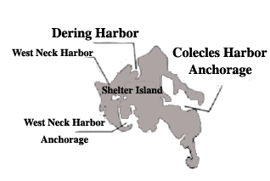
Tucked between the forks of Long Island, Shelter Island lures cruising sailors with its quiet well-protected harbors as well as its many nautical nooks and crannies. Boaters coming from Long Island Sound can use the Plum Gut approach while those coming from Block Island sound or the Atlantic Ocean can reach around Gardiners Island and through Gardiners Bay. Current charts should be consulted for the passage through Plum Gut (current velocity can reach 5 knots). The island, approximately seven miles long and four miles wide is great for biking, hiking and spotting birds (more than a quarter of the island is a nature conservancy). In addition, there are two public golf courses, tennis courts and horseback riding for your enjoyment.
A ferry trip from Dering Harbor to Greenport will find several marinas, shops and a supermarket. Coecles Harbor on the east side can be approached from Gardiners Bay. By circumnavigating Shelter Island under sail west along the north or south shores one can enter West Neck Harbor.

Coecles Harbor
Be alert! The entryway to the harbor is not easily seen as you approach. The water depth in the channel is 7 ft; on the north side it is 5 ft, while on the south it is only 3 ft.
Coecles Harbor, located on the east end of Shelter Island, has one of the largest marinas on Shelter Island. The marina (VHF 9 or 631-749-0700) has 55 slips ($4.00/ft) and 50 moorings available ($1.50/ft minimum $45.00) (2016) as well as a pool and laundry. Transportation is provided to local shops and restaurants.
The marina provides ship repairs, ice, fuel, water, electric and pump out service. For those who like to anchor there is a Special Anchorage on your port as you enter the harbor between buoys C “5” and C “7”. Like a free overnight mooring? The Ram’s Head Inn (631-749-0811) has them available for those who dine there. See chart on page 92.

Dering Harbor
Dering Harbor is on the northeast side of the island and is a most frequented harbor. Private moorings as well as those maintained by marinas dot the harbor and the Shelter Island Yacht Club – established in 1886. Follow the buoys and don’t cut them, as there are large boulders outside Dering Point. Anchoring is possible about one quarter of a mile from the land, but when the winds blow out of the north, the seas become choppy. Mooring, dockage, swimwear, beach gear, tackle, ice water, fuel, hot showers, laundry and all types of bait are available at the marinas or shops located here.

West Neck Harbor
West Neck Harbor on the southwest side of the island is a popular well-protected anchorage. Past voyages have found the SBCC cruisers rafted here for a day or two enjoying this peaceful retreat. Dink or swim to shore and cross over the spit to Shell Beach for excellent swimming or sun bathing. North of C “1” and N “2” one will find the Island Boatyard Marina (www.islandboatyard.com) (631-749-3333) that has fuel, showers, laundry and pump out services. In addition there is a coffee shop and a restaurant. If you see a wolf, don’t panic, she belongs to the manager.
Feel adventurous? Take a scenic dinghy trip north along the creek to West Neck Bay. Or take the mother ship north (there is deep water - 10/15ft in this creek) and drop the anchor in 12 ft of bay water. Only one caveat: there is a 4 ft spot just north of the point. Favor the eastside in 16 ft of water until the water depth reaches 10 ft.

Eastern End of Long Island

Greenport Harbor and Stirling Basin
NOAA Chart 12358
About ½ mile north of Dering Point, berths, electric, fuel, water, ice and repairs are available. The Greenport harbormaster controls the dockage and moorings in the basin. There is a town dock south of the railroad station for transients. Claudio’s Raw Bar and Restaurant (631-477-0355) on the dock is one of the most spirited around here. Dock space is available for transients. Did you know that during prohibition, Claudio’s was a speakeasy? Powerboats entered through the pilings and continued underneath the restaurant where the bootleg liquor was unloaded through trap doors in the restaurant’s floor.

Sag Harbor
NOAA Chart 12358
An enclosed harbor and a favorite of cruisers, it is extremely popular and crowded. Town slips (631-725-2368) and moorings are available for early birds. Anchoring is not permitted inside the breakwater. Anchoring in good holding ground is acceptable outside of the breakwater. The Sag Harbor Yacht Club (631-725-0567)(VHF 09) may have accommodations. The town is accessible by dink and offers everything a bustling community can have for the tourist. All provisions necessary for your cruising pleasure can be found here: gas, diesel, ice, groceries and clothing. The restaurants along Main Street and the waterfront are well rated. Its older homes reflect its historical significance as a whaling port of yesteryear.
Threemile Harbor
NOAA Chart 13209
Threemile Harbor is one of the many harbors that are an easy day’s trip for sailors who take the inside route through the Shinnecock Canal. The harbor approach is well marked. Within, there is water depth of 11 feet with good holding ground (mud) that provides a confidant nights stay at anchor. There are marinas and a few restaurants on the east side of the channel.

Lake Montauk
Lake Montauk is positioned on the north side of the south fork of Long Island about four miles west of Montauk Point and twelve miles east of Threemile Harbor. It is a convenient stopover when en-route to Block Island, Newport, Greenport or any easterly destination.
The entry is wide and well buoyed. Inside the jetties you will find Gosman’s Dock
Restaurant on the starboard side. It is a good eatery for a fish dinner with a view.
At the intersection in front of the Coast Guard Station turn to starboard, continue south to Star Island Marina and Yacht Club (631-668-5052) slip fee $5.50/foot, utilities $30/day (2014) or Snug Harbor Motel and Marina (631-668-2860) where transients may find berths. Or turn to port at the intersection and proceed south past the Montauk Yacht Club (631-668-3100) (a marina, not a Yacht Club) and the dozen mooring balls to the open pond for anchoring which can be a challenge because of the eelgrass. Lake Montauk has many marinas waiting to accommodate the visiting sailor.

Great Peconic Bay

Bullhead Bay
NOAA Chart 12352
Entrance coordinates to this quiet harbor and to Bullhead Bay Yacht Club are 40°.55.200’ N // 072°27.600’ W. The way in is marked with ten buoys with water depth of 5 ft at low water. The entrance channel turns to port as you enter and then to starboard. Water depth here is approximately 10 ft. During an SBCC cruise the Bullhead Yacht Club (631-283-9403) extended the use of their facilities, moorings and clubhouse to the visiting fleet. Moorings are $25.00/night that includes ice and showers.

Shinnecock Canal
NOAA Chart 12358 (Circa 1892)
If you plan to lower the mast and pass south through the canal call the lock tender at 631-852-8291 for the latest information. For slip reservations call 631-854-4952. There is a two-week limit for transients at this Suffolk County Parks Department Marina. There is a six-hour window to pass safely through the canal locks, 3 ½ hours before high water at Sandy Hook and 2 ½ hours after.

North Shore

Mattituck Inlet
NOAA Chart 12358
Mattituck Inlet, about 18 miles west of Orient Point, leads to Mattituck Creek (5 ft at low water) and the Town of Mattituck. It wanders for two nm before entering the town basin.

Northport
NOAA Chart 12364
This harbor, 45 miles west of Mattituck Inlet, is entered from Huntington Bay. Start at R “8” Bell at the beginning of Huntington Harbor and set course at 155 degrees magnetic to buoy G “1” (the entrance to Northport Bay). Follow the channel buoys to 40°55.000’ N //73°22.000’ We then head south into Northport Harbor. Here the skipper will find a Special Anchorage, many marinas and two yacht clubs. The Northport Yacht Club (631-261-7633, VHF 71) has 13 moorings ($60.00/night 2016) available for transients that include use of the club facilities.
Town docks, buoy 10, are free during the day, from 5pm to 10pm $20, from 10pm to 8am $2.00/ft. (2014) Be alert! The dock is stationary and the tidal range here is 8ft; Use spring dock lines, aft line forward to the dock cleat and the forward line aft to the dock cleat.
For the latest information on harbor conditions go to the Northport Chamber of Commerce web page (www.northportny.com).
Need relief? Northport pump out boat is waiting on VHF 09.

Lloyd Point
NOAA Chart 12365
Located about a ½ nm south of this point is The Sand Hole (40°56.400’ N // 073°29.300’ W), it is a well-protected anchorage with good holding ground. The New York State Park Commission has jurisdiction over this basin, since it is part of Caumsett Park. During the summer it is crowded and noisy with powerboats. Just like Gilgo Beach it appears not to be a place for rest and relaxation, yet everyone seems to be having a good time. Note in 2005 the entrance channel was only 25ft wide and 2ft deep at low water. Navigational aids? None.

Oyster Bay Harbor
NOAA Chart 12365
A short distance west of Plum Point, Centre Island you will find the Seawanhaka Yacht Club (516-922-6200) and the Sagamore Yacht Club (516-922-0555). Approximate coordinates for the clubs and a Special Anchorage are 40°53.800’ N // 073°30.800’ W. The Sagamore club (launch services via VHF 78) has 12 guests moorings and a lounge, while the Seawanhaka club’s reciprocity is restricted.

Manhasset Bay
NOAA Chart 12366
The bay entrance, almost 1 nm wide, is between Barker Point and Hewlett Point. As you sail into the bay, Plum Point and buoy G“1” will be off the ship’s port. Passing these change course to 060 degrees magnetic to find the Mattituck and two marinas.
The club (516-883-9823) has 5 courtesy berths and moorings at $25.00 / night (2009).
To locate the Manhasset Bay Yacht Club (516-767-2163) continue south to buoy R N”4”
then head east. The club has courtesy dockage for visiting yachts. If all are occupied the captain can drop the hook in one of three Special Anchorage areas in the bay.

Hempstead Harbor
NOAA Chart 12366
Hempstead Harbor (40°52.00’ N // 073°40.00’ W), 15 miles west of Northport is 4 miles wide at the entrance between Matinecock Point and Prospect Point. The harbor offers safe anchorage in any weather. In strong north winds, move behind the breakwater where there is a Special Anchorage and protection.
Desire a marina? Then sail to Mosquito Cove and enter Glen Cove Creek, (dredged depth is 6 feet; watch the power cable that crosses: its height is 65 ft). Several marinas are located here.

Narragansett Bay, Cape Cod and Islands
Narragansett Bay and Cape Cod are similar in that one could spend two or three weeks poking in and about its ports and harbors. Narragansett Bay has two passages north, one is the East Passage and the other is the West Passage. At the foot of Narragansett Bay on the East Passage is the famous yachting harbor of Newport. At the head, 24 miles north of Rhode Island Sound are two cities-Providence and Fall River. In between are numerous islands, peninsulas, bays and passages, easy to navigate and lovely to sail.

East Passage
NOAA Chart 13223

Newport
Newport, where the film “The Great Gatsby” was shot, boasts excellent facilities at its docks and shipyards. Visiting Yachts have many choices from berths, moorings or anchorages, for details call 800-263-6030. Recommended reading before one venture’s here is The Cruising Guide to the New England Coast.
Newport has a litany of “oldest” including the oldest Synagogue in North America (circa 1763): the Touro Synagogue is located on Touro Street. Nearby is Moonstone Beach, a seabird sanctuary
for birdwatchers.
The Ida Lewis Yacht Club (www.ilyc.org/) (401-846-9420 x3 dock master) has moorings ($90.00/night 2016) available with tender service to the club included in the mooring fee. There is also a wonderful activity, called “Grill Night”. Fridays the club sponsors a dinner that is limited each night to the first 120 registered guests. Bring your own steak, fish or fowl and the club’s chef will cook it to your satisfaction. The small fee of $16.00 includes all the trimmings with desert and nonalcoholic beverages. The view from the clubhouse at sunset is extraordinary as you look out over Brenton Cove and the East Passage.

Bristol Harbor
Bristol Harbor lies 10 miles north of the Jamestown –Newport Bridge between the prongs of Bristol and Popasquash Neck. It is one of Narragansett Bay’s busiest pleasure boating harbors. Here several generations of Herreshoffs built notable yachts. Enter this harbor, which is more than a mile wide, through well-buoyed channels on either side of Hog Island and proceed north to the anchorage. See chart on page 93.

Bristol Yacht Club Contact them at 410-253-2922 or VHF 68 for a mooring ($40.00/night 2016) or Bristol Marine at 410-253-2349 for a berth. Should you be inclined to anchor there is plenty of room with good holding ground. Chart on page 93.
The attraction is Bristol’s Fourth of July celebrations from its famous parade to the fireworks display in the evening.

West Passage
NOAA Chart 13223

Dutch Island Harbor, Rhode Island
Dutch Island is a State park surrounded by shoals and foul ground. The harbor, which is east of the island, has a limited number of state moorings and excellent anchorage with sticky holding ground in 12 to 48 feet of water. Dutch Harbor Shipyard, 401-423-0630 / VHF 68 has twenty guest moorings available.

Wickford, Rhode Island
In Wickford, the next harbor north, anchorages are almost nonexistent (and hot) except in the cove outside the entrance. The Wickford Yacht Club (401-294-9010) has 5 guest moorings at a cost of $40.00/night (2016). The latitude and longitude coordinates for the club are 41º54’32” / 71º26’50”.
Hail the harbormaster on VHF channel 65 to pick up a state mooring in the harbor. It is free for the first 24 hours.
The Wickford Cove Marina (401-884-7014) has slips. Like to try something different? Go to Brewer’s Marine (401-884-7014, VHF 9). They will show you how to secure your ship between two poles one line aft the transom and the other forward of the bow. A walk to Main Street will put you in contact with a supermarket, liquor store, druggist, fine shopping and a delightful Tea Room overlooking a picturesque pond.

East Greenwich, Rhode Island
NOAA Chart 13224
One of the best natural harbors on Narragansett Bay is located 13 miles north of Whale Rock Gong. Sail along the West Passage to Warwick Point thence west 2.2 miles to C “5”. From here a magnetic course of 254 degrees will bring you to C “7” and the mouth of Greenwich Cove.

The Wickford Yacht Club, 410-884-7700, deserves special recognition for being one of the most hospitable clubs in the vicinity. In times of yore a group of SBCC cruisers spent a few days on moorings ($40.00) here enjoying all the special attention offered by the club that included a superb twin lobster dinner at a nearby restaurant, all for a reasonable price. Need docking assistance? Hail “EGYC” on VHF channel 9. The town is within walking distance, up hill, to where all sorts of supplies can be obtained.

Buzzards Bay
NOAA Chart 13229
Note: Avoid entering Buzzards Bay when the wind and current are in conflict, the seas can be steep, 3-4 ft high and can cause the heartiest of crew to mutiny.

New Bedford, Massachusetts
NOAA Chart 13232
This harbor of refuge is one of the largest deepwater ports from New York to Maine. A 1½ mile breakwater with a 150 ft gated entrance protects it.
There are beautifully restored 19th century mansions, museums and a variety of festivals throughout the summer months.
In 1993, after 15 years of planning, the State of Massachusetts Department of Environmental Management fully commissioned Pope’s Island Marina. The marina monitors VHF 74. It has 198 slips that include water and electric (125/250 VAC). Amenities include laundry facilities, showers and pump-out.

New Bedford Yacht Club (508-997-0762) (www.nbyc.com) In July of 2007 SBCC members were welcomed and led to moorings by the club launch (VHF 68). Since this town has a large Portuguese community, one must take time to dine at their fine restaurants.

Marion, Massachusetts
Marion (Sippican Harbor NOAA Chart 13236) is a popular harbor especially on weekends. It affords limited space for anchoring. Permanent moorings are everywhere.
Beverly Yacht Club (41°42.200’ N // 070°45.600’ W)(617-748-0540) located on the west shore enjoys the distinction of being the oldest club on Buzzards Bay. They welcome visitors and sometimes have moorings available. The walk to town is an easy one, providing the stroller with views of typical rose covered New England homes.

Onset, Massachusetts
Onset is a good rest stop for vessels awaiting favorable current through the Cape Cod Canal. The entrance from Hog Island Canal is clearly indicated by a fixed 27 feet high red marker “21” off of Hog Neck. The Point Independence Yacht Club is northeast of C “11” to your right as you enter. This sociable club provides visitors with moorings, ice and fuel. Its clubhouse is open only for club related activities. However, the hot showers are accessible from the outside. Walk north ¾ of a mile to shop and use the laundromat. East of Wickets Island there is a special anchorage (41°44.300’ N // 070°39.000’ W) with depths of 6 to 10 ft.

Red Brook Harbor, Massachusetts
NOAA Chart 13236
An alternate to Onset is Red Brook, well protected during a heavy blow or hurricane. This harbor is about 1-½ miles east of the Cleveland Ledge Channel and can be entered through Pocasset Harbor. Marinas and moorings as well as anchorages are located here. Gas, diesel, showers, laundry and groceries are available. Parker’s Boat Yard, 508-563-9366, is a sailboat marina! 95% of his 130 moorings are occupied by sailboats.

Cape Cod Canal and Bay
NOAA Chart 13229
The Cape Cod Canal, the longest sea level canal in the world, opened in 1914 to ship traffic. It is five miles long and 500 ft wide with a depth of 32 ft. The currents are swift; velocity reaches 4.6 knots at the railroad bridge, canal station 338. With your vessel and current going in the same direction, the passage can be quick, with some yachts clocking 9 to 10 knots over ground!
Of course this means you MUST plan your voyage or you will never make it through the canal. Check with traffic control; ask if the ConRail Bridge will remain open during your voyage. Be aware the canal staff is watching. Television cameras are mounted along the canal walls. If you show any signs of difficulty in handling your vessel, the canal staff will be at your side before you can call for help. The trip is scenic with only one place to stop and that is the Harbor of Refuge on the south side at canal station 35. The basin is small and has one marina, a Coast Guard Station and a good restaurant overlooking the canal.
Looking for excitement? Time your westward transit to reach the Buzzards Bay end when a
southeast wind is howling and the canal current is opposed.
Traffic control monitors channel 13. When communications have been established, traffic control will ask you to switch to channel 12 or 14.

Plymouth, Massachusetts
Plymouth (NOAA Chart 13253), located 20 miles north of Cape Cod Canal Breakwater, is a bustling town with excellent restaurants and just enough tourism to support a variety of recreational activities. The entrance channel from C “1” meanders around for 5 ½ miles (keep to the left – to the right is Duxbury) to a large well-protected harbor. Moorings are available from the Plymouth Yacht Club, 508-747-0473 or VHF 8, at $50.00/night (2016). They have a snack bar, launch service and hot showers. Slips can be rented from Brewers
Plymouth Marina (VHF 09). This marina is large, clean and friendly, and provides full services including marine supplies, its own restaurant and raw clam bar.
The replica of the Mayflower is in the harbor and the Plimoth Plantation a replica of the first Pilgrims village is a short ride from town. Both are worth a visit. Their guides are actors who portray the real inhabitants of Plimoth in 1627 and they do it so flawlessly that one has the sensation of going back in time.
Interesting sites include the Cranberry World Visitor Center that shows the cultivation and harvesting of cranberries.
Near the Plymouth Rock Monument there is a small colonial mall with modern shops and a second floor restaurant with a spectacular harbor view in addition to good food and prices.

Provincetown, Massachusetts
NOAA Chart 13249 – Caution - tidal range is 9 feet!
Provincetown (“P” town) is expensive. This - the first landfall for the Pilgrims, was rediscovered by New York artists and writers in the 1920s.”P” town is located about 20 miles NNE from the Cape Cod Canal East Breakwater at the tip of the hook. The town has two centers of activity: one located in town on the bay side and the other on the Atlantic side, Race Point. It boasts historical sites, many tourists and a thriving new business of whale watching seven miles off shore.
Need exercise? There are 20 miles of bicycle trails. Rather go swimming? The National Park Service has beaches at Race Point and Herring Cove.

Boston
NOAA Chart 13270

Boston Harbor is the largest seaport in New England. The Inner Harbor is approximately 40 miles north of Plymouth. Entry is challenging, sailing past many small islands, rocks and commercial vessels. Once inside secure a berth at Boston Yacht Haven, (617-523-7352), which is south of the Commercial Wharf near the Marriott Hotel (rooms cost $465 to $600/night in high season). To quote an SBCC member who secured his vessel (June 2010) at Boston Yacht Haven: “This place has 3 things going for it Location-Location-Location!”. The North, South and Quincy Markets are a short walk from the dock. Encounter history by walking the two-mile Freedom Trail. See the State House, Granary Burial Ground, Kings Chapel, Old South Meeting House, Faneuil Hall (known as the Cradle of Liberty), Paul Revere House, and many more historical sites.
If after a day of walking you still have energy, listen to a concert by the Boston Pops at Symphony Hall. Buy tickets for the “floor” where you can purchase food and alcoholic beverages as you are entertained. Not into light classical music? Downtown clubs offer opera, jazz, blues, rockabilly or country. For dynamite dancing go to Sophia’s on Boylston Street.
Did you know that the first lighthouse was Boston Light, circa 1716?

Buzzards Bay and Vineyard Sound

Cuttyhunk, Massachusetts
NOAA Chart13329
(www.impuz.net/buzzardbay/harbor/cutty.htm) about 2 miles long and ¾ mile wide is the gateway to the vast 1,800 square mile vacation land that includes Cape Cod, Martha’s Vineyard, Nantucket and the mainland communities. The Indian name for the island was Poocuochhunkkunnah, which translates to Land End or Point of Departure. Basically, it is a 150 ft high hill on which some 40 families live year round, joined each year by a handful of summer people. The harbor is crowded on weekends, but early afternoon arrivals during the week can (if they are lucky) pick up any mooring of the 46 located in the inner harbor. The harbormaster (508-990-7578) will come by and collect the fee, which in 2012 was $40.00. He can be hailed on channel 09/10. If none are available try Frog Pond Marine, (VHF 72) for accommodations in the outer harbor. Look for bright orange buoys, cost per night $45.00 (2014).
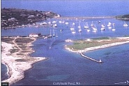
Walk up the hill from the town dock to a small grocery for basics. In addition, there is a bakery and a fish dock where one can buy the catch of the day.

Hadley Harbor, Massachusetts
Hadley Harbor (41°30.900’ N // 070°42.000’ W) is one of the few places the cruiser dreams about all through the winter season. Nestled in a cove between Uncatena and Nonamsset Islands (NOAA chart 13235), it is bucolic bliss. The Naushon Trust owns the Naushon Island. The largest one in this group and has been in the Forbes family for generations. Great mansions grace the hilltops like castles on a Scottish moor. The harbor shore is but a line’s throw away from the anchor rode and accommodates horses, cows, deer and a few summer residents. The Forbes family have not only graciously given permission to anchor in the harbor, but have even set aside one of their small islands, Bulls Island, on which visiting sailors are invited to stretch their legs. There are no provisions available so be sure to bring everything you’ll need for the duration of your stay.

Woods Hole
Woods Hole (NOAA Chart 13229) is the home of the Woods Hole Oceanographic Institute, the Marine Biological Laboratory and the United States Fish and Wildlife Service. A visit to the aquarium at the Wildlife Service is an interesting one for all family members. There are three anchorages here: Eel Pond, Great Harbor and Little Harbor. The only one with any room and some quiet water is Great Harbor. Head for the Northwest corner (40°31.600’ N // 070°40.900’ W) and drop anchor in the 7 to 11 ft of water. Come early and just maybe you can pick up one of the few moorings available here although the night might be noisy when the current changes direction and the metal balls rub against the ship’s hull. See chart on page 94.

Tarpaulin Cove
NOAA Chart 13229
Tarpaulin Cove located on the southern shore of Naushon Island is a great anchorage for a lunch break or longer stays. Anchor near the southwest part of the cove.

Falmouth
Falmouth (NOAA Chart 13230) about 3 ½ miles northeast of Woods Hole in Vineyard Sound offers the visiting yachtswomen or yachtsmen every facility including major vessel repairs, shopping, laundry, fine restaurants, etc. If you plan to stop here hail the harbormaster on VHF 09 for a town mooring or contact one of the marinas for a slip. There is no room to anchor. This is a busy harbor!

Hyannis
NOAA Chart 13229
Well-known and one of the largest towns on the Cape, its harbor is used as a harbor of refuge. During the summer when tourists from Boston and New York arrive by air and steamers, the harbor is lively. On shore are restaurants, shops, marinas, a summer theater and recreational facilities. The Hyannis Marina (508-775-5662) (VHF 09 & 16) has slips for transients that include showers, laundry, pump out, fuel, ice and water. There is also a restaurant and swimming pool.
Anchoring is possible in the “outer” harbor along the west breakwater wall in 5 to 14 feet of water; the holding ground is mud. The inner harbor, about 2 miles further on, is crowded with moorings. The steamers heading to Nantucket churn the waters.
On route to the inner harbor one sails past Lewis Bay, on starboard, stop here and drop the hook for a quiet night.

Chatham (Stage Harbor)
“Chatt-um” Harbor is approximately 18 nautical miles east of Hyannis at the southeast corner of Cape Cod just before the open waters of the Atlantic Ocean. This harbor is not on the must visit itinerary of most yachts sailing the New England Coast because it is off the beaten path. Call 800-715-5567 for daily activities.
Chatham is a lovely New England summer resort community with expansive beaches nearby. Sites of interest include the Chatham Railroad Museum and the Old Atwood Museum. Bring a blanket for the concerts in the park.
Stage Harbor just west of Chatham has moorings available. Through the harbormaster (VHF 9) one will also find marinas here and at Chatham or try the Stage Harbor Sailing Club for a mooring. Seek local advice before entering because the entrance is subject to shifting sands.

Monomoy Islands, south of here, consists of a 2,750-acre national wildlife refuge that is home to 285 species of migrating birds. Harbor and gray seals make this their home from November through May.

Martha’s Vineyard and Sound
(www.mvy.com)
Martha’s Vineyard and Sound offers a variety of topographical, social and economic conditions. Just four miles off Cape Cod at its nearest point, spectacular clay bluffs at Gay Head, vast sandy beaches, rose colored New England cottages, flat inland farmlands and historical buildings are just a few of its beckoning reasons to visit.
The Vineyard’s towns and harbors are as varied as its land. Martha’s Vineyard is New England’s largest island: 100 square miles in size.

Menemsha
NOAA Chart 13233
Menemsha provides the first available shelter for a vessel headed east through Vineyard Sound and is therefore a tempting spot for an overnight stay. There are two moorings in the center of the Menemsha Creek. Each can accommodate a three-boat raft; however it is tight. Sport fishing boats and powerboats passing by churn the water and with a tidal range of 3 feet the current is strong. Continue south through a narrow passageway to Menemsha Pond and anchor in quiet water with depths of 16 feet. Before you attempt to enter this pond contact the harbormaster on VHF 09 for local advice on shoaling. A trip to The Gay Head Light is rewarding with its scenic view of surrounding area.

Lake Tashmoo
Lake Tashmoo (41°28.000’ N // 070°38.000’ W) has a shallow narrow entrance; which was dredged in July 2002 that leads into a large bay. This scenic spot has good swimming and was a secluded anchorage for an overnight stay; as of 2016 anchoring is not recommended to protect the eel grass however the harbor master will provide moorings. Follow the tide and current tables when entering.

Vineyard Haven
Known locally as Tisbury (NOAA Chart 13238), is the commercial hub of the island known as Martha’s Vineyard. Entrance to the harbor is between East Chop and West Chop. Be attentive as you sail round the West Chop. The current velocity can reach 4 ½ knots and the wind from the south can knock the ship down. Dockage and moorings are available through the harbormaster (VHF 9). Mooring fee is $50/night.
Need provisions? Row your inflatable into shore and shop the boutiques, supermarkets, etc.

Oak Bluffs
This well protected harbor 4 miles east of Vineyard Haven brings the visitors back to the middle of the 1800s, at which time a Methodist Camp Ground was built here. The small closely- constructed Victorian gingerbread cottages, built in a circle, are well worth seeing.
One of the oldest Carousels in the country is just a short walk up town.
The harbor offers slips and moorings; anchoring is taboo. Be aware if you choose a slip over a mooring it can be a very boisterous stay.
Would you like to see Nantucket? No time to sail there? Take the ferry from Oak Bluffs to Nantucket for a short stay.

Edgartown
Edgartown, about 5 miles southeast of Oak Bluffs, is the showplace of the Vineyard. An almost perfectly preserved town of the eighteenth and nineteenth century, this harbor is lively and crowded with vessels of all sizes, from the small dinghy to elegant yachts from Europe.
There is a Special Anchorage just east of Chappaquiddick. But the harbor bottom is gravel and the tide runs strong. For peace of mind, continue south about 1-½ miles to Katama Bay and secure your vessel to a town mooring. Cost as of 2016 is $40.00/night. Anchoring is no longer permitted. Tender service will transport you and crew to town. Dock fee is $5.00/ft, min 50 ft.
The harbormaster, VHF 74, has control of over 700 moorings: the light blue ones are for those of us who arrive early and the yellow moorings required a reservation (508-627-4746).

Nantucket Island
NOAA Chart 13242
Nantucket Island lies 18 miles southeast of Martha’s Vineyard, yet so different in character, it would lead one to believe it is 1800 miles away. It is flatter, sandier, and foggier and perhaps a bit more romantic than the Vineyard. The island is far enough off the main land that it has its own weather.
Its key town is also called Nantucket and boasts a major, full service marina located at the foot of the cobbled stone Main Street. The Island has more than 800 houses built between 1740 and 1840. The-whaling captain’s old brick homes still sit grandly on the hill behind the harbor. Shops and restaurants abound. If you plan on staying at the Boat Basin reservations cannot be made before March, call 508-228-1333. If you sail in without a reservation hail the harbormaster on VHF 9 or moorings on VHF 68.

One minute of latitude = 1 international nautical mile
One international nautical mile = 6,080 feet = 1,850 meters = 1.85 kilometers
One fathom = 6 feet = 1.83 meters
One knot = one nautical mile/hour

Knot – the nautical measure of speed, one knot = one nautical mile per hour the term comes from the knots on the line of a chip log which were spaced at 47 feet 3 inches. The number of knots that ran out in 28 seconds gave the speed of the ship in nautical miles per hour

New Jersey
NOAA Charts 12316, 12323, 12324

Shark River
Sail in here if heavy weather closes in before you reach Manasquan Inlet. The first bridge about 250 yards inside the jetties is the Ocean Avenue Bridge. Call via VHF 13 before you enter and wait for the bridge to open, then proceed to an anchorage just east of the State Highway 71 Bridge and drop the hook in 12 ft of water.

Manasquan Inlet
Manasquan Inlet is your port of call after a 45 nm leg from Fire Island Inlet. This inlet is short and can be challenging when wind and current are opposite. Once inside, there is limited room to anchor. Willis Hole off your port has 7/10 ft of water and is about 300 ft wide. However, there is heavy fishing traffic. In the past, one could tie alongside the Shrimp Box’s bulkhead. That is no longer true. Hoffman’s West has slips available, however be alert: the current can be a problem. (732-528-6200)
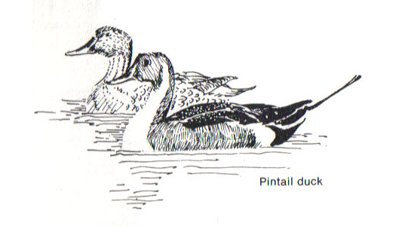

Point Pleasant Canal
NOAA Chart 12324
This canal is your passageway from Manasquan Inlet to Great Barnegat Bay and the inland waterway to Atlantic City. With its swift currents, narrow banks (200 ft wide) and two bridges that open slowly it makes for a stimulating voyage. Going south the first bridge responds to a VHF 13 (low power) call as ” Route 88 Bridge” the second one as “Bridge Avenue Bridge”. Check the current tables before motoring through. A slight opposing current or slack is recommended for sailboats. Current velocity can reach 6 knots!
Marine traffic has the right of way. Bridges open about 300 times a day in season!
After your vessel has passed through the canal, a safe harbor with good holding ground is the Medtedaconk River (40°03.200’ N // 074°04.000’ W) in 7 ft of water and just about ½ nm wide. This river is similar to the Connetquot River.

Barnegat Bay
Barnegat Bay (Barnegat a Dutch word meaning inlet breakers) about 4 miles across and about 25 miles long, is the next inland cruising ground going south and is like the Great South Bay, 5/7 feet of water in the channel at the north end and later on 7/10 ft. However be vigilant for the shoal spots.

Barnegat Inlet
Approximate coordinates for this inlet are Latitude 39°45.450’ N and Longitude 074°05.400’ W. It is 60 nm from the Patchogue River and 20 nm south of Manasquan Inlet. This inlet entrance and Oyster Creek Channel (which leads into Barnegat Bay) are well marked, however the buoys are not shown on nautical charts due to frequently shifting sands and shoaling. As of 1 January 2009 “Old Barny’s” light shines once more and is visible for 25 nm. On entering follow the buoys for deep water! Do not be misled by appearances. Inside the breakwaters this inlet is only 4ft deep. Consult the Local Notice to Mariners 5th Coast Guard District for the latest buoy positions. Most guides do not recommend traversing this inlet without local knowledge. Recently an SBCC cruise entered (for the first time) when there were breakers across the entire inlet, the excursion was stimulating!
Once inside turn to port past the lighthouse to Myers Hole and drop the hook in 14/18 ft
of water in well protected anchorage. There are a number of marinas here; all have shallow water (4 ft) except the Lighthouse Marina (8/10 ft) that is #093 on the NOAA chart. If you require local knowledge contact Boat US or Sea Tow on VHF 16.

Absecon Inlet
(Atlantic City 39°22’ N // 074°24’ W)
Has a 43ft (13.1 m) high light that marks the entrance. This inlet is about 300 yards wide and deep; once inside the captain can anchor the vessel just north of buoy C ”13” in 7 ft of water.
Here the current is swift. With a tidal range of 4 ft, make sure that the anchor is set!
To avoid wrapping the anchor rode around the ship’s keel tie the helm over to one side. Chart on page 91. There are sheltered anchorages just inside Rum Point (39º 23’ N) with 24 ft of water. Seek local knowledge before entering; the entrance way does shoal. SBCC members have secured vessels at Kammerman’s marina $2.25/ft, $3.25/ft -Friday/Saturday (2016) and at Atlantic City Marina 800-353-8418 / VHF 16.
For the Senator Frank S. Farley State Marina, run by the Trump Castle Association, monitor channel 65 or 800-876-4386. It has 640 berths, slip fee year 2016 is $3.00/foot plus $5.00/night for electric.
Do you have a desire to exercise after that long leg from Fire Island? Yes! Great, let’s go for a walk. The boardwalk along the ocean shore is six miles long.

Cape May
This is the last convenient stop to purchase fuel for vessels in transit to Delaware Bay through the Cape May Canal until you arrive at the Chesapeake & Delaware Canal, about 60 nm hence. Several marinas are located here, anchorage is possible about a 1/8th of a mile west of buoy Fl G 4s “5’ in 7/10 feet. This harbor provides good shelter in a storm.
The only concern is the vertical clearance of the Cape May Canal Bridge at 55 feet.(16.8m) If your ship’s mast is higher, then you must sail around Cape May Point, a distance of 9 nm from the east end of the Cape May entrance to the west side of the canal. Inside through the canal the distance is 6 nm.

DELAWARE
NOAA Chart 12304, 12311
Few cruise captains sail this bay except to travel “inside” to the C&D Canal. The only harbor en route to the Chesapeake and Delaware Canal is the Cohansey River (39°20.700’ N // 075°21.900’ W). With its 6 ft tidal range, swift current and narrow banks that twist and turn for 24 miles, it is not recommended unless your navigator insists because darkness is near or foul weather approaches. If you do wander in here before approaching a dock, check current flow and approach. Then dock against the current for control, before settling in for the night. Check current flow direction at time of departure. If it is from the stern, turn the ship around at slack water. The writer did not and had to cut the dock lines to regain control.
There are marinas and an excellent restaurant with a view of the Cohansey River and the marshland which stretches to Delaware Bay.
Further north on the bay is an excellent anchorage: Reedy Island, a former Federal quarantine and detention center, protected from the wake of passing commercial vessels by Reedy Island Dike. The entrance location is (39°30.225’ N // 075°34.125’ W) marked by two buoys and is about 4nm south of the “CD” bell buoy or 44 nm north of the west end of the Cape May Canal. Inside you will find water depths of 7 to 35 ft.
Do not (unless you enjoy fighting the elements) sail the Delaware Bay when the current and wind are conflicting it makes for a slow wet voyage (seas 3 to 10 ft high).
There is an option for refuge but it is about 15 nm off the preferred northern route to the C & D canal and that is the Maurice (Morris) River.
An alternate stop for the night is Delaware City Marina on the Delaware City Branch Channel; with current velocity near 4 knots and a channel width of 50 feet this location is not recommended.

About 30 nm upstream of the C&D entrance on the Delaware River is Philadelphia; the captain will find two marinas by the Ben Franklin Bridge. Philadelphia Marine Center (215-931-1000) has 380 deep water slips, charges $2.00/ft with a minimum of $60.00 includes electric. The second marina is The Piers Marina (215-351-4101). Slip cost is $1.50/ft, electric $3.00/night (2016).

MARYLAND
NOAA Chart 12273, 12263

Chesapeake and Delaware Canal

Chesapeake and Delaware Canal (NOAA Chart 12777), 19 miles long and 400 feet wide, is the entryway to the Chesapeake Bay; channel 13 is the communications channel for traffic in the C&D Canal. Consult the current chart before you enter the canal, the current’s maximum velocity is 2.6 knots. About 12 nautical miles west from Bell RG “CD” Fl (2+1) R 6 s is Chesapeake City, your first stop for victuals. Slips and moorings are offered and restaurants line the shore (the Bayard House and Chesapeake Inn are examples). The entrance way does shoal, proceed with prudence. One may also tie to the bulkhead on the west side of the harbor; remember the tidal range is about 3 ft! Secure your dock lines with some slack.
Anchoring in the basin is easy and the holding ground is firm: however, it can be crowded.
If the captain cannot find anchorage room or a slip and you still have stamina? Continue for about 9 miles passing Welch Point, Old Point, Old Town Point Wharf and Town Point to buoy R “16” head 140º M to the mouth of the Bohemia River and drop the hook in seven feet of water for a quiet night.

THE BOHEMIA AND SASSAFRAS RIVERS
(NOAA Chart 12274)
Bohemia River is the first river you reach as you exit the C & D Canal. It is off your port by buoy R”16” Fl R 4s. The mile wide entrance leads to 7 ft of water and offers good anchorage. This river flows between wooded shores and pleasant rustic country.

Sassafras River
Sassafras River, about 10 nautical miles southwest of the Bohemia River, is one of the loveliest on the bay. The water is FRESH and the wildlife thrives. Some sections of the riverbanks rise gently to meet open fields; elsewhere they are 80 feet high. Follow the meandering river about 8 nm east to historic Georgetown and Fredericktown.
From here the possibilities are endless from Havre De Grace to Worton Creek to St. Michaels to Oxford to Rockford to Baltimore to Annapolis to Chestertown to the Kent Narrows and many (hundreds) more ports of call…enjoy.
The Panama Canal is only 1800 nm south.

Annapolis
(NOAA Chart 12283)
If this is your first visit to Annapolis you must secure your vessel to the town bulkhead in Market Slip better recognized as EGO ALLEY by locals (38º58.600’ N // 076º29.140’ W).
The dock master can be reached at 410-263-7973 or via VHF channel 09 & 17. Dock fee in 2016 was $2.75ft with a minimum $40.00; moorings in the bay cost $35.00/day.
Did you know that you could moor your vessel in Ego Alley during the winter for a fee of $5.00/ft/month, utilities included?

St. Michaels
(NOAA Chart 12270)
Settled in the late 1600s. St. Michaels has always been a beehive of boating activity. The Chesapeake Bay Maritime Museum (38°47.250’ N // 076°13.150’ W), located here may have room for you. Contact 410-745-4946 or VHF Channel 16. They offer free berths for members. If you are fortunate, the captain can secure his vessel alongside the bulkhead at the Crab Claw Restaurant.

Kent Island Narrows
(NOAA Chart 12272-2)
Caution! If you are sailing south from the C&D Cannel to the Kent Island Narrows via the new north channel, seek local advice before entering the channel. Shoaling has been reported (2006) north of the Route 18 bascule bridge (bridge tender monitors VHF 16) depths of less than 4.5 ft have been recorded. Dredging during the summer (2014) resulted in a depth of 6ft.

Baltimore Inner Harbor
(NOAA Chart 12280)The Patapsco River leads into this harbor. Upon arrival the captain has to choose where to secure the vessel. There are many options….Make fast alongside the bulkhead? Anchor in the harbor? Maybe call the harbormaster at 410-396-3174 to find a slip at the public piers? Perhaps slide into a slip at a private marina? There are many marinas but the closet to the heart of town is the Inner Harbor Marine Center, 410-837-5339 or VHF 69, which has 125 slips. Slip fee is $3.00/ft + electric (50 amp) at $18.00/day (2016). Once the vessel is secured, the captain and crew are faced with an incredible selection of activities and places to visit. A week’s visit will let one see only a fraction of the harbor and surrounding places of interest. The best course of action is to visit the information center.
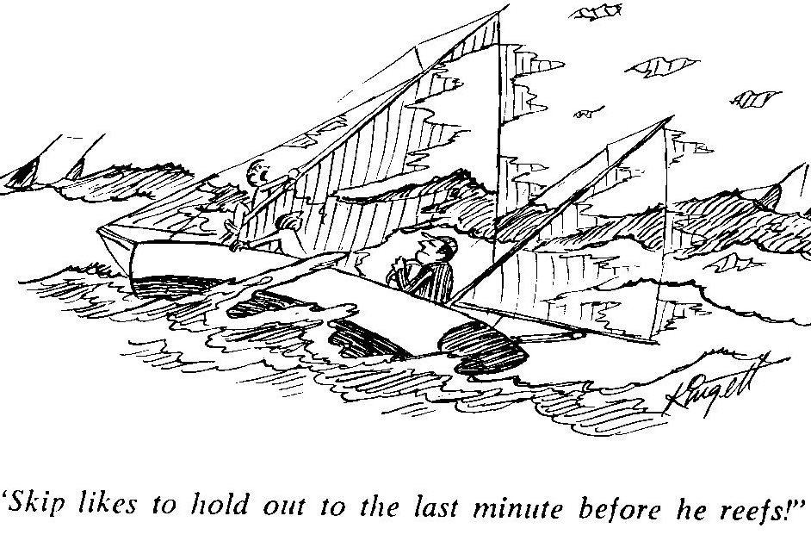
Yachting 1977

Hints for the Cruiser

Getting Ready
Keep paper and pencil handy – especially at bedside- to jot down those little details you know you’ll forget by morning. Make lists.

Menu Planning
Select foods that your family enjoys. Cook, slice, wrap and freeze roasts and bake goods well in advance of departure. Roasts that are sliced then sealed in plastic bags or plastic containers and then frozen are easier and more convenient for main courses or sandwiches. Home made or packaged gravies can be added at serving time. Cheeses should be wrapped in wax paper for preservation.
Canned ham, smoked meats or turkey will not spoil during your cruise.
The galley crew should be flexible. Weather, personal temperament, dining out or the long day en route to the next port of call are some considerations that dictate preferences for meals. Sandwiches are always a good substitute in heavy weather and enjoyed by the crew.
Before getting underway in the morning, brew coffee, tea or cocoa and keep them hot or cold in thermos vessels.
Organizing Provisions
Keep a record of all provisions aboard in a small notebook. This is your reference for the season. Keep it current! Organize the provisions aboard; keep them in their special nooks. Maintain a daily or weekly inventory and learn what food and dry goods are in demand and which are not. This will simplify life at seasons end when the time comes to cart unused goods ashore.
Beginning the Season
For the initial shakedown cruise, plan your first days on the water with hassle free meals. Cook meals at home, keep them light, cold chicken, salads, cold cuts, peanut butter or vegetarian dishes.
Shelf life
After initial storage aboard, within seven to ten days, replenish perishables. By that time frozen foods, meats, etc. will have thawed. Fresh fruits and vegetables that are ripe spoil quickly. Fruits and vegetables that are in various stages of ripening such as carrots, potatoes onions and winter squash will last longer.
Keep the victuals in a container in the ‘icebox” or place in a loosely knit sack and hang in the cabin.
Breads and pastry products should be stored in a cool place.
When in doubt, throw it out.

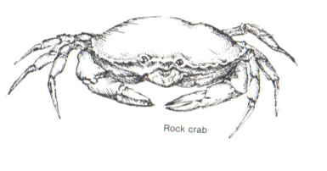

Avoiding Pitfalls
Even though you have planned carefully, it seems that occasions or obstacles sometimes get in the way of on board mealtime preparations. By being aware of the most common pitfalls you can either choose to accept them or forge ahead with plans. The most difficult to avoid is the cocktail hour once the fleet has reached its port. When you’ve rafted alongside your cruising friends, delightful tidbits emerge from the various galleys and they are so hard to resist. You may found that you are too full to eat the meal planned and besides it is 8:00pm! Other hazards include late lunches or ice cream enjoyed ashore, or perhaps you might decide to join a group for dinner at a local inn. At any rate planning ahead is a must but be flexible.

Some Boat keeping Ideas
‘DON’T BRING OR BUY AN ITEM THAT DOESN’T JUSTIFY TAKING UP VALUABLE SPACE’
Pots and pans should be of the size that will fit on the range of your two or three burner stove. Find good quality utensils that will hold up considering the use and the storage. Aluminum cooking utensils will pit with exposure to salt air. Poor quality stainless steel will rust. Teflon coated items are easily cleaned but require extra care to keep surfaces intact. If you have space for one extra large pot (for lobsters, crabs, corn etc.) bring it along.
Paper Products and Containers
Paper goods are easy to use but generate litter. Paper plates and napkins for dining are good if the ship is alongside a dock and therefore you can easily dispose of the garbage.
Do purchase many rolls of paper towels.
Plastic containers or zip locks bags solve many storage problems aboard. They help keep food moisture free when store in the cabin or in the icebox. If you store canned goods in the bilge place them in plastic bins first.
Miscellaneous Cruising Tips
Remember a tide table indicates only the depth of the water. For detailed data use The Tidal and Current Table it reports the time, direction and velocity of the current you will encounter.
Remember that slack water rarely occurs at high or low water there may be a time difference of hours.
Is it possible to cruise without an inflatable on the two or three week cruise? Yes it is. However those who have done so advise against it. Some boats hoist their dinks on deck for the ocean passages; many don’t and a few wish they had.
If you have a sailing dink bring it along for those rare dinghy races at anchorages. Small outboard motors are great for putting out storm anchors in the middle of the night (why didn’t we set the storm anchor early?) or for transporting the pup to shore
When you enter an anchorage late, and most of the fleet is already asleep, try to do it soundlessly. It’s amazing how even the clink of an anchor chain can awaken a dozen skippers alert to the smallest new sound in the night.
Don’t let youngsters drop starfish into the Great South Bay. If these predators ever get a real start in our home waters, it’s good-bye clams
Don’t begin any long passage that lacks emergency shelter along the way without first getting a marine weather forecast.

Suggested Medical Kit for the Cruising Sailor
Before cruising you are urged to seek the advice of your personal physician in tailoring your medical supplies to suit your own needs. Things to consider are: how long is the cruise, how many crew will be onboard and what medical needs they have, how far will you be traveling and how quickly is medical help likely to arrive in the event of an emergency. The farther from shore you travel, the more elaborate the first aid kit you’ll need. You might also consider enrolling in a first aid training course. Regardless of the supplies you have or the level of training, if you have a true medical emergency, seek help immediately by calling the Coast Guard on Channel 16.
Make sure you have a marine first aid kit that is well-stocked, up to date and at the ready. Putting together your own first aid kit is easy enough to do, but there are many pre-packaged kits sold in drug stores and marine supply stores which are a good choice.
Contents of the Deluxe Family First Aid Kit by the American Red Cross: Aspirin 81mg. chewable tablets (2), Triple Antibiotic Ointment packs (5), Antiseptic cleansing wipes (6), Hydrocortisone Cream packs (2), Hand Sanitizer packs (2), 5x9 Trauma Pads (2), 4x4 Gauze Pads (6), 3x3 Gauze Pads (6), 4 inch and 3 inch Conforming Gauze Roll Bandage (1), 1inch x 10 yard First Aid Tape Roll (1), Instant Cold Compress (1), CPR one-way Valve Face Shield (1), Emergency Blanket (1), Triangular Sling (2), Assorted Band-Aids (60), Thermometer one-time use (4), Tweezers, Scissors, Latex-free Gloves (4) and the American Red Cross First Aid Guide.

Preparing Your Medical Kit for Cruising

Questions to consider: How long is the cruise?
How many people are traveling?
What infections or infestations are common to the area in which you are cruising?
A great resource to begin with is The Medical Kit for The Cruising Sailor, an updated guide which can be found on the SBCC website and also on the following pages.
Build or add to your kit based on your cruising and passenger’s need.
Before a long cruise, it is wise to put together a list of each crew member’s medications and medical history, including any allergies to medications. Keep this list in an obvious place like the medicine kit.
Compile a list of potential illnesses or weaknesses your crew may be prone to – Gilligan has diabetes and a peanut allergy. Ginger has a frequent urinary tract infection and Mary Ann gets eczema. In this scenario it would be good to have glucose, an Epi-pen, topical steroid cream and some antibiotics.
Anticipate what might occur on a long trip, for instance, skin (Staph) infection, pink eye, swimmer’s ear. Locally there should be plenty of health care options available, but the farther you travel, finding a pharmacy may be a challenge. Also the farther the trip and the longer the duration the more your medical kit should be stocked, including some antibiotics
(usually Cipro and Keflex are sufficient) , pain medication, muscle relaxants, albuterol in haler, yeast infection medication. With a longer cruise, consult with your physician to obtain and determine which prescriptions you will need to complete your medical kit.

It is most helpful to have aboard a book to assist in diagnosing and treating, especially if you are far from medical care. A book on wilderness medicine may be helpful.
Let’s not forget the ship’s VHF radio…
The above information certainly does not constitute medical advice and remember, it is important to have a discussion with your doctor about specific health care needs in order to outfit a medical kit tailored for your cruise. Gilligan and his pals got lucky, but it never hurts to plan for more than a “three hour cruise”.

Emergency Medical Assistance

“Medicine for Mariners” is a great resource and can be found on the SBCC website under the Club Presentations Section.

Allergy: Antihistamine such as Benadryl, Hydrocortisone Cream.

Antibiotic: Advisable when prolonged cruising is anticipated. Consult personal physician.

Bee Stings: Epi-Pen if allergic.

Bruises and Sprains: Ice for 20 min. on and 20 min. off for the first 24 hours, support with elastic ace bandage and elevate for 48 hours. Use anti-inflammatory such as Advil or Aleve.

Concussion: Watch out for the Boom! Some of the signs and symptoms of a mild concussion include confusion, drowsiness, headache, a short period of loss of consciousness. Treatment includes rest, applying ice wrapped in a towel and over the counter Tylenol. Some signs and symptoms that require immediate medical attention include neck pain and stiffness, slurred speech, blurry or double vision, persistent headache, amnesia, dizziness, nausea and vomiting. *Persons who take aspirin or blood thinners must seek medical attention right away.

Fractures: Immobilize the injured extremity promptly. Splints can be improvised from pillows, battens, poles, etc.

Heat Exhaustion: Move to a shaded location, sponge with cool water, fan and give fluids: ½ glass every 15 minutes if no vomiting occurs. Elevate legs. If no improvement in 30 minutes get medical help.

Hypothermia: Symptoms include confusion, slurred speech and lethargy. A person remaining in the water will become unconscious and the heart and respiratory rates will slow and eventually stop. What to do: Call for medical help, remove wet clothing and wrap the person, including their head. Add heat, an external source like a fire or lying next to a person of normal temperature. If conscious give warm liquids to drink but not coffee which is a diuretic and by causing water loss, increases dehydration. Avoid alcohol. If you find yourself in the water, assume the HELP (heat, escape, lessening position). Cross arms over chest and in close to your body, pull legs to groin and move as little as possible.

Jellyfish Stings: Rinse with seawater, soak in vinegar, rub baking soda on the sting and monitor for allergic reaction.

Lyme Disease: Lyme disease is endemic to many coastal areas in the Northeast. The deer tick that feeds on the white footed mouse, deer and other woodland animals spreads it. Be aware of these tiny troublemakers, which are no bigger than the head of a pin. Be sure to check yourself and your children thoroughly if you’ve been in a grassy and or wooded area. Preventive measures include wearing light colored clothing with long sleeves and tucking pants into socks. Insect repellent containing Deet can be sprayed on clothing.
Ticks should be removed from the body only with tweezers. Care should be taken not to crush the tick. You may wish to save the tick in a plastic jar for later identification and consult your personal physician regarding the need for treatment. Although Lyme disease is a serious problem, it is treatable and curable especially during the initial stages.

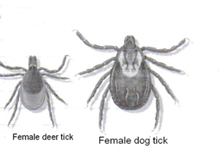

Poison Ivy: The best way to keep from getting poison ivy dermatitis when going ashore is to wear long trousers and long sleeved shirts. Should you come in contact with any part of the plant, a thorough washing with a good oil removing soap as soon as possible may prevent a rash. Saltwater soap and a dip in the bay can accomplish the same thing. Remember that contact with shoes, clothing or pets that have been exposed to poison ivy can do as much harm as the actual direct contact with the plant.

Rash/Itching: Hydrocortisone cream 1% available over the counter.

Seasickness: Eating saltines and staring at the horizon can often control moderate seasickness. Dramamine or Meclizine 25 mg. (Bonine or Antivert) is usually effective. Severe seasickness can be treated with the US Navy combination of Phenergan 25 mg and Ephedrine 50 mg every 6 hours or one Transderm Scop patch applied behind one ear every 3 days.

Hyperacidity and Hangovers: Zantac or Pepcid over the counter.

Sunburn: For prevention, use a broad spectrum sun block or sunscreen with an SPF of 15 or greater. Use a lip balm with sunscreen. Wear a hat and other protective clothing. Wear sunglasses with UV protection. For relief of sunburn use aloe lotion and avoid “caine” derivatives as they can cause allergic reactions.
Trauma: Open wounds: control bleeding with direct pressure, wash wound thoroughly, apply antibiotic ointment to gauze pad and cover the wound. Secure with tape.

Stomach Upset
Pepto-Bismol, Antacids: Calcium, Tums

Hemorrhoids – Preparation H with Cortisone

Reflux
Zantac or Pepcid (over the counter)

When traveling with children include Syrup of Ipecac.
Store medicines and ointments in a locked box or cabinet in a less accessible place than a First Aid Kit, which should be available immediately for treating wounds.

*This information is not intended to replace the diagnosis or treatment by a physician. Seek the advice of your personal physician as needed.

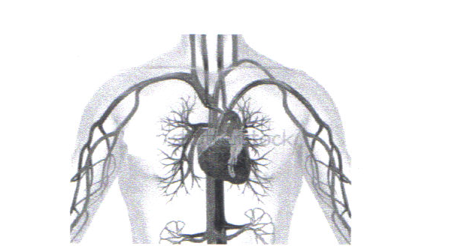

Bridges (VHF 13) (except Florida VHF 09)
There are five bridges between Smith point and Shinnecock Canal, four bascule bridges and one fixed bridge.
The fixed bridge is the Ponquogue Point Bridge; its listed vertical clearance is 55 feet at mean high water (MHW) or chart datum.
The four-bascule bridges between Smith Point and Shinnecock are staffed as follows: May 1 through September 30 from 0600 to 2200 hours
October 1 through April 30 from 0800 to 1600 hours
The bridge personnel will react to the proper sound signal, one long and one short blast of the horn, and will open for ship traffic as soon as they are able. Avoid long strings of boats that cause traffic congestion on the roadway. Remember that fire vehicles, ambulances, etc have the right of way bridges will not open during an emergency.
Most bridge operators will not open to boats under sail because of unpredictable currents and wind conditions as you pass through. Lower sails, start the ship’s engine!
Bascule is the French word for seesaw

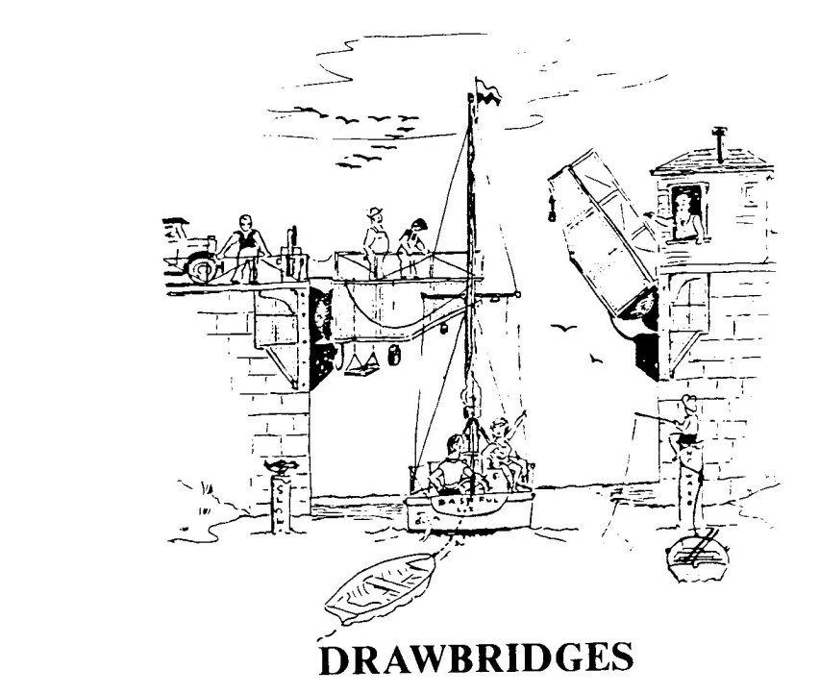

Roger G. Ramsdell 1989

Traveling west thru the inside passage there are 7 bridges that challenge the SBCC member.
To request an opening call the bridge tender via telephone, VHF radio or sound one long and one short blast on the ship’s horn.

Long Beach Bridge 516-571-7785 or VHF 13
Week day openings – 0800 – 2400 hours on demand
Weekends and holidays – on demand except from 1500 – 2400 hours when it opens every ½ hour

Railroad Bridge or Channel Bridge 516-889-9169 or VHF 13
Week day and weekend openings-on demand, 24 hours a day, except when a train is approaching. Important –Request full opening state that you are a sailboat!

Atlantic Beach Bridge 516-239-1821 or VHF 13
Weekday openings – on demand except form 1600 – 1900 hours then on the ½ hour
Weekend and holiday openings – call bridge tender

Captree Bridge 631-952-6777 or VHF 13
Every day from 0730 – 1600 hours; call 2 hours prior to arrival

Wantagh Bridge (Sloop Channel Bridge) 516-242-2637 or VHF 13
Week day openings on demand after 1600 hours on call
Weekend and holiday openings – requires ½ hour notice, once an hour on the ½ hour from 0730 – 2020 hours

Meadowbrook Bridge 516-578-5903 or VHF 13
Weekday openings – on demand with ½ hour notice to bridge tender
Weekend and holidays – every hour on the hour from 0730- 2020 hours

Loop Bridge 516-578-5903 or VHF 13
Weekday, weekends and holidays openings – every 20 and 50 minutes after the hour
After 2030 hours on demand

Directory of Useful Telephone Numbers
Coast Guard Groups

New York
Rockaway 718-634-2848
Freeport 516-785-2921
Jones Beach 516-784-2921
Fire Island 631-661-9101
Montauk 631-668-2716, 2773
Moriches 631-395-4400, 4430
Northport 631-261-6599
Shinnecock 631-728-0343, 0078
New Jersey
Manasquan Inlet 732-899-0130
Atlantic City 609-344-6594, 609-677-2207
Atlantic City Air Station 609-677-2225
Barnegat Inlet 609-494-2661
Cape May 609-898-6695, 6997
Maryland
Station Annapolis 410-267-8108
Station Curtis Bay (Baltimore) 410-576-2625
Station Taylors Island 410-397-3103
Massachusetts
Boston 617-223-3000, 3224
Nantucket 508-228-0388
Woods Hole 508-457-3219, 3250
Rhode Island
Point Judith 401-789-0444
Newport 401-846-3675
Block Island 401-466-2086
To report an Emergency on the waters around Long Island
Nassau Marine Bureau 516-573-4450
Suffolk Marine Bureau 631-854-8328
Shinnecock Canal Lock Tender 631-852-8291
Town of Islip Marine Enforcement 631-224-5656
Brookhaven Bay Constable 631-475-5686
Hurricane Information 305-229-4483
U.S. Army Corp of Engineers 518-474-9758
GPS System Status 703-313-5907
New York State Parks 631-669-1000
Long Island Maritime Museum 631-447-8679
Suffolk County Bridges
Smith Point Bridge 631-
Nassau County Bridges 631-578-2995
Department/ Transportation North Merrick 516-578-5905
Wantagh, Loop and Sloop Bridges 516-242-2637
Captree Bridge 631-952-6777
Department/Transportation Nassau County 516-378-3552

Flag Etiquette

The correct display of flags, signals and ensigns is one of the more obvious marks of a true yachtsman. The code is inflexible steeped in the tradition of the sea and promotes uniformity in communication and identification between yachts.

The U.S. Ensign (Old Glory, 50 stars and 13 stripes) is proper without reservation for all U.S. yachts. Fly the ensign when under way from the leech of the after most sail at a height that is 2/3 of the leech above the clew or from the stern staff. At anchor the ensign should be
flown from the stern staff. Display the ensign form 0800 hours to sunset.

 The U.S. Yacht Ensign (Betsy Ross flag) with a fouled anchor in the union and 13 stars was originally restricted to documented vessels but now it is acceptable to display on recreation vessels of all types. This ensign is displayed just like Old Glory. However neither ensign should be on display while racing.

The Club burgee is displayed whenever the ensign is displayed but may be displayed separately while at anchor or underway, on the masthead of single mast vessel or on the forward masthead of two masts vessels or at the starboard spreader. Most SBCC captains display the club burgee all the time, beginning at the hoisting gun on Commissioning Day. Unlike some other clubs, the SBCC members fly the burgee while racing

The Private Signal
The owner’s private signal may be displayed between the hours of 0800 and sunset on a single mast yacht that is underway in place of the club burgee at the masthead or on two masts yachts at the after masthead, at anchor or underway.

Flag Officers Flags
A flag officer shall display his or her flag both day and night in place of their private signal on the after masthead of two mast yachts or at the masthead of a single mast vessel.

Race Committee Flag
The race committee shall display the flag at the aftermost masthead, only while acting as the committee boat.
Squall a sudden increase of wind speed by at least 16 knots, the speed rising to 22 knots or more and lasting for at least a minute

Signal Flags
The starboard main spreader shall be employed only for alphabetical signal flags and numerical pennants
Such as the “Y” Yankee signal a yellow and red diagonal stripped rectangular flag whose message is “I am dragging my anchor” or the “O” Oscar signal for man overboard.

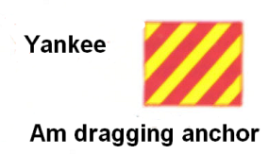

Size of Flags
The ensign should have a minimum of one inch of fly for each foot of the yacht’s overall length and the hoist should be 2/3 of the fly.
The burgee, private signal and flag officer’s flags should have a minimum of ½ inch of fly for each foot of the height of the highest mast and the hoist should be 2/3 of the fly.

Use of VHF Marine Radio
VHF marine radio is a vital communication link for the yachting community and with understanding, courtesy and proper use, a great benefit to all in the boating fraternity.
Until recently in the Long Island area channel 9 was our hailing channel and channel 16 was for emergency transmissions. South in the Chesapeake or north in New England channel 16 is the hailing and emergency channel.
Because the United Coast Guard does not have the capability of announcing an urgent marine information broadcast or weather warning on channel 09,use of channel is optional Quote U.S. Coast Guard. “We recommend boaters normally keep tuned to and use channel 16 in those waters unless otherwise notified by the Coast Guard.” When hailing another vessel in close proximity transmit with low power (one watt) on VHF 09 or 16 and after contact has been established switch to an agreed upon channel for conversation.

U.S. VHF Marine Radio Channels and Frequencies
Although there are many VHF channels only a few are available to us. Each channel has a designate purpose, the channels highlighted in bold are for recreation vessels. Note that the U.S. Coast Guard broadcasts urgent message alerts that are of importance to mariners on channel 16 the actual message is broadcast on channel 22.

Channel Number | Ship Transmit  MHz | Ship Receive  MHz | Use
09 | 156.450 | 156.450 | Boater Calling. Commercial and Non-Commercial.
10 | 156.500 | 156.500 | Commercial
11 | 156.550 | 156.550 | Commercial. VTS in selected areas.
12 | 156.600 | 156.600 | Port Operations. VTS in selected areas.
13 | 156.650 | 156.650 | Intership Navigation Safety (Bridge-to-Bridge)
14 | 156.700 | 156.700 | Port Operations. VTS in selected areas.
15 | -- | 156.750 | Environmental (Receive only). Used by Class C EPIRBs.
16 | 156.800 | 156.800 | International Distress, Safety and Calling. Ships required to carry radio, USCG, and most coast stations maintain a listening watch on this channel, hailing
20 | 157.000 | 161.600 | Port Operations (duplex)
20A | 157.000 | 157.000 | Port Operations
21A | 157.050 | 157.050 | U.S. Coast Guard only
22A | 157.100 | 157.100 | Coast Guard Liaison and Maritime Safety Information Broadcasts. Broadcasts announced on channel 16.
23A | 157.150 | 157.150 | U.S. Coast Guard only
25 | 157.250 | 161.850 | Norfolk, VA Marine Operator
26 | 157.300 | 161.900 | Norfolk, VA Marine Operator
27 | 157.350 | 161.950 | Norfolk, VA Marine Operator
28 | 157.400 | 162.000 | Wilmington, DE, Marine Operator
65A | 156.275 | 156.275 | Port Operations
66A | 156.325 | 156.325 | Port Operations
68 | 156.425 | 156.425 | Non-Commercial
69 | 156.475 | 156.475 | Non-Commercial
70 | 156.525 | 156.525 | Digital Selective Calling (voice communications not allowed)
71 | 156.575 | 156.575 | Non-Commercial
72 | 156.625 | 156.625 | Non-Commercial (Intership only)
73 | 156.675 | 156.675 | Port Operations
74 | 156.725 | 156.725 | Port Operations
77 | 156.875 | 156.875 | Port Operations (Intership only)
78A | 156.925 | 156.925 | Non-Commercial
79A | 156.975 | 156.975 | Commercial. Non-Commercial in Great Lakes only
81A | 157.075 | 157.075 | U.S. Government only – Environmental protection operations.
82A | 157.125 | 157.125 | U.S. Government only
83A | 157.175 | 157.175 | U.S. Coast Guard only
88 | 157.425 | 162.025 | Public Correspondence only near Canadian border.
88A | 157.425 | 157.425 | Commercial, Intership only.

Handheld Radio Transmission Range Possibilities

How far?

Handheld antenna height Receiving antenna height Range
(Feet) (Feet) (Miles)
6.0 8 3.25
6.0 48 6.75
12.5 48 10.75
6.0 90 (CG) 10.50
12.5 90 (CG) 14.50
Courtesy Boat/ US

Marine Operator
As of June 2003 placing a telephone call from your vessel via VHF is no longer possible.

Weather channels

WX-1, WX-2 and WX-3
The National Oceanic and Atmospheric Administration (NOAA) broadcasts computerized weather reports over these channels. The subject matter is repeated every few minutes and updated periodically.
Generally you can expect reception of strong signals if you are within 40 miles of the transmitting station.
The three channels mentioned above cover a large geographical area that include, New Hampshire, Massachusetts, Rhode Island, Connecticut, New York metropolitan area, Long Island and New Jersey as while as 20 miles offshore.
Note that these channels are for reception only.

For automated weather conditions, forecast and tide reports in our local area contact National Weather Services (NWS) at 631-924-0517

How to call another Yacht
First make sure that your radio power is turned on, select channel 09 or 16 and listen to make sure it is not in use.
Select low power (one watt) if the hailed vessel is within a few miles.
Depress the microphone button and hail the boat you wish to contact by speaking directly into the mike and state the vessel’s name three times followed by “This is (the name of the your vessel) and the word OVER”. After contact has been established, agree upon a conversation channel and start the conversation by saying “This is (your boat’s name) over.”
After communications are completed each ship must give its name before signing off or returning to another channel.

Emergency Marine Radio Traffic

Distress calls
Distress calls indicate a vessel or aircraft is threatened by grave and imminent danger and requests immediate assistance; they have priority over all other transmission. Mayday-Mayday-Mayday is the distress signal for immediate assistance. All boaters who hear the distress call must cease all transmissions immediately and stand by.

Urgent calls
Urgent calls consist of repeating the words “PAN PAN” pronounced Pahn-Phan three times. This signal indicates that the calling station or ship has an urgent message concerning safety of a ship, aircraft, other vehicle or person.

Safety calls
Safety calls consists of repeating the word “Security” pronounced say-curitay This signal indicates that the station or ship will broadcast a message concerning safety of navigation or give important weather warnings including dangers regarding derelicts or obstacles to navigation.

Example of Marine Emergency Distress Call
Make sure the radio is on; select channel 16, depress the mike button and speak slowly and distinctly
- MAYDAY-MAYDAY-MAYDAY
- This is (boat name)
- Give location, Latitude // Longitude or nearby navigation aids or shore points
- Explain the situation
- Explain assistance needed
- Describe vessel, sail or power, color, size etc
- This is (boat name) standing by channel 16 over

VHF Digital Selective Calling (DSC)
If you plan to purchase a new VHF radio make sure it has the DSC function.
Over the next three years (2004 – 2007) the Coast Guard will phase in their new Rescue 21 VHF communications network.
This consists of a VHF radio programmed to broadcast an alert message to the Coast Guard that will identify your vessel and give its location via channel 70.
For the system to function you must register your radio with Boat US or Sea Tow for a mobile maritime identity number (MMSI) unique to your vessel and if your radio does not have GPS built in you must interface the ship’s radio with a GPS.

Pump Out Facilities

New York
Glen Cove Glen Cove Yacht Service & Repair 516-676-0777
Hempstead Brewer Yacht Yard 516-671-5563
Northport Britannia Yacht Club 516-261-5600
Lindenhurst Surfside 3 Marina 631-957-5900
Shelter Island Coecles Harbor Marina 631-749-0700
Sag Harbor Sag Harbor Yacht Club 631-725-0567
Shinnecock County Boat Basin 631-852-8291
Three Mile Harbor Harbor Marina 631-324-5666
Lake Montauk Montauk Yacht Club 631-668-3100
Star Island Marina 631-668-5052
Great Peconic Bay Southampton Pump Out Boat 631-283-6000
Quantuck Canal Bath & Tennis Yacht Club 631-288-0380
Moriches Bay Southampton Pump out Boat 631-283-6000
East Moriches Windswept Marina 631-878-2100
Great South Bay
Atlantique Marina 631-583-8610
Bayshore Marina 631-224-5413 RobertMoses State Park 631-669-0449
Captree State Park 631-669-0449
Cedar Beach Marina 631-669-5949
Davis Park Marina 631-451-6133
Sailor’s Haven 631-597-6171
Timber Point East 631-854-4952 Tobay Heading 631-797-4110
Watch Hill 631-597-6644
Patchogue Bay
Leeward Cove South 631-954-3106
Morgan’s Swan River Marina 631-758-3524
Pier 66 631-654-3106
Sandspit Town Marina 631-475-1592
Connetquot River Suffolk County Marina 631-581-9299

Fire Island Inlet Captree State Park 631-669-0449
R. Moses State Park Basin 631-669-0449
Sore Thumb Jones Beach State Park 516-785-2988
(Coast Guard Station)
Reynolds Channel Hempstead Marina West 516-431-9200

Note the marinas are listed as a service for SBCC members they are not endorsed by the South Bay Cruising Club Call, before you travel to the marina make sure that they are in operation.

Pump out Facilities

Rhode Island

Newport Newport Yachting Center 800-653-3625
Bannister’s Warf Marina 401-846-4500
Block Island Champlin’s Marina 800-762-4541
Block Island Boat Basin 401-466-2631

Connecticut

Stonington Dodson Boat Yard 860-535-1507
Mystic Mystic River Marina 860-536-3123
Old Saybrook Saybrook Point Marina 800-243-0212
Essex Essex Island Marina 860-767-1267
Brewers Dauntless Shipyard 860-767-2483
Branford Brewers Bruce Johnson 203-488-8329

Massachusetts
Boston Constitution Marina 617-241-9640
Edgartown Edgartown Marine 508-627-4746
Falmouth MacDougall’s Marine 508-548-3146
Mattapoisett Mattapoisett Boatyard 508-758-3812
Nantucket Boat Basin 800-626-2628
Nantucket Nantucket Moorings 508-228-4472
New Bedford Pope’s Island Marina 508-979-1456
Oak Bluffs Oak Bluffs Marina 508-653-4355
Plymouth Brewers Plymouth Marina 508-746-4500
Scituate Scituate Harbor Marina 617-545-2165

New Jersey
Atlantic Highlands Municipal Harbor 732-291-1670
Brielle (Manasquan) Brielle Marine Basin 732-528-6200
Atlantic City Frank S. Farley State Marina 800-876-4386
Cape May Canyon Club Resort Marina 609-884-0199

Note the marinas are listed as a service for SBCC members they are not endorsed by the South Bay Cruising Club.Call before you travel to the marina make sure that they are in operation.

Pump out Facilities

Maryland
Chesapeake City Chesapeake Inn & Marina 410-885-2040
Schaefer’s Marina 410-885-2204
Chestertown Worton Creek Marina 410-778-3282
Rock Hall Swan Creek Marina 410-639-7813
Rock Hall Landing Marina 410-639-2224
St Michaels Town Dock 800-678-8980
St Michaels Harbor Inn 410-745-9001 / 800-955-9001
Oxford Pier Street Marina 410-226-5171
Oxford Boatyard 410-226-5101
Baltimore Inner Harbor Marina 410-837-5339
Annapolis Chesapeake Harbor Marina 410-268-1969
Mears Marina 410-268-8282 / 301-261-1234
Port Annapolis Marina 410-269-1990 / 301-261-1999
Annapolis City Dock 410-263-7973

HEADS - the name given to that part of the ship forward of the forecastle and around the beak which was used by the crew as their lavatory. It was always referred to in the plural to indicate the weather and lee sides.

Note the marinas are listed as a service for SBCC members they are not endorsed by the South Bay Cruising Club.Call before you travel to the marina,make sure that they are in operation.

Great South Bay Marinas

Marina Fuel Pump out
Amityville
Amity Harbor Marine Gas
631-842-1280
Babylon / West Babylon
Babylon Marine Inc Gas Y
631-587-0333
Babylon FishingStation Gas
    - Diesel
Degarmo Marine Svc Gas
631-669-0789
Bergen Point Gas Dock Gas
631-669-9234
Sea Gull Marina Gas
631-669-9552
Bayshore
Capatin Bills
631-665-3677
Bay Shore Marina Gas
    - Diesel
Seaborn Marine Gas
516-665-0037 Diesel
Blue Point
Blue Point Marina Gas
631-363-3200
Tabat Marine Gas
631-363-6060
East Islip
East Islip Marina Y
631-224-5413
Lindenhurst
Surfside 3 Marina Gas Y
    - Diesel
Oakdale
Oakdale Yacht Svc Gas
    - Diesel
Timber Point East County Gas Y
631-854-4949

Note the marinas are listed as a service for SBCC members they are not endorsed by the South Bay Cruising Club.Call before you travel to the marina,make sure that they are in operation.

Marina Fuel Pump out

Patchogue
Morgan’s Swan River Marina Gas Y
631-758-3524
Patchogue Shores Marina Gas
631-475-0790
Dockside 500 Marina Gas
631-289-3800 Diesel
Patchogue Marine Inc
631-654-3106
Lee Cove Marina Y
631-758-2550
Sun-Deck Marina Gas
631-654-8266

Sayville
Lands End Marina Gas
631-589-2040 Diesel
Westins Boat Shop Gas
631-589-1526 Diesel

West Sayville
West Sayville Boat Basin Y
631-589-4141

Holding Tank Full?
and
You are sailing on the
waters of
Patchogue
or
Moriches
call
Pump-out Boat
VHF 73

Note the marinas are listed as a service for SBCC members they are not endorsed by the South Bay Cruising Club.Call before you travel to the marina,make sure that they are in operation.

Moriches Bay Marinas

Marina Fuel Pump out

Al Grovers Gas
631-874-2111
Davison Marina Gas
631-878-9400
FJM Marina Svc Gas
631-878-1235
Pendzick’s Boat Yard
631-878-2244
Senix Marina Inc Gas
631-874-2092 Diesel
Cerullo Brothers Marine Gas Y
631-878-4560 Diesel
Moriches Boat & Motor
631-878-0023
Windswept Marine Gas Y
631-878-2100
Seatuck Cove Marine Inc Gas Y
631-325-0367
Stirz’s Marina
631-399-0661
Remsenberg Marina Gas Y
    - Diesel
Hampton Watercraft/Marine
631-288-2900
South Shore Boats Gas

Note the marinas are listed as a service for SBCC members they are not endorsed by the South Bay Cruising Club.Call before you travel to the marina,make sure that they are in operation.

Shinnecock Bay Marinas

Marina Fuel Pump out Web / email

Aldrich Boat Yard
631-653-5300
Hamptons Shipyards
631-653-6777
Frank’s Landing
631-728-0619
Hampton Boat Works
631-728-3111
Hampton Harbor Marina
Hampton Wartercraft Marina www.hamptonwatercraft.com
631-728-2800
Jackson’s Marine Gas www.jacksonmarina.com
    - Diesel info@jacksonmarina.com
Mariner’s Cove Marina Y
631-728-0286
Modern Yachts Inc Gas
    - Diesel
Molner’s Landing Inc
631-728-1860
Ponquogue Marine Basin
631-728-2264
Shinnecock Fishing Station Y www.co.suffolk.ny.us
631-728-6116
Shinnecock Canal Suffolk County Y
631-852-8291
Spellman’s Marina
631-728-1341
Tulley’s Harbor
631-728-9043
Sherry & Joe Corr’s Boat Works Gas Y
631-283-7395

Note the marinas are listed as a service for SBCC members they are not endorsed by the South Bay Cruising Club.Call before you travel to the marina,make sure that they are in operation.

Long Island North Shore

Marina Fuel Pump out

Hempstead Harbor
Brewer Marine Gas Y
    - Diesel
Glen Cove Yacht Svc Gas Y
516-676-0777 Diesel
Tappan Beach & Marina Gas Y
516-797-4110 Diesel Y

Huntington Harbor
Huntington Yacht Club Gas Y
    - Diesel
Willis Marine Center Gas
631-421-3400 Diesel

Manhasset Bay
Brewer Capri Marina Gas Y
    - Diesel
Manhasset Bay Marina Gas Y
    - Diesel

Mattituck Inlet
Matt-A-Mar Inc Gas
    - Diesel

Northport Harbor
Britannia Marina & Yacht Club Gas Y
    - Diesel
Seymour Boat Shop Gas
    - Diesel

Oyster Bay
Oyster Bay Marine Center Gas
    - Diesel

Port Jefferson
Danford’s Marina & Inn Gas Y
631-928-5200,VHF 09 or 71 Diesel
Town of Smithtown Gas Y
631-360-7643
Southold
Port of Egypt Marine Gas Y
631-765-2445

Note the marinas are listed as a service for SBCC members they are not endorsed by the South Bay Cruising Club.Call before you travel to the marina,make sure that they are in operation.

Hudson River Marinas // Yacht Clubs

Marina Fuel Pump out

Chelsea Yacht Club
845-831-9802
Poughkeepsie Yacht Club Gas Y
    - Diesel
Catskill Yacht Club Gas
518-943-6459
Hidden Harbor Yacht Club
845-338-0923
Nyack Boat Club
Hook Mountain Yacht Club
Albany Yacht Club Gas Y
    - Diesel
Roger’s point Boat Club (Hyde Park) Gas Y
914-229-2236
Tarrytown Marina Gas Y
    - Diesel
Rondout Yacht Basin Gas
    - Diesel
Haverstraw Marina Gas Y
    - Diesel
Catskill Marina Corp Gas Y
    - Diesel

Block Island Marinas

Champlins Marina 401-466-2641
Block Island Boat Basin 466-2631
Payne’s Dock 466-5572
Old Harbor Town Dock 466-3235

Note the marinas are listed as a service for SBCC members they are not endorsed by the South Bay Cruising Club.Call before you travel to the marina,make sure that they are in operation.

Mileage (nautical miles, fairly accurate)

New York Verrazano Bridge (East)
Staten Island 09
Rockaway Inlet 06
East Rockaway Inlet 16
Jones Inlet 23
Fire Island Inlet 36
Shinnecock Inlet 80
Montauk Point 110
New York Verrazano Bridge (North)
Tappen Zee Bridge 30
Grassy Point (Haverstraw) 40
Bear Mountain Bridge 46
West Point 52
Chelsea 63
Hyde Park 78
Kingston 85
Catskill Creek 105
Albany (Dunn Memorial Bridge) 134
Fire Island Inlet (Points East)
Connetquot River 12
Patchogue River 17
Shinnecock Inlet 42
Lake Montauk 83
Block Island 88
Shinnecock Inlet
Block Island 45
Mystic, Connecticut 54
Essex, Connecticut 68
Cuttyhunk 80
Menemsha 83
Branford, Connecticut 85
Block Island (Great Salt Pond)
Point Judith 10
Napatree Point (Watch Hill) 15
Fishers Island (West Harbor) 20
Newport, Rhode Island 21
Cuttyhunk 35
Onset (Cape Cod Canal) 55
Tarpaulin Cove 45
Vineyard Haven 50
Oak Bluffs 55
Chatham 84
Edgartown 60
Nantucket 72
Cape Cod Canal (Onset Entrance)
Provincetown 32
Plymouth 35
Scituate 37
Marblehead, 60
Gloucester, Maine 62
Boston, Massachusetts 65
Fire Island Inlet (New Jersey Coast)
Sandy Hook 35
Keyport 42
Manasquan Inlet 45
Barnegat Inlet 63
Atlantic City 90
Cape May 125
Cape May (East Entrance)
Cohansey River 34
Chesapeake & Delaware Canal 52
Chesapeake City 62
Bohemia River 72
Sassafras River 80
Philadelphia, Pa. 85
Baltimore Inner Harbor 115
Baltimore Inner Harbor
Rock Hall 20 Annapolis (Eastport) 30
Knapps Narrows 45
St. Michael’s 48
Oxford 55
Cambridge 58
Cambridge (Black walnut Pt) 64
Patuxent River & Solomons Island 68
Patuxent River
Potomac River (Pt. Lookout) 25
Mount Vernon, Virginia 110

Speed = 60 x Distance
Time

Time = 60 x Distance
Speed

Distance Traveled = Speed x Time
60
(Note: time is in minutes)

Location, Location, Location …..

Below are approximate Latitude and Longitude coordinates that will aid in finding the sites that everyone is talking about. Before getting underway to any destination consult your charts for precise locations.

New York Harbor & Hudson River

Destination | Commentary | Latitude | Longitude
Chelsa |  | 41º33.200’N | 073º58.300’ W
Ellis Island |  | 40.42.000 | 074.02.500
George Washington Bridge |  | 40.51.100 | 073.57.200
Grassy Point | Haverstraw | 41.13.200 | 073.57.200
Indian Kill | Entrance | 41.50.100 | 073.56.600
Kingston | General | 41.56.000 | 073.59.000
Liberty Island |  | 40.41.400 | 074.02.600
Poughkeepsie Bridge |  | 41.42.600 | 073.56.700
Rondout Creek | “1” Fl G4s 25ft | 41.55.180 | 073.57.730
Tappan Zee Bridge |  | 41.04.200 | 073.52.900
Verrazano NarrowsBridge |  | 40.36.400 | 074.02.600
West 79th Street | Boat basin | 40.47.200 | 073.59.200
West Point |  | 41.23.500 | 073.57.000

South Shore, Long Island

Deadhorse Bay |  | 40º35.100’ N | 073º54.200’ W
East Rockaway Inlet | Bell RW “ER “ | 40.34.500 | 073.46.000
Fire Island | Whistle RW “FI” | 40.36.700 | 073.18.800
Jones Inlet |  | 40.34.700 | 073.35.000
Robert Moses Boat Basin | Entrance | 40.37.520 | 073.15.950
Rockaway Point | FlR “4” 34ft | 40.32.400 | 073.56.400
Sheepshead Bay |  | 40.34.900 | 073.56.200
Shinnecock Inlet | Whistle RW “SH” | 40.49.000 | 072.28.600
Short Beach Anchorage |  | 40.35.450 | 073.33.000

Great South Bay

Atlantique | Entrance | 40º38.700’N | 073º10.450’W
Babylon Yacht Club |  | 40.41.250 | 073.18.700
Bay Shore, Islip | Pump out | 40.42.750 | 073.14.250
Bay Shore Yacht Club |  | 40.42.100 | 073.15.250
Bellport Yacht Club |  | 40.45.100 | 072.56.600
Brown Creek | Breakwater | 40.43.100 | 073.04.100
Cedar Beach at Cedar Beach Marina |  | 40.38.000 | 073.20.700
Coast Guard Cove | Anchorage | 40.37.500 | 073.23.100
Connetquot River | Anchorage | 40.43.500 | 073.09.000
Cormorant Point |  | 40.52.700 | 072.29.700
Davis Park | Boat basin | 40.41.200 | 073.00.200
Fire Island Pines |  | 40.40.100 | 073.04.300
Gilgo Beach | Inside harbor | 40.37.180 | 073.23.870
Great Gun | Anchorage | 40.45.850 | 072.46.450
Green Harbor | LIMM | 40.43.200 | 073.05.600
Heckscher Park | Boat basin | 40.42.200 | 073.10.500
Hemlock Cove | Anchorage east | 40.37.800 | 073.21.900
 | Anchorage west | 40.37.700 | 073.22.400
Oak Island Lead | Anchorage | 40.38.525 | 073.18.400
Ocean Bay Park | Boat basin | 40.39.200 | 073.08.100
Patchogue River | Buoy N”4” | 40.44.600 | 073.01.000
Ponquogue Bridge |  | 40.50.700 | 072.30.000
Robert Moses State Park | Boat basin | 40.37.500 | 073.15.900
Sailors Haven | Entrance | 40.39.800 | 073.06.500
Sayville Yacht Club |  | 40.43.800 | 073.02.200
Smith Point | Anchorage west | 40.44.100 | 072.52.300
 | Anchorage east | 40.44.300 | 072.51.700
Sore Thumb | Anchorage | 40.38.200 | 073.18.300
Talisman Park | Head buoy | 40.40.600 | 073.02.800
Tiana Bay |  | 40.50.900 | 072.32.500
Tobay Heading | Boat basin | 40.36.800 | 073.26.000
Unqua Yacht Club Unqua Heading (Private) | West Gilgo Beach | 40.37.000 | 073.24.900
Watch Hill | Head Buoys | 40.42.180 | 073.00.600
 | Boat basin | 40.41.600 | 072.59.400

Long Island’s North Shore & East End

Coecles Harbor |  | 41º04.200’N | 072º17.700’W
Cold Spring Harbor |  | 40.54.000 | 073.29.200
Dering Harbor |  | 41.05.400 | 072.20.900
Flanders Bay | General location | 40.55.000 | 072.35.000
Greenport |  | 41.06.300 | 072.22.200
Hempstead Harbor |  | 40.51.700 | 073.40.000
Lake Montauk |  | 41.03.500 | 071.55.000
Little Bay |  | 40.47.700 | 073.47.300
Little Neck Harbor | Anchorage | 40.46.800 | 073.45.600
Lloyd Harbor |  | 40.55.000 | 073.26.000
Manhasset Bay |  | 40.50.000 | 073.44.000
Mattituck Inlet | Buoy C “3” | 41.00.775 | 072.33.455
Mt. Sinai Harbor | General location | 40.57.700 | 073.02.000
Northport Basin |  | 40.55.400 | 073.20.700
Northport Bay | Inside | 40.55.000 | 073.23.000
Oyster Bay Harbor |  | 40.53.500 | 073.30.800
Plum Gut |  | 41.10.000 | 072.12.700
Port Jefferson | Inside | 40.57.900 | 073.05.000
Sag Harbor | Inside breakwater | 41.00.300 | 072.17.600
Shinnecock Canal | Buoy G “1” | 40.53.940 | 072.30.190
The Sand Hole | Inside | 40.56.400 | 073.29.400
Threemile Harbor | Buoy C”1” | 41.02.300 | 072.11.300
West Harbor |  | 40.54.000 | 073.32.000
West Neck Harbor | Anchorage | 41.02.600 | 072.20.700

Massachusetts / Rhode Island

Block Island |  | 41º12.100’ N | 071º35.650’ W
Boston | Inner Harbor | 42.22.000 | 071.03.000
 | Buoy G”1” | 42.19.900 | 070.58.740
Branford Harbor |  | 41.15.200 | 072.49.600
Bristol Harbor | North end | 41.40.600 | 071.17.000
Bristol Narrows  (Kickamuit River) | South entrance | 41.41.800 | 071.14.600
Bulllock Cove | Inside | 41.45.000 | 071.21.300
Cape Cod Canal | Buzzards Bay (Station 388) | 41.44.465 | 070.37.000
Cape Cod Canal | Cape Cod Bay (Station 10) | 41.46.700 | 070.29.400
Chatham Harbor | General location | 41.40.000 | 069.57.000
Clinton Harbor | General location | 41.15.600 | 072.32.000
Cuttyhunk Pond | Inside Pond | 41.25.500 | 070.55.500
Dutch Island |  | 41.30.200 | 071.24.000
Dutch Harbor | Anchorage | 41.30.000 | 071.23.400
East Greenwich |  | 41.39.600 | 071.26.600
East Providence |  | 41.49.000 | 071.23.000
East Providence | Swing bridge | 41.49.025 | 071.23.270

Edgartown | East of Chappaquiddick Pt | 41.23.300 | 070.30.000
Edgartown | N ‘8” | 41.23.380 | 070.29.960
Fall River |  | 41.42.200 | 071.10.000
Georges Banks | Winter fishing grounds | 41.45.000 | 067.00.000
Great Harbor  (Woods Hole) | Anchorage | 41.31.600 | 070.40.900
Great Salt Pond | Inside | 41.11.500 | 071.34.800
Hadley Harbor |  | 41.30.900 | 070.42.000
Hyannis Harbor |  | 41.37.600 | 070.17.300
Ida Lewis Yacht Club | Brenton Cove | 41.28.600 | 071.19.600
Lake Tashmoo | Anchorage | 41.27.500 | 070.37.500
Mattapoisett Harbor | Anchorage | 41.38.900 | 070.48.000
Menemsha Pond | Anchorage | 41.20.000 | 070.46.500
Mt. Hope Bridge |  | 41.38.400 | 071.15.500
New Bedford Entrance | Hurricane Barrier | 41.37.470 | 070.54.350
Newport |  | 41.29.000 | 071.19.200
Oak Bluffs | Mooring field | 41.27.600 | 070.33.600
Onset |  | 41.44.400 | 070.39.500
Plymouth / Duxbury | General location | 42.00.000 | 070.40.500
Plymouth | Inside breakwater  Duxbury Yacht Club | 41.57.700  42º02.300’ | 070.39.700  070º40.100
Point Judith | West entrance | 41.21.800 | 071.30.800
Point Judith | East entrance | 41.21.500 | 071.29.700
Providence Horn |  | 42.02.000 | 070.10.000
Quicks Hole | North entrance  South entrance | 41.26.500  41.27.200  41.26.000 | 070.50.800  070.51.000  070.50.000
Red Brook Harbor |  | 41.40.500 | 070.37.400
Sippican Harbor | General location | 41.42.000 | 070.44.000
Tarpaulin Cove |  | 41.28.400 | 070.45.000
Vineyard Haven Harbor |  | 41.28.000 | 070.35.300
Watch Hill Cove | Anchorage | 41.18.700 | 071.51.600
Wickford Cove | Inside | 41.34.200 | 071.27.000
Woods Hole | Buzzard Bay entrance R “10”  Vineyard Sound entrance G “1” | 41.31.150  41.31.245  411.30.565 | 070.41.000  070.41.395  070.40.265

Connecticut

East Haddam |  | 41º27.400’ N | 072º21.700’ W
Essex (Connecticut River) |  | 41.21.000 | 072.23.000
Hamburg Cove | Inside | 41.22.500 | 072.21.700
Mystic Seaport |  | 41.21.570 | 071.57.930
Milford Harbor | C “19” | 41.13.040 | 073.03.280
North Cove | Anchorage | 41.17.400 | 072.21.800
New London Harbor |  | 41.20.000 | 072.05.000
Saybrook | Outer bar channel | 41.15.800 | 072.20.500
Stonington Harbor | Inside | 41.20.000 | 071.54.800
The Gulf |  | 41.12.000 | 073.03.000
The Thimbles | General location | 41.15.000 | 072.45.000
Wethersfield Cove | Inside | 41.43.400 | 072.39.400
Watch Hill Cove | Anchorage | 41.18.700 | 071.51.600

New Jersey

Absecon Inlet | Atlantic City | 39º22.000’N | 074º24.000’W
Atlantic Highlands | Inside breakwater | 40.25.000 | 074.02.000
Atlantic Highland Yacht Club |  | 40.25.050 | 074.02.010
Barnegat Bay | General location | 39.50.000 | 074.08.000
Barnegat Inlet | “NB” 37ft tower  Anchorage | 39.45.550  39.45.700 | 074.05.400  074.07.000
Cape May Inlet | Atlantic Ocean side  Anchorage | 38.56.000  38.57.015 | 074.51.700  074.53.240
Forked River (For-ked) | General location | 39.49.570 | 074.10.000
Great Egg Harbor Inlet | RW “GE” Mo (A) Whistle | 39.16.240 | 074.31.930
Horseshoe Cove |  | 40.26.500 | 074.00.000
Manasquan Inlet |  | 40.06.000 | 074.01.800
Metadeconk River | General location | 40.03.100 | 074.05.300
Ocean City | Anchorage | 39.17.500 | 074.35.000
Point Pleasant Canal | North entrance  South entrance | 40.05.340  40.03.860 | 074.04.070  074.03.000
Red Bank | Navesink River | 40.21.300 | 074.04.000
Shark River | Outside breakwater | 40.11.200 | 074.00.400
Sherwsbury River | Buoy G”11” | 40.24.400 | 073.59.060
Toms River | General location | 39.56.000 | 074.08.000

Delaware

Cape May | Bay entrance | 38º58.000’ N | 074º58.000’ W
Chesapeake & Delaware Canal | Delaware Bay entrance | 39.33.800 | 075.33.000
Chesapeake City | Just outside entrance  Anchorage basin | 39.31.700  39.31.560 | 075.48.600  075.48.560
Cohansey River | Entrance | 39.20.600 | 075.21.800
Maurice River | G”5” & C”7” | 39.11.500 | 075.02.300
Reedy Island | G”1” & R”2” | 39.30.225 | 075.34.125

Maryland
Annapolis | Mooring field | 38º58.500’ N | 076º29.000’ W
Baltimore | Inner harbor | 39.17.000 | 076.36.600
Bohemia River |  | 39.29.000 | 075.55.000
Cambridge |  | 38.34.600 | 076.04.000
Chesapeake City | Just outside entrance | 39.31.700 | 075.48.600
Chester River |  | 39.02.000 | 076.16.000
Chestertown | General location | 39.12.700 | 076.04.000
Ft McHenry | General location | 39.16.000 | 076.35.000
Georgetown | Bascule bridge | 39.21.870 | 075.52.900
Gunpowder River | R “8” Fl R 4s | 39.18.390 | 076.18.900
Havre De Grace | Susquehanna River | 39.32.800 | 076.05.000
Kent Island Narrows | North entrance  NK “2” | 38.59.170 | 076.14.700
Kent Island Narrows | South entrance  G “3” & R “2” | 38.57.600 | 076.14.450
Knapps Narrow | West Entrance  “1” Fl G 4s 14ft | 38.43.270 | 076.20.770
Knapps Narrows | East entrance  “3” Fl G 4s 14 ft | 38.42.560 | 076.19.420
La Trippe Creek | Anchorage | 39.20.300 | 076.08.600
Magothy River |  | 39.04.000 | 076.28.000
Oxford |  | 38.41.700 | 076.10.000
Patuxent River |  | 38.19.000 | 076.25.000
Potomac River | Buoy RW “A” | 38.00.850 | 076.20.660
Rock Hall | 4M “5” Bell Fl G 4s | 39.07.830 | 076.14.900
Sassafras River | Entrance | 39.23.000 | 076.03.000
Selby Bay |  | 38.54.600 | 076.30.000
Severn River |  | 39.00.000 | 076.29.500
Skipton Creek |  | 38.53.000 | 076.06.200
Still Pound | Anchorage | 39.20.300 | 076.08.600
St. Michaels |  | 38.47.000 | 076.13.000
Swan Creek | General location | 39.09.000 | 076.15.000

Veazey Cove | Anchorage | 39.28.230 | 075.55.000
Whitehall Bay |  | 38.59.500 | 076.26.000
Woodland Creek | Old Field Point Anchorage | 39.21.800 | 075.55.200
Worton Creek | General location  R “2” | 39.18.000  39.17.500 | 076.10.000  076.10.200

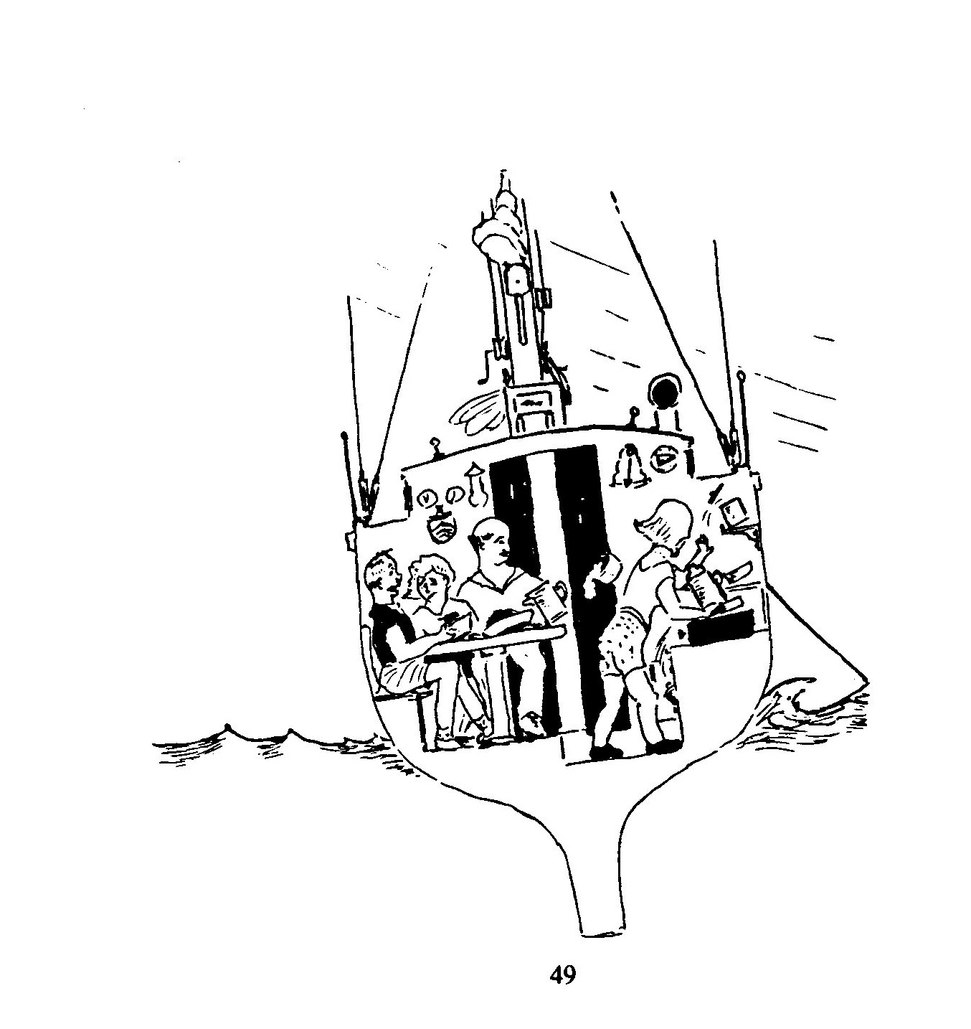

A page from the 1989 SBCC Cruising Guide – Roger G. Ramsdell - Artist

SBCC Cruising Song

Music: Wiffenpoof Song Words: Ed Schecker

From the sandbars at Moriches
To the shoals of Tuckernuck,
We have pressed our painted bottoms and our luck,
We’ve assembled in Great River
With our burgees raised on high,
And our anchors safely buried in the muck.

Yes,we’ve been to many places
Whose names we love well-
Shelter Island,Martha’s Vineyard,Buzzards Bay.
We are proud of who we are,
As we cruise both near and far,
We’re the South Bay Cruising Club and we can say:

We are sailing folks who have found our thing,
Blow,winds,blow.
We like the seas when the breeze is right;
We like the glow of a harbor light.
Blue skies by day and the stars at night,
Blow,winds,blow.
Blow,winds,blow.

Chantey,old ships’ songs sung on board to lighten the labor of working the ship.
The earliest know example of a true chantey,sung to coordinate the efforts of the men working occurs in the Complaynt of Scotland published in 1450. Some well known examples include “Billy Boy”, “Shenandoah”,
Blow the Man Down”

Glossary

U.S. Nautical Charts are published in five sizes,
- Sailing Charts scale 1:600,000- for ocean voyages
- General Charts scale 1:150,000- for coastal voyages
- Coast Charts scale 1:50,000 - off shore to inshore
- Harbor Charts scale >1:50,000 -harbors, anchorages
- Special Charts -intracostals, small craft areas
- NOAA Great South Bay chart 12352 page C, scale of 1:40,000 or 1 inch = 0.57nm
* NOAA Great South Bay chart 12352 page G, scale of 1:20,000 or 1 inch = 0.27nm
- NOAA Great South Bay chart 12352-2, scale of 1:50,000 or 1 inch = 0.61nm

Basic Information found on charts
- General Information Block describes the waters covered, distance scale, soundings, unit of depth measurement (feet, fathoms, metric)
- Notes that contain critical information for the mariner
- Latitude and Longitude Coordinates
- Bottom characteristics
- Chart number, edition number and date of revision

Chart No.1 is a booklet that shows standard symbols and abbreviations approved for use on all regular nautical charts.

Did you know that?
VERTICAL lettering on a chart indicates features that are dry at high water.
LEANING lettering is used for water, under water and floating items but not for depth figures.

United States Coast Pilots are a series of nine nautical books that cover information important for the cruiser. Subjects include general information, channel descriptions with controlling depths, anchorages, bridge and cable clearances, dangers, weather, small craft facilities, harbors, navigation regulations and a great deal more.
Example - U.S. Coastal Pilot 3 covers the Atlantic Coast from Sandy Hook to Cape Henry.

Local Notice to Mariners is a U.S. Coast Guard publication that provides information on changes to local waters such as buoy relocation, shoaling, hazards to navigation, etc.

Light Lists are a series of publications issued by the U .S. Coast Guard that describes the lights, buoys, day beacons, and radio beacons, maintained in the navigable waters of the United States. They consist of seven volumes. Volume I covers the waters of the Atlantic Coast from Maine to Maryland.

Coastal Warnings
- Small Craft Advisory wind velocity at 18 knots +
- Gale Warning wind velocity at 34 to 47 knots
- Storm Warning wind velocity at 48 to 63 knots
- Hurricane Warning wind velocity at 64 knots +

Global Position System (GPS) is a space – based positioning system that contains 24 satellites in six orbital planes that will provide the receiver with at least the latitude and longitude coordinates of the ship’s location and when under way with speed over ground.

DSC “Digital Selective Calling” is a VHF emergency communications system that when activated alerts the Coast Guard of a serious problem.

RACONS (Radio beacons) are low powered radio transmitters located in buoys or at strategic locations that are activated by a ship’s radar signal. The RACON returns a distinctive signal that provides range and bearing data.

Buoys are aids to navigation, when depicted on charts consist of a system of fixed and floating aids with varying degrees of reliability.
Besides navigation, buoys have additional uses such as “watch buoys” that enable a lightship to check her position.

Tsunamis (seismic sea waves) are the product of submarine earthquakes, which some times can be 100 miles in length, can reach speeds of 300 to 500 knots. Ships in the area near land should head out to sea.
This phenomenon is more likely to occur on the west coast of the United States rather then on the east coast.

Special Anchorages are sites defined by geographical coordinates expressed in terms of latitude and longitude that identify anchorage areas for large and small vessels.
Vessels 20 meters in length or less do not have to display day shapes or lights while at anchor.

Harbors of Refuge are shown on nautical charts are a safe haven during storms.

Tidal Current Tables are published (hard copy or CD) by the National Ocean Service Publications in two volumes: Atlantic Coast of North America and Pacific Coast of North America and Asia. They give the times and direction of minimum currents or slacks when the current reverses. Tables are published in two volumes: Atlantic Coast of North America and the Pacific Coast of North of America and Asia.

Tidal time difference from reference to local area
(Listed time differences are averages that are fairly accurate +/- 15 minutes)

Patchogue High Water Reference
Approximate
Local area Time Difference

Hours
Babylon - 1
Bay Shore - 1
Browns Creek 0
Connetquot River 0
Fire Island Light House (bay side) - 3
Fire Island Inlet - 4
Gilgo Beach (Hemlock Cove) - 1
Jones Inlet - 4
Sailor’s Haven - 1
West Fire Island (Saltaire, Atlantique) - 1

Example:
If High water in Patchogue Bay is at 12:00 (noon) then high water at Sailor’s Haven was at 11am.

Fire Island Inlet Reference
Approximate
Local area Time Difference

Hours - minutes
Babylon + 3 -
Bay Shore + 3 -
Browns Creek + 4 -
Connetquot River + 4 -
Fire Island Inlet 0 -
Fire Island Light House (bay side) + 1 -
Gilgo Beach (Hemlock Cove) + 3 -
Jones Inlet 0 + 15
Patchogue + 4 -
Rockaway Inlet (Jamaica Bay) + 1 -
Sailor’s Haven + 3 -
West Fire Island (Saltaire, Atlantique) + 3 -

Example: If high water in Fire Island Inlet is at 8 am then high water at Sailor’s Haven is at 11 am.
Sandy Hook High Water Reference
(Times listed are averages)

Local Area Approximate Time

Difference

Hours - minutes
Shinnecock Inlet - 0 50
Moriches Inlet - 1 -
Fire Island Inlet - 0 40
Bellport + 3 45
Patchogue + 3 25
Bayshore / Babylon + 2 25
Jones Inlet - 0 20
Manasquan Inlet - 0 10
Rockaway Inlet - 0 5

Example:

If high water at Sandy Hook is at 8am then high water at Patchogue is around 11:25am

Slack Water after High Tide
Hours - minutes
Fire Island Inlet + 3 -
Jones Inlet + 1 30
Shinnecock Inlet + 2 -
East Rockaway Inlet + 1 -

Example:

If high tide at Fire Island Inlet is at 8am then slack water is at 11am.

Having difficulty determining if current is slack, flood or ebb? Buy a copy of
“ELDRIGE TIDE AND PILOT BOOK” it lists tide and current data from
Boston to Maryland!

Conversions
From
Degrees – Minutes – Seconds
To
Degrees - Minutes

Having a difficult time changing LORAN or Local Notice to Mariners Longitude / Latitude numbers to your GPS?
Try this table…..
Seconds Minutes

60 1.000
56 .937
54 .906
52 .875
45 .750
42 .687
40 .656
38 .625
34 .563
30 .500
26 .437
- .406
23 .386
21 .348
20 .330
15 .250
14 .234
13 .218
12 .200
10 .168
09 .150
07 .114
03 .045
01 .020

Example:
Fire Island Inlet Horn (44 ft high) is located at
40º 37’14“ North
073º 18’23“ West
or
40 º 37.234’ North
073 º18.386 ‘West

References

a. United States Coast Pilot Region 1 Atlantic Coast: Eastport to Cape Cod
b. United States Coast Pilot Region 2 Atlantic Coast: Cape Cod to Sandy Hook
c. United States Coast Pilot Region 3 Atlantic Coast: Sandy Hook to Cape Henry
d. Cape Cod-Official National Park Handbook
e. U. S. Coast Guard Radio Information for Boaters
(MarComms dated 02 May 2001)
f. Cruising Guide of the South Bay Cruising Club
(Fourth Edition)
g. The Oxford Companion to The Ships and The Sea.
h. SBCC members cruising logbooks

Recommended Reading

a. The Cruising Guide to the New England Coast, 12th edition $49.95
Duncan, Duncan, Fenn, Fenn

b. A Cruising Guide to Narragansett Bay Including Buzzards Bay $37.95
Nantucket, Martha’s Vineyard and Block Island

c. A Cruising Guide to the Maine Coast, 4th edition $42.95
Taft & Rindlaub

d. Cruising Guide to the Chesapeake, 3rd edition $39.95
Shellenberger

e. Guide to Cruising Chesapeake Bay $39.95
2006 edition (877-904-8624)

f. A Cruising Guide to New Jersey Waters $19.95
Captain Donald Launer

g. Cruising Guide to the Hudson River, Lake Champlain $36.95
and St Lawrence River
Alan & Susan McKibben

h. Eldridge Tide and Pilot Book $11.95

i. A Comprehensive Guide to Marine Medicine $16.95
Eric A. Weiss MD & Michael Jacobs MD

J. Doctor On Board $19.95
Dr.Jurgen Hauert

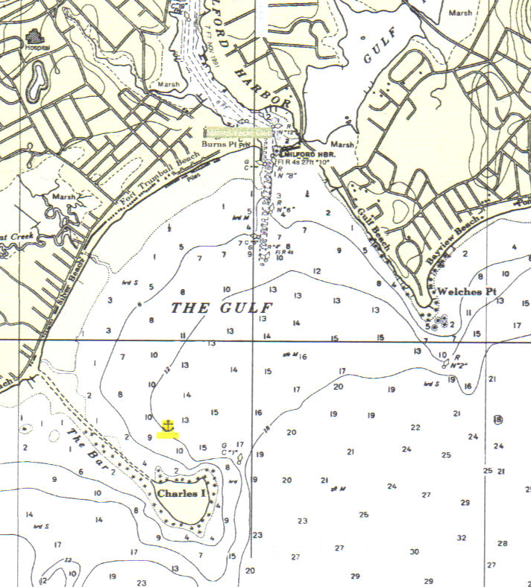
Anchorage
Milford Yacht Club

NOAA Chart 12370 (1993 edition)

The Gulf Anchorage
41°11.80’ N // 073°03’ W

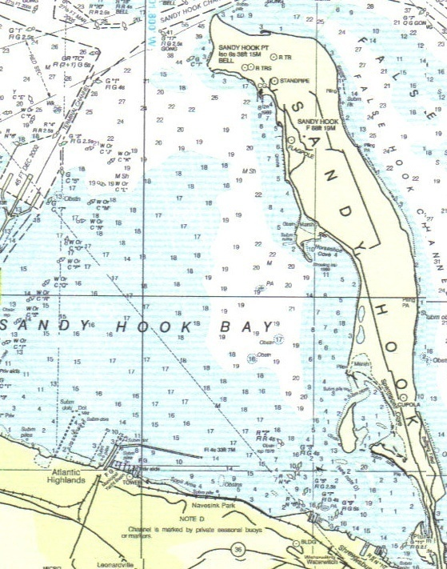
Atlantic Highlands Yacht Club
Anchorage

NOAA Chart 12324 (2005 edition)
Horseshoe Cove Anchorage
40°26.800’ N // 074°00’ W

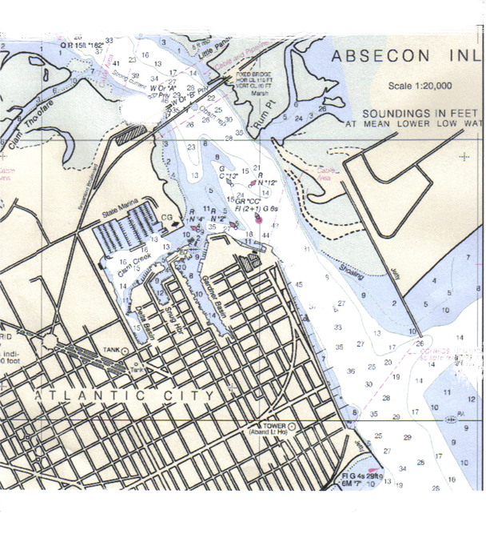
Anchorage
NOAA Chart 12318 (2001 edition)

Atlantic City Anchorage
39°22.900’ N // 074°25.200’ W

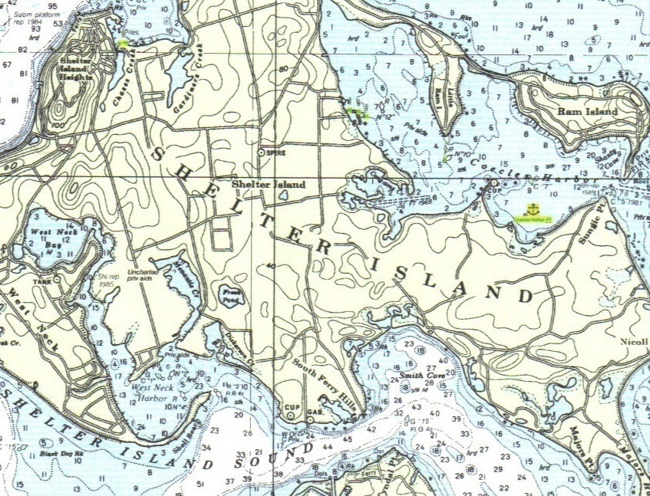
Anchorage

NOAA Chart 12358 (1994 edition)
West Neck Harbor Anchorage and Coecles Harbor Anchorage
41°02.600’ N // 072.20.800’ W - 41°04’ N // 072°17.500’ W

Bristol Harbor Anchorage

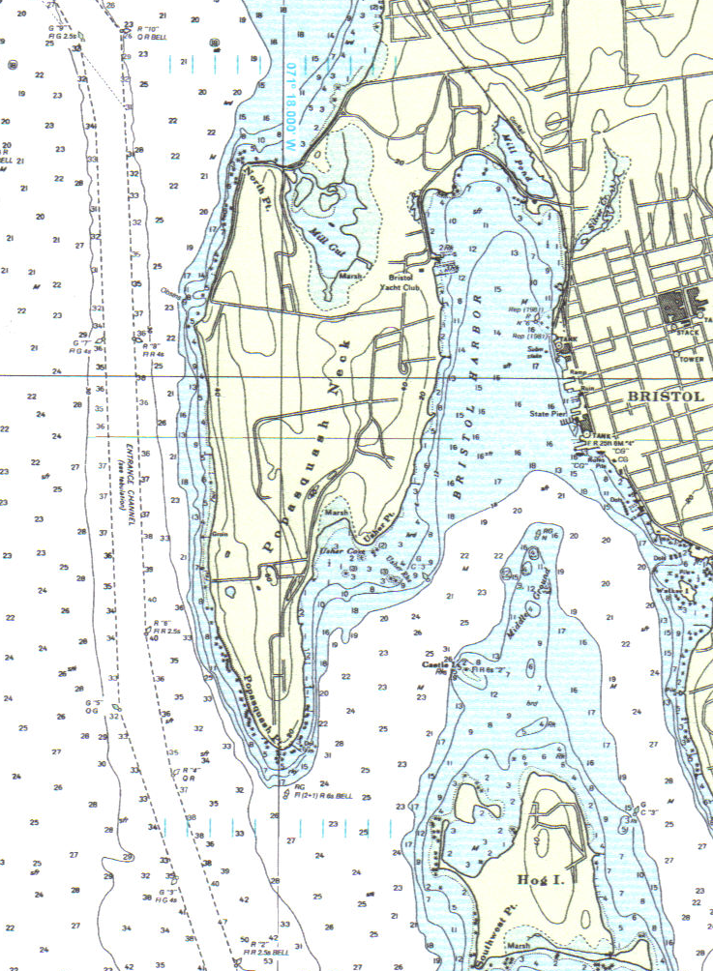
Anchorage
NOAA Chart 13224 (1994 edition)
Bristol Harbor Anchorage
41°40.500’ W // 071°17.00’ N

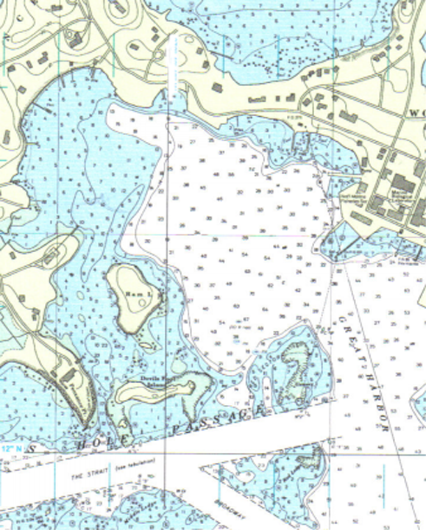
Anchorage
NOAA Chart 13235 (1994 edition)
Woods Hole Great Harbor North Anchorage
41°31.600’ N // 070°40.900’ W

