Web Site Maintenance WordPress
07-29-2024 Richard Mourino

Table of Contents

WebSite database Names: 2
Changing Code: 3
Using WordPress 4
Plugins: 5
Web Design Folders & Uses 9
Restore WordPress Site: 12
Migrating to another server for Testing 13
FtpZilla Picture 15
Updating Officers Page 17
Adding Photos with Jalbum: 19
Convert Docs or Excel to Jpg format (Image) 19
Converting PDF from YearBook, etc to web pages 19
Email PDF to Members 21
Race Results: 22
Events: 22
Slide Show 23

Installation programs:

- Get access to Club_Procedures\Technology_Web where all the utility Programs are stored.
- Since we are using WordPress there is no need for a publishing program as changes are done live.
- Install the FTP program called FTP-Zilla from the FTP folder.
- If you do not have winzip install this program. The folder has the same name.
- Reboot your computer
- JALBUM Creates the web pages for Photos.
- FireStone Viewer View all of the photos on pc
- FireStone Resizer Make pictures bigger for the slide show plugin if needed
- NOTE there is folder security on the Club_Documents using the a plugin called wp-Member. It uses wp-user accounts with lowest security as Subscriber and highest administrator.
- Uses 7Zip for compression and de compression

WebSite database Names:
Refer to security id’s document for more current info

Dbname User password Host name
Sbccsail_website sbccsail_webmast sail4ever51 sbccsail.org
Sbccsail_testsite sbccsail_webtest sail4ever1951 testsite.sbccsail.org
Sbccsail_racing sbccsail_webracing sail4ever51 test racing.sbccsail.org
Sbccsail_dm1 sbccsail_dm1 sail4ever51 dadamail production
Sbccsail_dm2test sbccsail_dm2test sail4ever51 dadamail test
Sbccsail_online sbccsail_developer sail4ever51 membership
Sbccsail_archive sbccsail_developer sail4ever51 membership
sbccsail_webuser sail4ever51 php membership
Sbccsail_clubstore sbccsail_clubstore sail4ever51 clubstore.sbccsail.org

Changing Code:
Since changes are done live I would suggest running the cronjob backup first before making changes. On each function of WP is a publish button.
Restore function will be documented later in this document.

PLEASE NOTE THERE ARE DIFFERENT WP_CONFIG.PHP FILES FOR EACH DATABASE.
You will find then in the main site folder for each one.

wp-config-mainsite.php
wp-config-testsite.php
wp-config-racing.php

Using WordPress

Access to WorPress uses your browser to get to the administration page of the site.
Using www.sbcsail.org get you to the site using http://www.sbccsail.org/clubloginadmin gets you to the administration page to make changes. There are numerous plugins installed to provide better functions that are needed to maintain the site all but one are free or using the free version. The PDF enabler is the only one at this time that is a paid version.
WP admin page login info: Id admin pw sail4ever51

Plugins:
The list of plugins is listed below:
------------------------------------------------------------
Plugins in use 12-2022
Plugin Name | Description | Author | Current Version
Advanced Editor Tools (previously TinyMCE Advanced) | Extends and enhances the block editor (Gutenberg) and the classic editor (TinyMCE). | Automattic | 5.6.0
Classic Editor | Enables the WordPress classic editor and the old-style Edit Post screen with TinyMCE, Meta Boxes, etc. Supports the older plugins that extend this screen. | WordPress Contributors | 1.6.2
Disable XML-RPC | This plugin disables XML-RPC API in WordPress 3.5+, which is enabled by default. | Philip Erb | 1.0.1
Email Log | Logs every email sent through WordPress | Sudar | 2.4.8
Embed PDF Viewer | Embed a PDF from the Media Library or elsewhere via oEmbed or as a block into an `object` tag or Google Doc Viewer as fallback. | Andy Fragen | 2.3.0
eStore Manual Checkout Form Builder | eStore addon for customizing manual checkout form | Tips and Tricks HQ | 1.4
eStore Variations UI Addon | Adds a user-friendly product variation configuration form in eStore product creation menu | Tips and Tricks HQ | 1.9.5
Events Manager | Event registration and booking management for WordPress. Recurring events, locations, webinars, google maps, rss, ical, booking registration and more! | Pixelite | 6.1.6
Extra Shortcodes for WP eStore | Adds some extra shortcodes that can be used with the WP eStore plugin. | Tips and Tricks HQ, Ruhul Amin | 5.2.4
iQ Block Country | Block visitors from visiting your website and backend website based on which country their IP address is from. The Maxmind GeoIP lite database is used for looking up from which country an ip address is from. | Pascal | 1.2.19
Mammoth .docx converter | Mammoth converts semantically marked up .docx documents to simple and clean HTML. | Michael Williamson | 1.20.0
MetaSlider | Easy to use slideshow plugin. Create SEO optimised responsive slideshows with Nivo Slider, Flex Slider, Coin Slider and Responsive Slides. | MetaSlider | 3.28.0
Query Monitor | The developer tools panel for WordPress. | John Blackbourn | 3.10.1
Safe Redirect Manager | Easily and safely manage HTTP redirects. | 10up | 1.11.1
Ventus - Weather Map Widget & Shortcode | Easily customise and embed the windy.com widget as a native WordPress widget or shortcode. | David Matthew | 1.4.0
Wordpress File Upload Pro | Simple interface to upload files from a page. | Nickolas Bossinas | 4.16.4
WP-Members | WP access restriction and user registration. For more information on plugin features, refer to <a href="https://rocketgeek.com/plugins/wp-members/docs/">the online Users Guide</a>. A <a href="https://rocketgeek.com/plugins/wp-members/quick-start-guide/">Quick Start Guide</a> is also available. WP-Members(tm) is a trademark of butlerblog.com. | Chad Butler | 3.4.6
WP-Members Advanced Options | Adds a tab of advanced options for WP-Members. | Chad Butler | 2.2.4
WP-Optimize - Clean, Compress, Cache | WP-Optimize makes your site fast and efficient. It cleans the database, compresses images and caches pages. Fast sites attract more traffic and users. | David Anderson, Ruhani Rabin, Team Updraft | 3.2.10
WP eStore | A Robust Shopping Cart Plugin to sell digital (ebook, mp3, photos, videos, software etc.) and non digital products from your wordpress blog. The digital goods are automatically delivered to the buyer after purchase using encrypted and time limited download links. | Tips and Tricks HQ, Ruhul Amin | 8.4.0
WPForms Lite | Beginner friendly WordPress contact form plugin. Use our Drag & Drop form builder to create your WordPress forms. | WPForms | 1.7.8
WP FullCalendar | Uses the jQuery FullCalendar plugin to create a stunning calendar view of events, posts and eventually other CPTs. Integrates well with Events Manager | Marcus Sykes | 1.4.1
WP Mail SMTP | Reconfigures the <code>wp_mail()</code> function to use Gmail/Mailgun/SendGrid/SMTP instead of the default <code>mail()</code> and creates an options page to manage the settings. | WPForms | 3.7.0
WP Migrate Lite | Exports your database as a MySQL data dump (much like phpMyAdmin), does a find and replace on URLs and file paths, then allows you to save it to your computer. | Delicious Brains | 2.5.0
WP Payment Gateway Bundle | A payment gateway library bundle that allows you to process payment using various payment gateways | Tips & Tricks HQ | 2.4.9
WP Rollback | Rollback (or forward) any WordPress.org plugin or theme like a boss. | GiveWP.com | 1.7.2
WPS Hide Login | Protect your website by changing the login URL and preventing access to wp-login.php page and wp-admin directory while not logged-in | WPServeur, NicolasKulka, wpformation | 1.9.6
WP Statistics | This plugin gives you the complete information on your website's visitors. | VeronaLabs | 13.2.9

Web Design Folders & Uses

The web is devided into a few sections(Sub Domains) due to the size of the information that is stored there. The main directory is public_html with several separate directory that were created by making sub domains on the server. These other directories are documents photos and memberinfo .

Public_Html main directory used by Wordpress and in the web site containing the information that is normally displayed on the web site. All of its files begin with WP_.
A copy of this folder is required to be copied to your pc
Domain name sbccsail.org

Documents folder contains all the documentation of the club and is secured by an id and password sbcc4committee 4youreyesonly at this time. A copy is required on your pc
Sub Domain name documents.sbccsail.org

Photos contain all the photos and videos of the site and photos are in Jalbum format and this software ftp’s the data directly to the server Photos sub domain.
It is required to keep a copy of them on this pc.
Sub Domain name photos.sbccsail.org

Memberinfo contains a php program that can display the membership database and is restricted to the DBA , Membership and some others. It is not required to be on your pc.
Sub Domain memberinfo.sbccsail.org

All of the above are backed up by the server on a weekly basis in a tar compressed format called tar gzip. And it would be good to download them to your pc on a weekly basis.

WordPress Admin is used to maintain the information on the main domain.
Instead winfcp is used to migrate photos from club pc to the site and back when necessary. Sbccsail.org/wp-admin. Its data resides under the Public_Html folder.
Additional security added admin login is now https://sbccsail.org/clubloginadmin
https://testsite.sbccsail.org/clubloginadmin or https://racing.sbccsail.org/racingloginadmin

Word Press has an additional backup which just backs up its own files only in case a restore is needed because you messed something up. There are at least 1 daily and 1 weekly backups for them. They reside under the root folder of the server with the names backup-daily*** backup-weekly***.

The main functions used in WP can be broken down to

Themes How the entire site looks generally, using Vantage theme
Pages Data for each Page. Note links are not show here
Links Rather than a page it is a link to external file usually a PDF
Menu The structure of the menu on the site. The links are shown here.
Widgets Things on the right side of the page.
WPForms The email form builder.
NOTE POSTS are not used in this site only Pages, Email Forms, Widgets and Menus.

On the server under public_html are the WP folders and program as well as few other
Folders with special purposes. All WP items start with wp- .

Forms contain Doc, Docx and PDF files used either in pages (copy paste) or in links to PDF files, or used in the PDF Enabler plugin. This folder is actively used in the web site as any PDF that is linked to in WP comes from this folder. The data here is mostly word docs that are copied and pasted into the WP pages. In those situations where a PDF is a better fit then WP page I used a link to the PDF file located here. So this folder must be available to WP at all times. The PDF Enabler allows one to include a PDF into a WP page and this PDF MUST be imported into WP. A link cannot be used. This plugin may be removed if found not to be useful.

Pictures source images that are imported into WP Pictures and must be imported and cannot be used as links. Images cannot be linked into WP they must be imported into the WP upload area in its environment. So this folder is the source of the WP Images.

Archive Folder containing old docs and other items no longer need on the site and no longer in the Forms folder

SCS_Client where the desktop client sits for membership program (windows program) it is here so newer versions can be download by membership when needed.

Backup_Scripts unix scripts that are used to run the crontab backup jobs and other maintenance database jobs. They are really run from the root directory but these are copies of the code. They are refreshed when ever the Con jobs run so they are always uptodate.

Root Directory contains all of the backup files in tar gzip format.

In the root directory there is a PC msi install program that was provided to members that do not have any backup feature on their PC. It is called Backup_script.msi.

Creating a pulldown menu on web menu:
PullDown menu in WP Is created in the Menu function by replacing the URL field
with # . This causes the menu item to be a header with no action. You then add additional Menu items under it and slightly indented in the order you wish.

NOTE always name files so that there are no spaces between name Use an underscore to make the one word file. EX report test should be report_test Unix does strange things with spaces so the underscore prevents this strange items.

Under WordPress a space is nothing more than a space and there is no issue under WordPress only under Unix.

Widgets (right side of screen). The standard widget editor is uses plus the calendar plugin. Add or update the Coming Up Events as it has a very good editor in it.

Inserting DOCX Files into a page: There is a Plugin at the bottom (Mammoth Docx Converter) of the WP page that imports Microsoft word (must be a docx format) much better than just copy paste from word. I recommend using it.

If the document or pdf cannot be used as a copy and paste or use the Mammoth Docx Converter then the pdf is linked to in the web site.

Restore WordPress Site:

For restoring the main site due to an oops. Ask for vendor help

- Using the Direct Admin to get to the File Manager.
- Locate the Backup_files folder
- There are daily and weekly backups pick the one you need.
- Go to the Extract folder under it and erase all of the files.
- Go back to Backup_files folder and select the backup to use and extract the data
  - To backup_files/extract/
- Make sure that there is data in the extract folder.
- At this point the data for that domain will be in the extract sub folder. You can copy some folders or all to the real domain
- The sql for reloading is also in the extract folder and one can use myphpadmin to reload the sql.

In the main site and also the backup you will find copies of the wp-config for each server so you can verify that you are using the correct wp-config.php file

wp-config-mainsite.php
wp-config-testsite.php
wp-config-racing.php

Migrating to another server for Testing

A www.testsite.sbccsail.org is available for testing a new feature without harming the main site. It has the same id and password as the main site. The only difference it the password for the test dadabase. It is sail4ever1951

You will need to use the plugin WP Migrate DB from production system to convert and dump the sql from prod to import it into test system. This plugin downloads the sql to your PC so I can be imported back to the test database. This plug in converts any reference to the production web site addresses to the test website domain.

I do not recommend migrating code from production to test rather re key it in after you are happy with your testing.

Overlaying the TestSite with Production data (wp-content).

Using the Direct Admin to get to the File Manager. Looking at Production
Domain/sbccsail.com/publib_html/wp-content/

- Locate the folder to copy wp-content
- Copy it to the domain/testsite/
- Use the Migrate DB Plugin to create sql that converts production sql to sql for the testsite

In the production backup there are 3 config , one for each system note racing is not used at this time.

wp-config-mainsite.php
wp-config-testsite.php
wp-config-racing.php

Migrate DB plugin values that are used in the plugin :

Find Replace
//sbccsail.org //testsite.sbccsail.org
Sbccsail_website sbccsail_testsite
/home/sbccsail/public_html/ /home/testsite.sbccsail/
Sbccsail_Daily_Backup Testsite_Daily_Backup
Sbccsail_Weekly_Backup Testsitel_Weekly_Backup
Many more options are already built

If the test site just needs to be refreshed with some minor changes to production then just run the plugin migrate Db from production and upload the database to the Test system. Generally that is all that is needed.
WP-EStore has to be set to sandbox mode.

FtpZilla Picture

FTP server: ftp.sbccsail.com
Port: 21
Transfer: plain FTP, no encryption
user - ftpsail@sbccsail.com
password - jp7R3p1Hz4

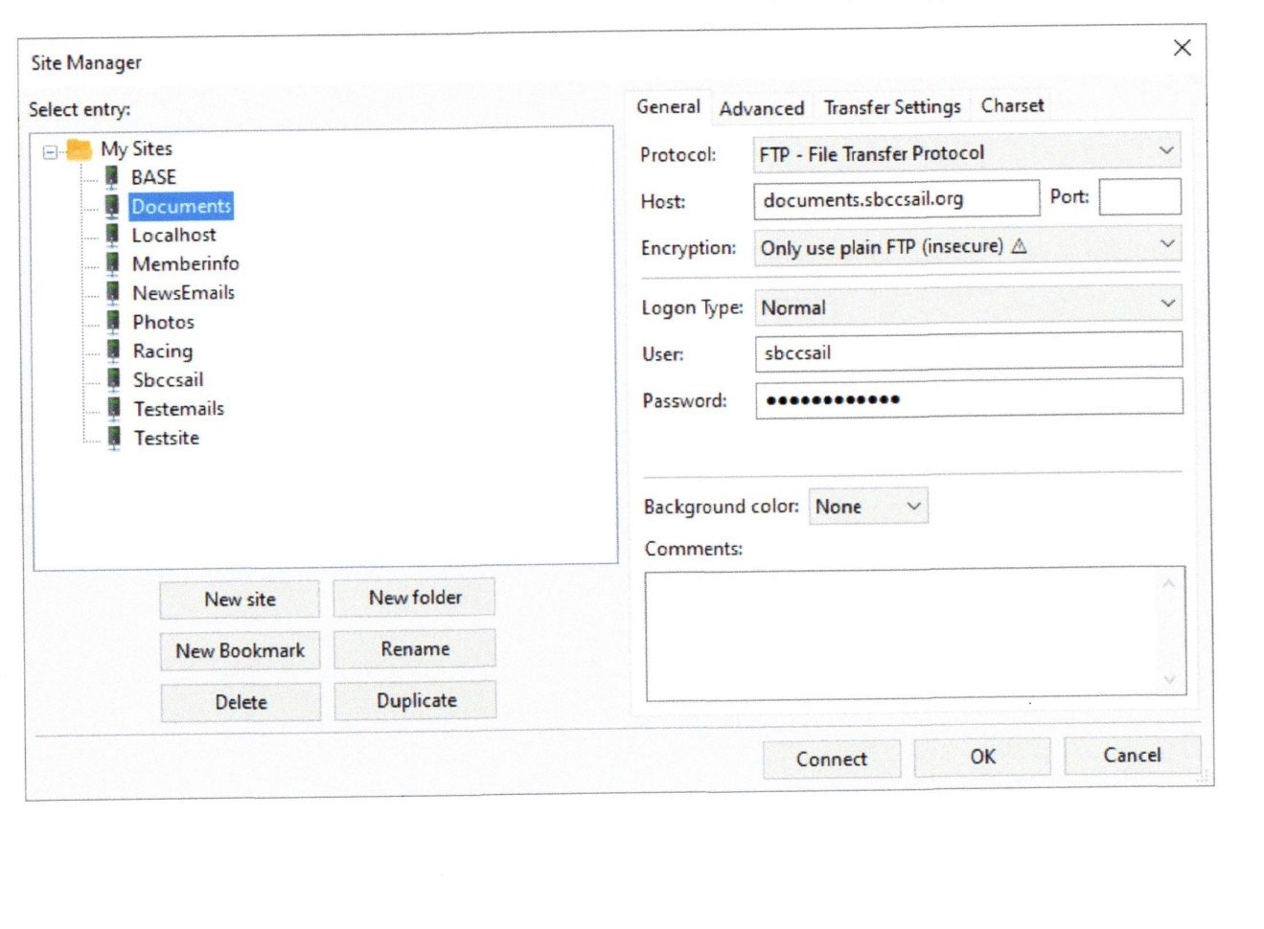
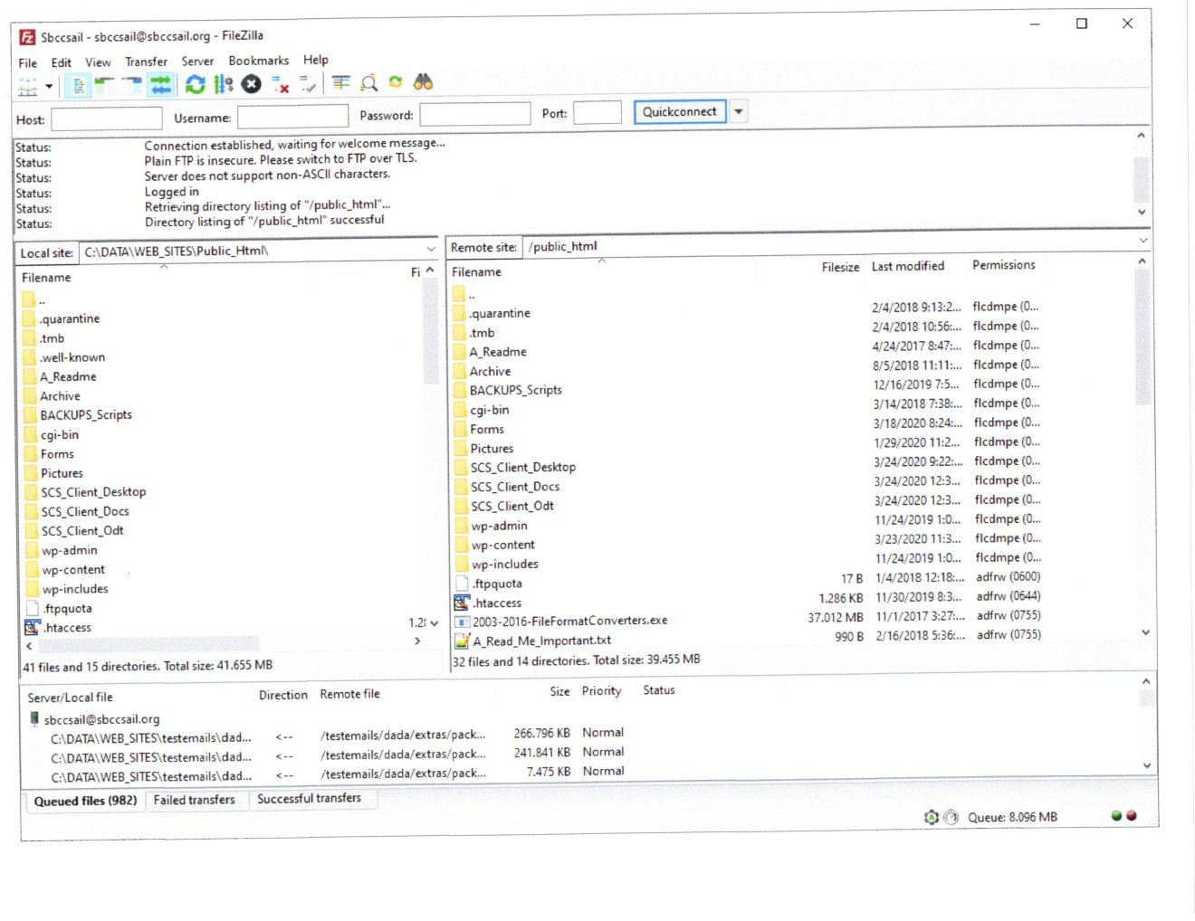

When it opens set the local folder so you can see both sides together like this
There is an option to download or upload the file if it is newer than the existing one. This saves time in getting your copy in sync with the server.
Under the File menu look for Site Manager .
Select the File or folder you need to transfer .

Updating Officers Page
For Server support new vendor
https://www.entirelydigital.com/manage/login

Find Under Form Folder on the web called Officers_web_page.xls and send it to the new Commodore so it can be updated with the new assignments.
The Commodore MUST update the member’s name and email addresses Column 2 and 5 only. This will be used to update the forwarding email alias to the real person’s email address. The first 3 columns will be used in the web site Officers_Page The entire xls is used to update the forwarding email address in Hosting Matters.
DO NOT CHANGE ITS ORDER.

There are 2 tables in the page. The first contains the Officers picture edited to fit. The second is an Image of the Officers Name and club email in an image format to prevent Bots from gaining access.

Using the Excel set the print area so only the first 3 columns will be printed. Now create a pdf (save as pdf) as this will be used to create the Image file just containing the first 3 columns for the html page.

If Using CPANEL following will work :

Login to the Hosting Matters web site using the master id and password. Proceed to the
“MAIL” “Forwarders” function. Delete all Forwarders Except Administration as one will need to add all new entries. This function only allows add or delete Modify does not exist. The administration entry has to be manually added back in.
MAKE SURE IT IS SET TO SBCCSAIL.ORG

Return to home and now select from the “MAIL” “Address Importer”
On the next page select “Forwarders” and find the file that you saved in the xls format.
Follow the instructions on the page.
And identify the last 2 columns needed to mass input the new fowardings.
Allow the mass input if all looks good.

If using Direct Admin :

You will need to modify each forwarding address to the new member address.
There is no automatic load function at this time.

Using the Officers_web_page.pdf and using the Smart PDF utility convert the pfd to an Image for the web page. This prevents any bot from grabbing the system email address.
The file that it creates should have this name Offficers-Web-Page_0001.jpg.
Publish the file.

In the Canned report page of the membership system is a report that will extract all the board members with their titles and email addresses. This program gathers the data that is current as of Jan 1 or later. The report name id Officers Web page list. The sql program that creates this is called Rpt_board _officer_list stored in the procedure section of the database sbccsail_online.

Adding Photos with Jalbum:

Install JAlbum by reading the install instructions in the JAlbum folder

License key is in the folder.

Steps:
- Download photos to C:\data\temp\folder name
- Copy new folder to Pictures folder
- Open Jalbum and import, edit to your liking and upload to server
- Open Picasa so they are loaded for safe keeping
- Add to website Photo Page

Convert Docs or Excel to Jpg format (Image)

Using Office version 2007 or above save the file (excel or Word ) to a PDF format.
Then Using the Smart PDF Converter Pro input the PDF and convert it to IMAGE file
The Officers page must be done this way to reject any Bots from getting the email addresses.

Converting PDF from YearBook, etc to web pages

At the beginning of the year one should ask for a copy of the Final Year Book in PDF form. Using the program Smart-Pdf-converter (folder with the same name in Club_Procedures\Technology_Web ).
One can use the Utility function to EXTRACT a piece of the year book pdf and create a smaller version that can be added to the web site.

The default screen of this program allows one to extract a piece of the PDF to a word doc file. Under the PDF TOOLS tab one can EXTRACT a piece of the pdf file to another smaller pdf file.

I have used both functions in the following manner.

Using the Year Book pdf I extracted out a small pdf with the All Events Schedule.
I converted that to a DOC file so I could during the year edit the doc file and remove older months of the schedule as the months go by. Then I recreate a new pdf from the DOC that reflects the current and upcoming months to a new pdf and place that in to the web site. REMEMBER THAT NAMES CREATED SHOULD MATCH THE FILES THAT ARE ALREADY IN THE WEB SITE.

The easiest way to move files around (if they have the same name) is to copy the new file directly into the FTP folder on the PC and then FTP it to the server allowing it to replace the existing file. I recommend using c:\data\website\sbcc_site\ structure on your PC and using winscp ftp them up to the server.

Email PDF to Members

This is special facility on the Club’s pc only.

To email to a members their individual Dues letter or to email out the Year Book Verification email one needs to perform several steps using special utilities one is called Smart-Pdf-Converter the other is A-PDF AutoMail .

First one need to run either the detail dues letter or the YearBook Verification word macro to generate a word document. They must be saved as a PDF and not word.
Save the pdf to a folder on your machine I used DOCUMENTS / A-PDF AutoMail
With subfolders that represent the email function.

Empty out these folders so they only contain the PDF you just saved. Now run the special utility called Smart-Pdf-Converter to SPLIT the pdf into individual pdf files either 2 per page or 1 depending on what you need to do. The SPLIT is a sub function of the Converter and will split the target pdf into a number of files. Let them go to the the same folder that has the master one.
There should be a distinct folder for the Dues and a different one for the Verification letter.

Once they are split then run the special Utility A-PDF_Emailer and point it to the distinct folder. There are 2 control files one called YearBook.rul , Name_Tags.rul, PastDue.rul, Reminder_Letters.rul that define where the email address in in the pdf.

The pdf-emailer settings are Output SMTP email server = sbccsail.org Authication is checked user name = membership_dues@sbccsail.org password = sail4ever
Email address = membership_dues@sbccsail.org your name = membership
In the web server there is an email set up for this user already.
Yes you are using the web server to do this, NOT your own email. There is a forwarding item in the web server (CPanel) to send all mail to membership_dues to the membership committee chair.
Takes about 10 minutes to email up to 200 members. It uses the servers smtp service to do this email.

Contact Us :

This page uses the WPForms plugin to create many possible email screens.
At this time there are several to specific club officers including a RSVP form.
They are coded to send email to the officer requested with a copy going back to the sender. To whom it is send is controlled in the form itself. The design is a WPform which is attached to a page giving a unique page for each officer or chair.
The Membership applications are also done in this way. WPForm creates the form and it is then included into a page.

Race Results:

Regatta site does this now.

Events:

Events are created with the plugin Event-Manager. The interface to Google maps is done through the Google API under the account of sbcc.membership@gmail.com account. The api is the non secure one as I could not get the web based one to work.

The steps to create an Event :
Create the new Event under the Event screen of WP and copy , paste or use the pdf include to get the info into the page. Add the Form rsvp-special to the bottom of the page. You will need to modify the Notification section of the Email Form to point to the email of the person to receive the RSVP as the use of the generic RSVP may not be used anymore (generic one goes to Hospitalityrsvp account).

Add in the location on the bottom so the map appears. There are several already created and it may give you a selection as you start to type.

The widget calendar is coded to show only the first 4 events.

For recurring Events use the Recurring Event process of the event plugin. I used this to generate individual events for Board Meetings and Racing and rendezvous events.

Slide Show

The slide show plugin requires that pictures be loaded into the WP MEDIA area in order to use them. Since most pictures may be small one may need to use the Firestone Resizer program to make them bigger so they work fine in slideshow. Generally pictures need to be 1400 X 800 to look good. I also use Firestone Viewer rather than picasa as it is no longer being supported.

